8 Nagging Realities for 2021
“The only constant in life is change”
Heraclitus
The need to update, question, and occasionally discard beliefs is constant in geopolitics. In the modern world, information, decisions, diseases, and innovations propel global change at an unprecedented rate. While the current rate of speed is unsettling for many, the pattern of acceleration has existed for centuries. With subsequent changes it is inherently prudent that we question our core beliefs. Many of these realities may be difficult to reconcile given our personal political leanings or worldview. However, seeing the world clearly often necessitates a somber and pragmatic approach.
“The truth is incontrovertible. Malice may attack it, ignorance may deride it, but in the end, there it is.”
Winston Churchill
- Political Protests often fail to inspire change.
Political protests often coincide with a positive connotation, invoking images of the righteous and moral standing up against evil or immorality within the world. In part justly so, some of the most famous protests are remembered for their success and the nobleness of their cause. These successes, though monumental, are often the exception.
Political protests intend to place overwhelming pressure on elected representatives and rulers. Structurally a greater pressure can be exerted on elected officials which must regularly face free and fair elections. Officials or rulers in flawed democracies or authoritarian states are structurally more insulated from such protests. Vladimir Putin has dealt harshly with his most vocal critics and cracked down immediately at the first hint of public protests. Victor Orban of Hungary has weathered consistent protests since 2018 without making any serious concessions and the protests of the Venezuelan people have largely fallen on the deaf ears of the Maduro government. Many protests fail due to the efficacy of the incumbent state, and their willingness to engage in oppressive tactics. Protests also regularly fail to coalesce around a preferred alternative or consistent set of demands.
Even within the United States protests over the Black Lives Matter movement have failed in many instances to create the desired legislative changes. While elected officials have been forced to confront and discuss the issue at length within local, state, and federal governments the outcomes have been mixed. Protests surrounding the 2020 presidential election failed to overturn state or federal election results and again have produced a piecemeal of legislative results. While protesters in democratic nations are able to bring substantially more political and financial pressure on their elected officials, we must grasp the reality of many protest efforts. Political protests inherently stem from perceived grievances or injustice, and such beliefs must meet a substantial threshold to inspire a general protest of sufficient magnitude. Thus, protests are more rarely carried out by the political majority, which holds the necessary legislative power to enact the desired changes. Yet the minority must be sufficiently large in order to muster an effective protest. Political protests are often ineffective, yet are vital to the function of genuine democracy and the exercise of free speech. Political protests, no matter how righteous their cause often run a long and arduous course, and success is not guaranteed.

- The Two-State Solution is dying if not already dead.
An internationally mediated peace settlement and the establishment of a functional and internationally recognized Palestinian state based on the 1967 borders no longer appears realistic. Israel’s immense economic growth and demonstrated military prowess have empowered their negotiating position. With a GDP of $402 billion, Israel’s economy has surpassed that of its combined former enemies. The modernization of their military and technological arsenal has rendered them immense advantages in airpower, intelligence, and cyberspace.

Furthermore, the fracturing of Palestine’s supporters has greatly reduced foreign support for their cause. Iraq and Syria have devolved into failed states, largely incapable of conducting an effective foreign policy. Lebanon is embroiled in economic depression and has failed to grapple with the influence of Hamas. The United Arab Emirates and Bahrain established formal diplomatic relations with Israel in the 2020 Abraham Accords, reflecting the reality of Israel’s strengthening position and the fragmentation of Arab states on their commitment to the Palestinians. Israel’s territorial expansion beyond the 1967 borders has been met intermittently with military retaliation, but current evidence demonstrates that the pace of expansion will be dictated in Tel Aviv and increasingly less dependent on negotiations with the Palestinians or their Arab neighbors. The military imbalance is epitomized by Israel’s use of the Iron Dome defense system as the Palestinians make use of small arms, unguided rockets, and most recently flammable balloons.
A survey by the Rand Corporation found that support for a two-state solution was below 50% for Jewish Israelis, Arab Israelis, and Palestinians. Growing pessimism surrounding the creation of a separate Palestinian state similarly reflects the shifting reality. The promise of a viable two-state solution, which captivated the world from the Oslo Accords on to the beginning of the Camp David Summit has been in decline, and present realities show the slow dying if not death of the two-state solution.

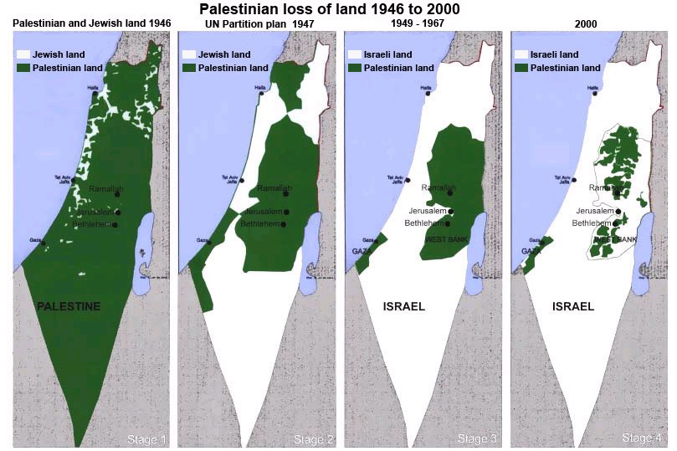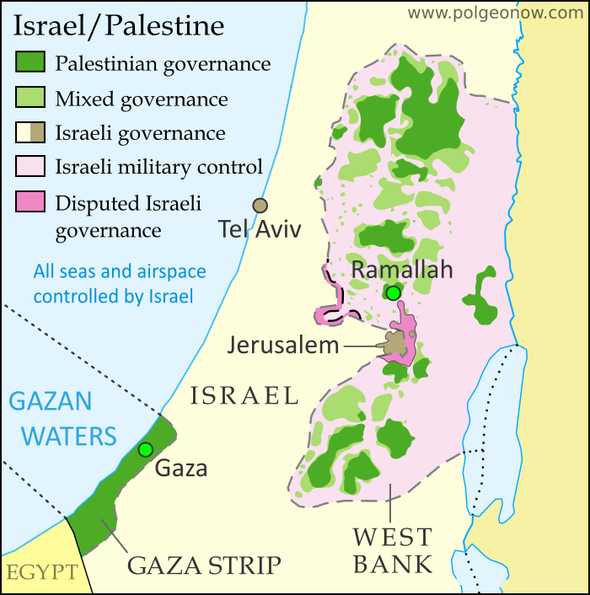

- Sanctions are efficient but not always effective.
Sanctions have increasingly become the go-to method for punishing international bad actors. The United States has levied sanctions against Russia for their annexation of Crimea and interference in foreign elections. Venezuela has been sanctioned for abusing human rights and Syria was sanctioned for committing war crimes. Despite all of these sanctions: Vladimir Putin, Nicolas Maduro, and Bashar al-Assad all remain in power. Crimea is still controlled by the Russians and sanctions for interference in the 2016 elections failed to prevent interference in the 2020 elections. Bashar al-Assad has continued a bloody civil war where chemical and biological weapons have been regularly used against civilians. Nicolas Maduro has remained in power in part by increasing his relationship with other nations facing western sanctions such as Iran, Turkey, and Russia.

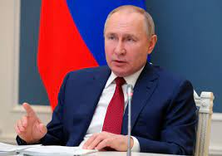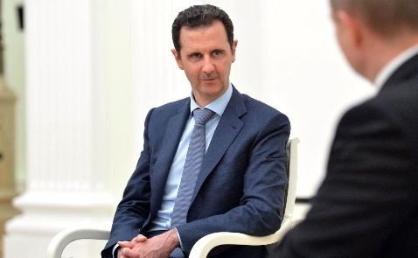

This is not to say that sanctions have not been efficient. At a minimal cost to the west a severe financial cost has been inflicted on sanctioned individuals and nations. In many instances crippling their economies, yet in these authoritarian states, leaders have proven able to survive protests and civil war. The leaders of Iran, Russia, Syria, and Venezuela have largely not yielded to the foreign pressure of sanctions. In perhaps the single most successful case, the sanctioning of Iran for the development of their nuclear program, which eventually led to the JCPOA, the deal eventually collapsed as the United States withdrew in 2018. Sanctions, like protests, are structurally more effective in democracies, where leaders are regularly held accountable for their actions and are forced to face a free and independent press. Authoritarian leaders are able to operate propaganda networks which they use to shield themselves from culpability and instead seek to unify their people into opposition of the sanctioning nation. While sanctions have proved a loss cost and popular tool for western government their effectiveness in changing the actions of foreign sovereign nations has been limited. Though a deterrent effect is undoubtably present, potential aggressors or criminal actors will be fully aware of the financial and economic impact of comprehensive and determined sanctioning efforts by the west.

- Globalization may have already peaked.
Globalization, the strength of international connections and cooperation, and the international flow of goods, people, and ideas may be in decline. Globalization has facing headwinds for years, particularly following the 2008 global financial crisis and the United States relative departure from the global stage. Just as the trend towards globalization following the collapse of the USSR was motivated by political, economic, and technological factors a forthcoming decline will see the next wave of corresponding influences.
Covid-19 has pressured many nations to rethink the utility of diverse and globalized supply chains. The United States has invested heavily in reducing foreign reliance on everything from microchips to construction materials and masks. Covid-19 exposed geographically diverse supply chains to an array of locations which handled the outbreak with varying levels of effectiveness. The pandemic also brought forward technological innovations which have and will continue to reduce factory work forces, a system greatly exposed by the highly communicable disease. The steady increase of labor prices throughout eastern Asia has altered the calculus for manufacturers, shifting economic incentives towards automation and more localized production.
Global travel has been immensely affected with the nearly instantaneous shut-down of international leisure travel. With international travel restricted purchases for vacation homes and recreational vehicles sky-rocketed in the United States. These purchases will have long term impacts, skewing owners to local and regional travel as they make use of existing purchases. While the United States and many OECD nations have effectively distributed vaccines many nations are still struggling to access and deploy effective vaccines. Many premier international destinations still face severe restrictions, a reality which may hold far longer than anticipated. Many poorer nations simply lack the infrastructure or capability to feasibly distribute vaccines to a sufficient percentage of the population in a timely manner.
The global flow of information also faces substantial head winds and new threats. The internet, long a bastion of free speech and the instantaneous interchange of content and ideas is now potentially falling victim to its own utility. While China has for over a decade maintained an effective firewall, restricting content and access to websites and material this service is now being offered abroad. Authoritarian leaders from Saudi Arabia, China, and Eritrea among others have used legislation and monopolized control of access to limit content and information sharing. The export of these capabilities increases the possibility of the evolution of multiple distinctly separate internets. This presents an extreme threat to a core aspect of globalization, alongside reductions in international trade and travel.
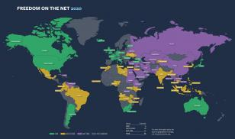
Freedom House: Freedom On The Net 2020 Rankings
https://freedomhouse.org/report/freedom-net/2020/pandemics-digital-shadow
- China’s population is no longer booming.
The common belief that China’s immense population growth will lead to global dominance can certainly be dispelled. While China’s future economic and military progress project upward their population is almost certainly facing decline. This is the result of a growing middle class, the infamous 1-child policy, and their rise from an agrarian society. China’s recent shift to 3-child policy, intended to initiate population growth again is the clearest possible indicator. The long-term effect of the 1-child policy is strikingly evident when viewing China’s demographic chart as envisioned below on the left.
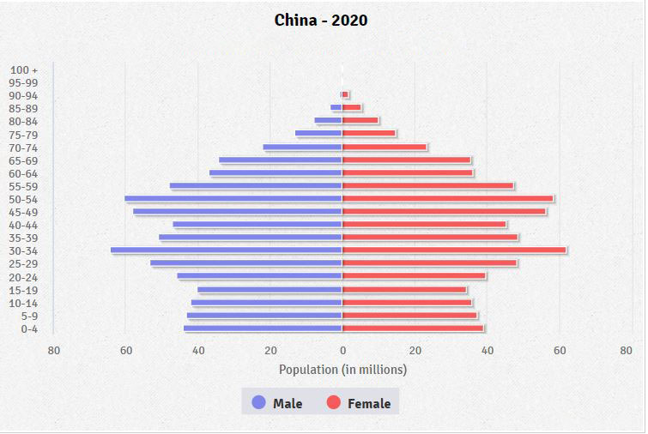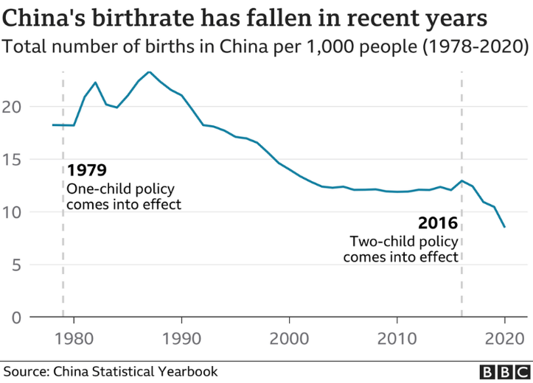

The smaller bars at the bottom reflect a significantly smaller youth population, much smaller than their parents. The long-term demographics of China’s population also play a significant factor in their economic growth, labor wages, and military capacity. China’s birth rate, above on the right, has seen a steep decline since its peak in the late 1980’s, a height it will likely never reach again given its economic progress. China is now home to a rapidly aging population and is demographically not the Chinas of decades past. While China may continue their unprecedented rise as an economic and military power, it will have to occur without a rapidly growing population.

- Oil will continue to have a future.
Obituaries for oil and other fossil fuel industries appear regularly in some of the world’s most prominent publications, but their decline is mischaracterized as death. For an industry whose product revolutionized travel, transportation, warfare, and has created some of the worlds most prosperous nations the prospect of a world without oil appears remote. While the ecological benefits of transitioning towards cleaner renewable energies are unquestionable the inertia of global oil consumption will ensure the industries survival for decades. Despite reading about the infamous instance of negative oil prices over a year ago on April 20th 2020, the oil industry has rebounded tremendously. In reality, the counter-intuitive prospect of negative prices for oil was the result of inadequate storage stemming from a sudden drop in demand caused by Covid-19.

Following this aberration, the (XLE) the sector ETF for petroleum companies has risen 37.3% over the past year, outperforming the S&P 500, which increased by 14.62% respectively. Buoyed by lower production and an increasing demand most oil companies have seen their stock prices rise significantly, and used the opportunity to improve both their balance sheets and long-term prospects.

While the growth of solar, wind, and hydro-power will continue, these energy sources remain economically non-viable without heavy government subsidies in many regions. Many of the worlds premier locations for wind power are extremely remote, and long distances from major population centers. Solar power has similar climate requirements and remains non-viable at scale in many climates. Hydro-power is obviously limited to the proximity of rivers and oceans and requires steady and predictable patterns. The graphic below illustrates the areas globally which could house viable clean energy projects. While technological innovation is consistently improving the cost and effectiveness of these projects the map illustrates the scope of the challenge at hand.
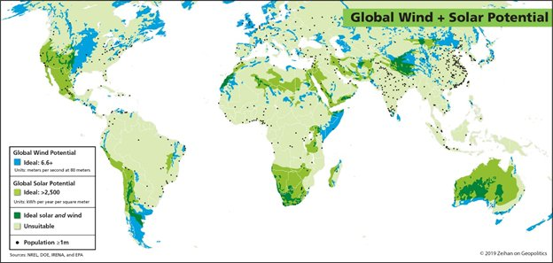

By overlaying the global population on top of the areas which are economically suited to clean energy production the population which can’t readily be serviced is evidenced. The lack of presently viable clean energy solutions in Nigeria, India, and east Asia are quite significant. Some of the most populous nations on earth contain climates which are presently unsuitable.
The current global infrastructure, which is presently centered around an oil driven economy, will remain necessary and in use to supply power to much of the world’s population. Even in the United States the steady clouds and rain over the eastern seaboard leave millions reliant on oil and fossil fuels for the foreseeable future. Some of the areas with the most consistent rates of geographic viability are remote locations or pose impediments to investment. While much of the Australian outback is viable for solar power, it is largely unpopulated and a vast distance from the population core on the Gold Coast. Southern Africa and Patagonia appear gifted, with suitable climates yet much of southern Argentina is unpopulated and Botswana and Namibia lack much of the required infrastructure. Similarly, Somalia and Eritrea represent extremely difficult political climates for energy investment. The transition to electric vehicles will remain slow as issues such as range anxiety, charge times, and charging infrastructure will require increased investment and innovation. While the transition to cleaner energy sources is occurring, oil companies remain in a strong position and will see continued demand, leaving oil to a decline but not imminent death.

- The United States is coming home.
While much has recently been made of the Biden administrations return to multilateralism and ambitious diplomacy long term trends will outlast this temporary surge. The fade of the unipolar moment, the long-term fiscal constraints imposed following the 2008 financial crisis, failed missions in the middle-east, the shale revolution, and the push to return domestic manufacturing are all long-term trends and developments which are cumulatively narrowing the United States foreign interests and refocusing the nation domestically. Rejoining the Paris Climate Accords, speaking fondly of NATO, and seeking a return to the JCPOA all hint at a future of increased multilateralism. However, behind these kind words the United States is withdrawing troops for Europe and the Middle-East, lacks the backing of necessary international partners to resume a comprehensive international agreement with Iran, and continues to pursue an independent energy future.
The arduous military campaigns in Afghanistan and Iraq have long outlived their original intent and placed a tremendous burden on the American citizens, greatly reducing collective willingness to support future endeavors. Syria and Libya have experienced near total collapse and these experiences have cautioned the United States greatly against the prospect of similar involvements. Foreign deployed troop levels are at their lowest in the last century and reflecting both economic and political realities. The 2008 financial collapse was followed by the Budget Control Act of 2011which served to reduce the expansion of the military budget limiting diplomatic and military engagement abroad.
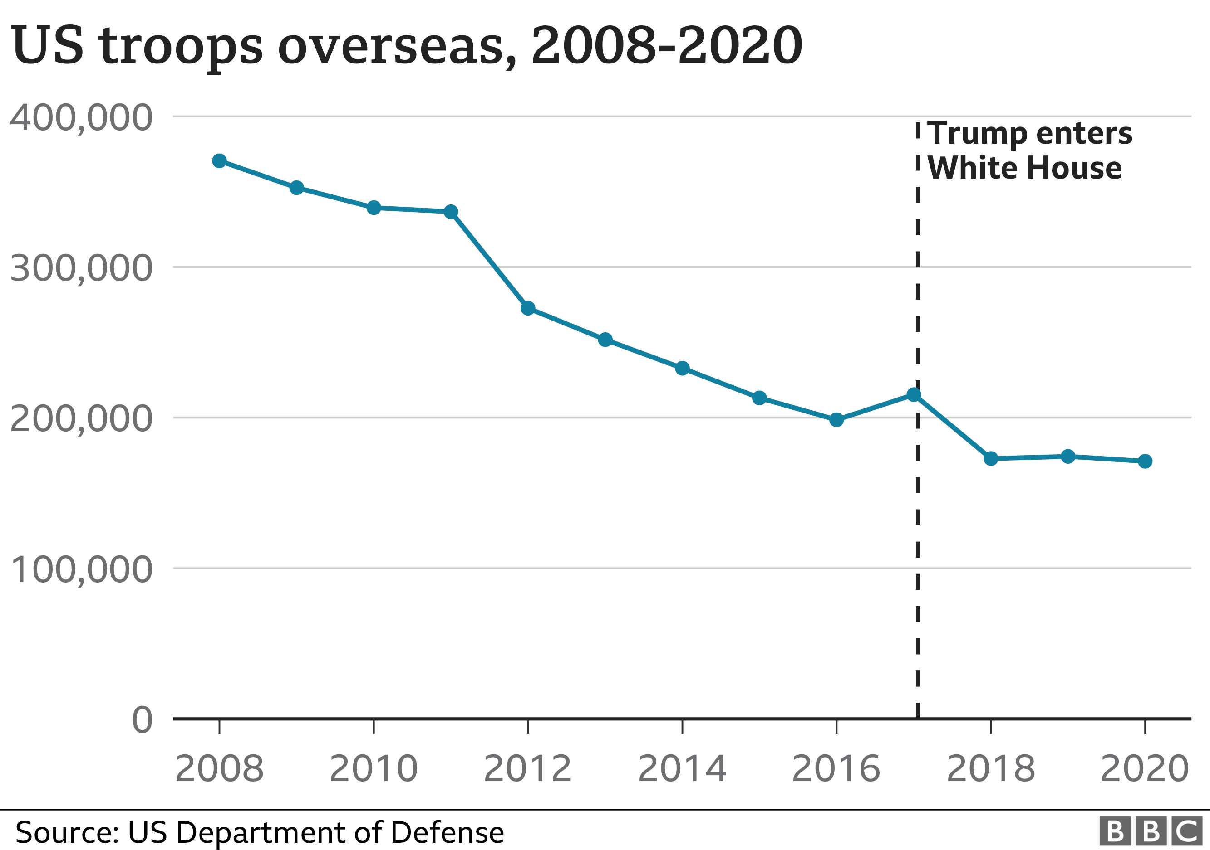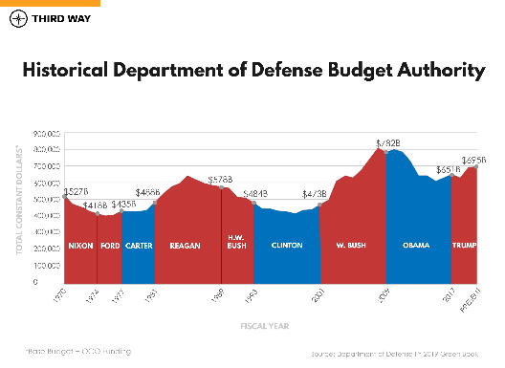
The shale revolution and eventual energy independence has created a new economic and political reality, one where the United States is affected by but no longer reliant on oil produced within the Middle East. This development has greatly impacted foreign relations with key allies in the region and removes an integral diplomatic tool from their arsenal. The increasing viability of automation, increasing labor prices abroad, and desire to return manufacturing to the United States in a post Covid-19 world will all conspire to reduce economic and diplomatic ties internationally. Having secured new trade deals with its most vital partners: Mexico, Canada, Japan, South Korea, and England, the United States has selected its group of core economic allies. A coalition far smaller than those of the cold war and Bretton Woods era.
The United States is shrinking its interests abroad, the result of both domestic and economic developments, and its not necessarily a bad thing. Allowing for a liberated foreign policy, no longer constrained by vast foreign entanglements and interests the United States can operate more selectively in foreign matters. The United States will continue to participate in global matters such as climate change, nuclear proliferation, cyber-crime, and counterterrorism but with a smaller cohort of selected allies on each issue. The selective nature of this cooperation can be beneficial, as consensus is more readily achieved amongst more narrowly exclusive groups. Many of the United States historic partnerships and alliances originated to combat threats which no longer exist today, or have experienced thematic shifts. More limited partnerships can protect the moral integrity of human rights missions, support democracy without hypocrisy, and provides flexibility in dealing with unpredictable leaders.

- What to do about NATO?

Before the collapse of the USSR a vast amount of geopolitics boiled down to tensions and conflict between the Warsaw Pact and NATO; the world’s two great military and ideological alliances. The prospect of nuclear annihilation propelled even minor proxy conflicts between the alliances to situations of the highest priority. In NATO’s first action after the dissolution of the Soviet Union NATO intervened in the civil wars of the former Yugoslavia, attempting to limit bloodshed and prevent war crimes and genocide. The United States brought along many of its NATO allies to conflicts in Afghanistan and Iraq in the early 2000’s and the intervention in Libya was conducted with NATO in command. Notably, these missions have been undertaken not against communist adversaries. Instead, they have been undertaken for a myriad of reasons, including the prevention of genocide, pursuit of terrorists, reducing violence, and building democracy, amongst others.
Former president Trump was notably outspoken in his disdain for NATO allies and their perceived lack of commitment to their own defense. While many NATO members have failed to meet the 2% of GDP target for defense spending others have largely broken ranks with the alliance on key security issues. Turkey has worked in opposition of NATO in Libya and Syria; Germany remains defiant in their pursuit of the Nord Stream 2 pipeline, a key to energy security within continental Europe. As the threat of communism has faded and NATO has expanded the necessity of the alliance has waned as member states now identify distinctly different threats. Turkey sees Kurdish independence movements as their largest threat, the United States places higher value on cyber-threats, and those states bordering Russia fear a repeat of the Crimean annexation.
Not only are the threats more diffuse but member states own interests. A lack of consensus within NATO has limited the alliance in many of its stated objectives. NATO maintains declared objectives in reducing piracy on the Horn of Africa, combatting counter-terrorism, and preventing cyber-crime. Yet, many members lack the capacity or capability to operate vessels off the coast of Somalia. The United States deadline to withdraw from Afghanistan by Sept. 11th will formally end many alliances foreign deployments targeting terrorists, and political differences have greatly muted the alliances’ ability to deter and prosecute cyber-crime. Divisions within the alliance and uneven capabilities have created an alliance that survives adrift of a central purpose. While NATO may well survive its internal divisions and challenges, it is severely lacking in direction and purpose. While conceptually the alliance holds tremendous value for its members, the lack of a unifying purpose and collective threat, means that the sum of the parts is no longer significantly greater than the individuals.

