Geopolitics of Fighter Jet Procurement
By Gregory Ayres
18 June, 2021
When Joe Biden met Vladimir Putin on June 16th expectations were low, in a heated exchange with a reporter Biden mentioned he was “not confident about anything” in relation to his talks with the Russian leader. Tensions between Russia and the west over increasingly evident cyber-crimes, human rights violations, and the annexation of Crimea cast the 2008 reset as a distant memory. Putin’s core interests envision Russia as a dominant global power, an increasingly irreconcilable aim. With a GDP comparable to the state of Texas and a military budget 1/10th that of the United States they have long lost their super-power status, although this regression has occurred on a global landscape with U.S. power and interests in relative retreat. The emergence of a multipolar world, bereft of consistent U.S. leadership, is the result of both fiscal constraints, unpopular military interventions, and divisive domestic politics. In this environment, Putin has played a weak hand well. Though as keenly as one may bluff and bet, he cannot change the hand which he was dealt when he took power in 2000, a hand of diminishing value. Meanwhile the United States hold many powerful cards, including the export of advanced 4th and 5th generation fighter jets.
Amongst Putin’s greatest concerns are his domestic popularity, territorial security, and Russia’s image abroad. These concerns are the primary driving forces behind the majority of his foreign policy decisions. Sponsoring groups to spread disinformation in western elections helps to delegitimize his adversaries, in an attempt to improve his own image via comparison. Invading Crimea ensures continued naval access to the Black Sea, and was popular amongst his electorate, allowing him to appear strong and defiant. Becoming militarily involved in Syria and Libya ensures Russia’s place at the negotiating table amongst the world powers. Overseeing the poisoning and arrests of political critics and opposition eliminates opposition groups and leaders. As disgusted as the west and United States are by these actions, they were all intended to solidify Putin’s political position.
These actions, though entered into logically all involve significant consequences. International sanctions have significantly impacted the Russia economy, limiting their access to foreign markets and goods, as well as impacting the flow of assets and capital. International backlash against Russia’s treatment of critics such as Alexei Navalny, Sergei Skripal, and Sergei Magnitsky has been widespread and highly impactful on Russia’s global perception.
With an economy heavily dependent on exports, consequences such as a negative international perception, isolation, and sanctions can be crippling. While Russia’s largest export sectors, petroleum products, metals, and minerals can be quite easily sold and traded globally Russian armaments are far more susceptible. Already facing negative long term geopolitical trends dating back to the collapse of the USSR, the number of capable and feasible export destinations for high-tech Russian armaments, such as jet fighter craft is decreasing. The recent invasion and annexation of Crimea, even through the use of irregular soldiers and asymmetric warfare incurred a harsh international response resulting in the passage of the 2017 Countering America’s Adversaries Through Sanctions Act (CAATSA).
The CAATSA increased the breadth of activities and actors susceptible to U.S. sanctions, a concern for both Russia and their prospective business partners. With a diminishing list of clienteles for fighter jets CAATSA further restricts an industry which has long allowed Russia to exert disproportionate global influence. The expansion of NATO, spread of democracy in eastern Europe, financially crippling sanctions and embargoes, and a perceived technological gap have severely impacted the potential suitors for Russian aircraft. Foreign sales and partnerships assuage development and production costs, a practical necessity for Russia given their current economics. The United States has utilized a multi-national array of partners to manufacture to worlds first 5th generation fighter aircraft, the multi-role F-35.
With numerous historical precedents, an embedded fear of invasion across the northern European plain permeates Russian defense planning. With the buffer states of the USSR long gone the operational distance between Moscow and NATO militaries is shorter than ever. The distance between Russia and their perceived opposition has shrunk in both miles and minutes, as military technology has greatly increased the pace of military operations. Both speed and stealth, embodied by 4th and 5th generation fighter craft respectively, have changed the landscape of defense planning. Russia now looks out at a comparatively smaller buffer with modern fighters accumulating closer to Moscow. Represented below by the increasing spread of blues and green in eastern Europe, a trend which is only further increasing as European states phase out again Russian aircraft from the Soviet-era. The allocation of 4th and 5th generation fighters can be seen below.
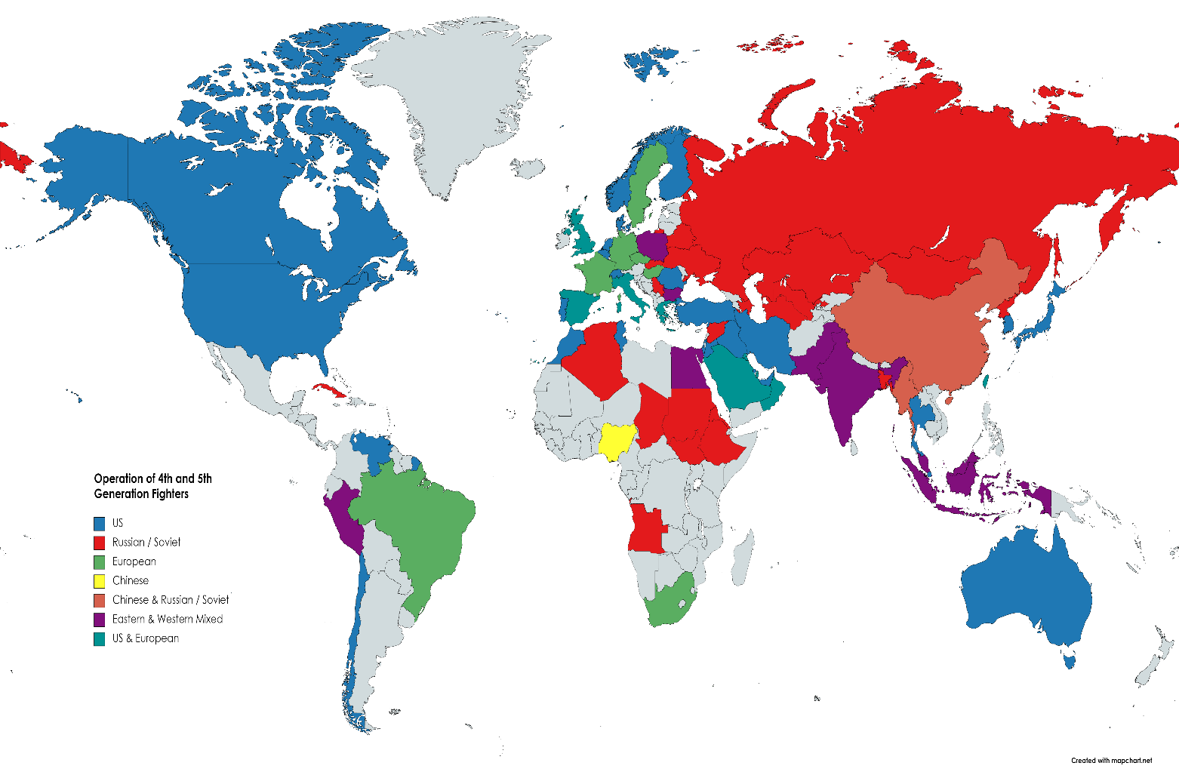
Given the preeminence of air-power in conventional conflicts following WWII the results of air superiority are unequivocal. In purely military terms, air superiority and air denial to the enemy have resulted in staggeringly lopsided military results. Though less effective against low-tech insurgencies the impact on conventional forces and conflicts is easily apparent. The recent conflict between Azerbaijan and Armenia was driven largely by Azerbaijan’s air dominance, as Israeli sourced drones recorded footage of relatively helpless Armenian ground forces suffering relentless aerial bombardment.
Air dominance, an offensive footing, relies heavily on the presence of superior combat aircraft, making 4th and 5th generation fighters key in great power competition. While the United States was the first into the 5th generation with the F-22 and F-35, China followed with the J-20 and Russia the Su-57. Wealthier nations deemed worthy of this technology have been able to purchase 5th generation fighters, while other nations have been limited to procuring 4th generation fighters. The export of advanced weaponry has enormous geopolitical implications.
Government procurement processes acknowledge the long-term ties created by purchases that often entail long term cooperation and trade. Iran, a U.S. ally before the Islamic Revolution of 1979 operated numerous U.S. produced F-4 and F-14A fighters. Since the hostage crisis of 1979-1981, and the sanctions that followed, Iran has struggled to maintain and repair their U.S. sourced aircraft. While attempts were made to reverse engineer replicas, such as the Saeqeh, the task has proved difficult and relatively ineffective. Subsequent purchases of Soviet sourced Su-24’s and Mig-29’s have been similarly difficult to maintain in the face of economic hardship and international sanctions. Iran’s situation demonstrates the long term financial and political commitments involved in procuring advanced fighter craft.
With service lives regularly lasting three decades or more, the purchase of foreign produced fighter craft offers particular insight into nations long term strategic goals. Throughout the Cold War, nations intending to remain neutral often avoided purchasing U.S. and Soviet fighter craft, instead opting for French or Swedish offerings. The same theme continues today, as the worlds three largest militaries seek to export 4th gen fighters, and in limited instances cutting edge 5th generation fighters such as the F-35 and Su-57.
The U.S. has experienced tremendous success exporting 4th generation fighter jets to global allies, as demonstrated in Figure A below. The combination of robust domestic economic growth, a dominant technological advantage present since the dissolution of the USSR, and effective alliance building techniques allowed the United States to manufacture and export significantly more 4th generation fighter jets. These sales have helped integrate armed forces within and among allied nations far beyond the original NATO members present during the Cold War. These arms exports, particularly those for top tier technology expanded and secured long-term partnerships and alliances. The export of 4,716 4th generation fighters has generated deep ties to many militaries and governments globally for the United States. The immense scope of the United States clientele is depicted in Figure B below, which maps current operators of U.S. sourced 4th and 5th generation fighters.
Figure A
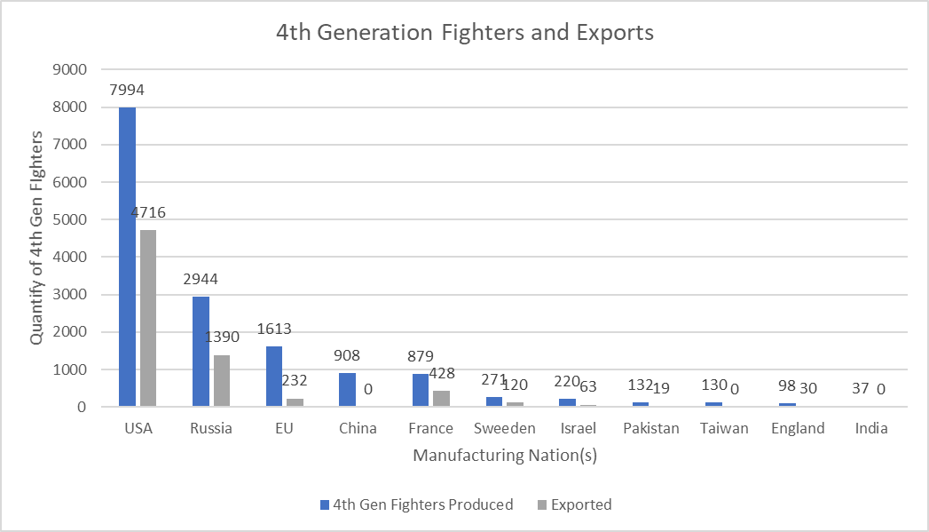

Figure B
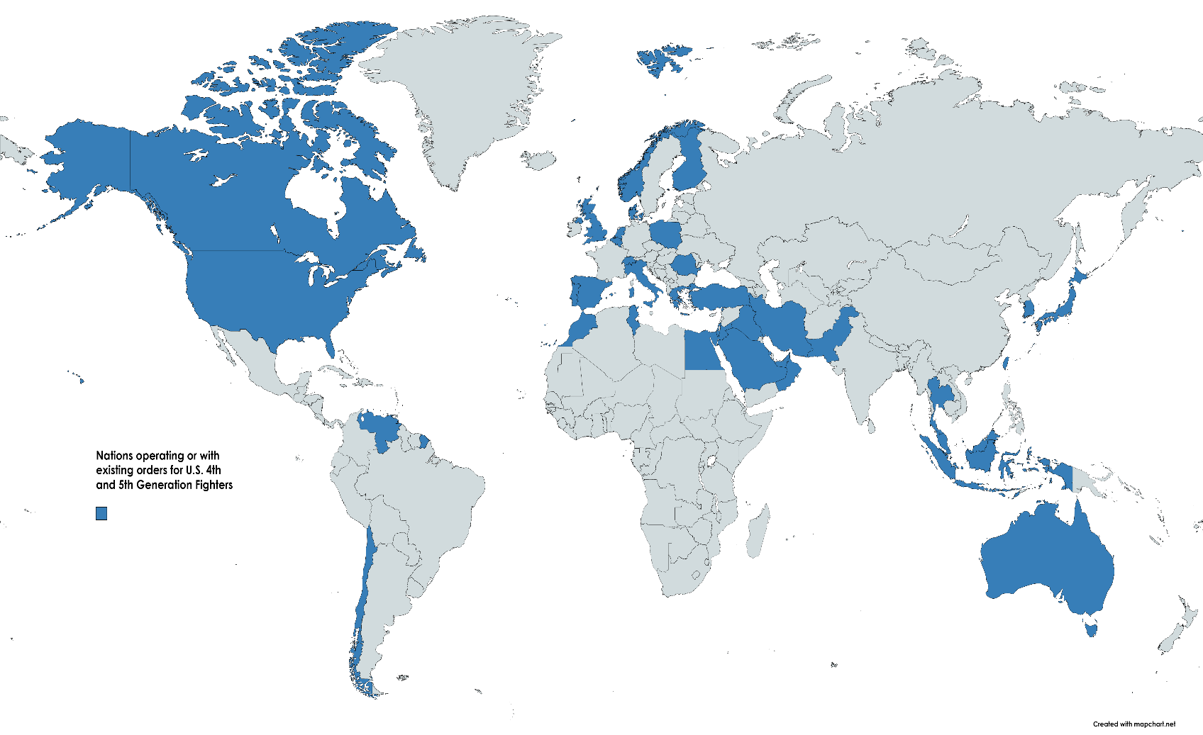

Given the complex nature of 4th generation fighter jet manufacturing and export, insights can be made into the relative strengths of participating nations. The United States utilized its dominant position over the last 50 years to secure a global network of partner nations. While Russian, and in previous decades Soviet production has been strong their ability to export has been limited since the collapse of the USSR. Many of their clientele states suffered greatly during the mid-90’s and modern clients have presented diverse problems. China, the largest purchaser of Mig and Sukhoi 4th generation fighters outside of the former USSR has notoriously copied much of the technology present in the Sukhoi jets to incorporate into their modern J -11 and J-15. For example, the Chinese J-11 is a near mirror copy of the Su-27.
Joint European efforts produced 1,613 4th generation fighters including variants of the Typhoon and Tornado. While popular within the joint manufacturing countries they failed to achieve export success comparable to their U.S. or Russian competition, often despite technological parity. China’s recent forays into fighter jet production have not resulted in any export sales. They have experienced difficulties finding buyers for the J-11 and J-15, in part due to the limited availability of testing data, and direct competition from nearly identical Russian products. France and Sweden produced significant numbers of 4th generation fighters, making strong efforts particularly given the size of their economies. French, Swedish, and Israeli efforts were cheaper to purchase and perhaps more importantly, allowed buyers to avoid political entanglements. The buyers of the Saab 93 Gripen, Rafale, Mirage 2000, and Kfir represent a unique set of nations with similar themes. The global allocation of 4th and 5th generation fighters can be seen below, categorized by the nation or region of origin. Global geopolitical fault lines are evident as colors clash at the fringes of power projection. With purple regularly representing the most hotly contested areas today.
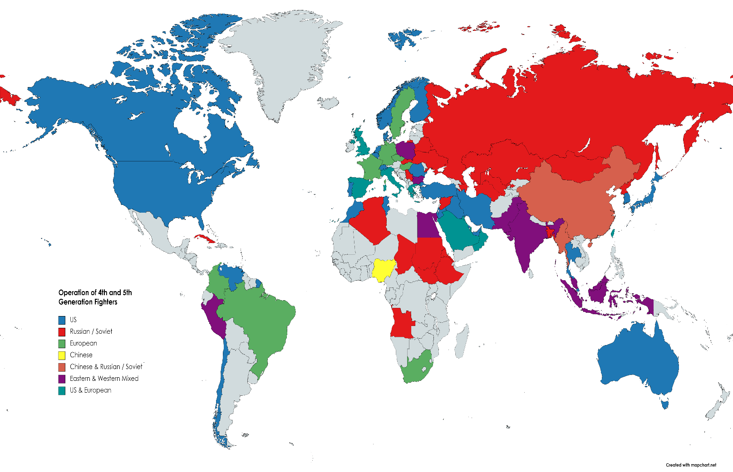
Nations seeking to avoid military commitments or balance relations between rival powers, the buyers of the French, Swedish, and Israeli fighters offered both flexibility and cost savings. India balanced relations between the USSR, China, and U.S. throughout the Cold War and continues to do so to this day. While historically procuring Russian fighters India also purchased 50 Mirage 2000’s and 36 Rafale’s. India previously agreed to co-produce the new 5th generation Su-57 with Russia, however, production delays, the threat of sanctions by the United States, and diplomatic missteps led to the deal being cancelled. In what would be a geopolitical coup, the United States government approved Boeing’s ability to manufacture and sell the F-15EX to India. India is currently exploring deals to acquire the Rafale, Gripen, or F-15EX. Any departure away from Russian sourced jets would signify greater alignment western democracies, a significant boon for the United States, and potentially a significant shift in geopolitical power.
Turkey, a NATO member state, is at odds with much of NATO, particularly the United States. Despite being a member of the alliance, differing viewpoints on threats related to the ongoing Syrian civil war have immensely strained relations, which further deteriorated with the purchase of the Russian S-400 Surface-to-Air-Missile System. The U.S. removed Turkey’s authorization to purchase the stealthy 5th generation F-35 in protest. The increasingly authoritarian Recep Erdoğan responded by inquiry into the purchase of Russian Su-35’s or Su-57’s. Such a move might be fatal for their long-term incorporation in the alliance, however tensions over human rights abuses, the Syrian civil war, the ongoing conflict in Libya, and long-standing territorial disputes have consistently eroded a once strong relationship for Turkey. Despite being sanctioned under CAASTA, and losing the ability to obtain F-35’s, Turkey continues to produce a limited number of components for the craft. The situation is emblematic of the long-term political impacts of fighter jet deals. Turkey previous commitments to both NATO and the production of the F-35 would make an attempt at departure from the alliance and their partner nations both difficult and costly. The inertia of previous defense deals might be all that is keeping Turkey within the alliance. Given their fleet of 293 U.S. fighters Turkey must reference Iran’s sanctions dilemma, and the crippling effects of international sanctions on their ability to maintain a fleet of American aircraft. Turkish F-16’s with decades of life span remaining would be extremely difficult to maintain and repair in the face of stricter U.S. sanctions.
Budget constraints and political concerns have driven many nations to purchase fighters from more politically independent manufacturers such as Sweden and Israel in recent years. Nelson Mandela, the post-apartheid leader of South Africa pursued a policy of “non-alignment” and accordingly purchased the Saab 93 Gripen, a choice which emphasized a prioritization of human rights. South Africa also faced considerable budget constraints in the mid 1990’s and the long-term maintenance costs of Saab’s Gripen are less than that of the F-16 or F-18. Sri Lanka utilizes a mixture of the Israeli Kfir, Chinese J-7, and Russian Mig-23. The piecemeal result of pressure from India w has prevented the planed purchase of Chinese JF-17’s. Indian pressure could also interfere with purchases from the U.S. or Russia, as Indian threats to boycott purchases represent a greater loss than potential gains from sales to Sri Lanka. India’s forthcoming procurement decision will likely have an enormous impact on Sri Lanka’s future procurement options.
Qatar, a small Shia majority state, has increasingly diversified and updated its air force following disputes amongst the Gulf Cooperation Council (GCC) stemming from the support of foreign actors following the Arab Spring. Following the a GCC blockade Qatar set about massively expanding their military forces, particularly through the procurement of 4th generation fighters. Qatar has diversified their procurement out of political necessity, purchasing aircraft from the United States, France, and Germany. The diversified nature of their procurement is in part due to Qatar’s regional neighbors, whom hold considerable sway over their access to U.S equipment. Regional fears of Qatar’s independent foreign policy, and relationship with Iran, have caused significant isolation for Qatar. Due to the immense anger of the remaining GCC states, and fears for their security, Qatar deepened military ties with Turkey and explored purchasing the S-400 system from Russia. Fearing military intervention Qatar signed deals to procure 4th generation fighters from the France, Germany, and the U.S. Qatar feared dependence on United States sourced assets, and complete military integration with American forces, as such a relationship could be susceptible to regional pressure from larger regional states with more historic ties to the United States. Qatar continues to spend extravagantly given their size on the F-16, F-15, Rafale and Typhoon. The current procurement plans wisely call for array of suppliers, providing political maneuverability while avoiding complete dependence on the U.S.
Egypt operates, and has placed orders, for a variety of modern fighters, as depicted below. Egypt’s Cold War allegiances resulted in a diverse procurement ranging from the U.S. to France, and Russia. Egypt has received over $50 billion in military aid from the United States since 1978, allowing for the procurement and maintenance of the American F-16, in part for a stabilization in relations with neighboring Israel. Relations between the Egypt and Russia have historically been complex, with low points occurring during Nasser’s presidency and the years following the 1979 Russian invasion of Afghanistan. Relations have improved since the end of the Cold War, particularly under Russian president Vladimir Putin and Egyptian leader Abdel Fattah Al-Sisi. Russian support for Al-Sisi quickly materialized following the removal of Mohamed Morsi, and has recently fostered the sale of the Su-35 to Egypt, despite the threat of U.S. sanctions. Longstanding ties to Russia and the desire to achieve political balance combined to yield Egypt’s current fighter fleet. With U.S.-Egyptian relations souring over Egypt’s human rights violations and anti-democratic leanings the presence of military aid and F-16’s ensure that Egypt will not depart the U.S. sphere of influence hastily. The United States foreign military aid to Egypt purchases significant influence within the nation, but not unlimited influence, particularly over the last decade. Al-Sisi, seeking to operate with fewer foreign constraints has decided to pursue closer relations with Russia, exemplified in the purchase of the Su-35, despite U.S. warnings.

Egyptian Air Force Inventory
Manufacturing Nation | Aircraft | Operational Quantity | Outstanding Orders
United States | F-16 A/C B/D | 218 | 0
France | Rafale DM/EM | 24 | 30
France | Mirage (B) 2000 EM | 19 | 0
Russia | Mig-29 M(2) | 44 | 0
Russia | Su-35 SE | 5 | 21
*Training aircraft included
Indonesia has continued to be leveraged by competing powers since their policy of non-alignment during the Cold War. After the Cold War Indonesia decided to purchase F-16’s which had originally been destined for Pakistan, a deal which eventually fell afoul of U.S. sanctions. In the early 2000’s efforts to update their Air Force turned toward Russian sourced Su-27’s and Su-30’s, due to a U.S. arms embargo stemming from Indonesian actions in East Timor. Longstanding disagreements and frustration surrounding the embargo have made Indonesia wary of further commitments with the United States. American disapproval eventually faded as the Obama administration authorized the sale of additional F-16’s. Meanwhile, Indonesia has sought to continue diversifying its procurement stream by agreeing to purchase the Su-35 from Russia. This action was met with stiff U.S. resistance, and the immediate threat of sanctions. Indonesia has strived to maintain a distanced relationship from the U.S. while acquiring modern 4th generation fighters to protect Indonesian interests in the highly contested South China Sea. Indonesia has explored purchasing the Eurofighter from Austria, the Rafale from France, as well as the F-15, F-16, and F-35. While a U.S. sourced fighter would provide superior interoperability with allies in a confrontation with China, Jakarta remains hesitant of over committing to American suppliers and American political pressure. A look at Indonesia’s current inventory of 4th generation fighters, including the proposed sale of Su-35’s illustrates the island nations balanced position. One where global powers seek to gain influence through the sale of military hardware.
Indonesian Air Force Inventory
Manufacturing Nation | Aircraft | Operational Quantity | Outstanding Orders
United States | F-16 C/D | 32 | 0
Russia | Su-30 MKK/MK2 | 11 | 0
Russia | Su-27 SK/SKM | 5 | 0
Russia | Su-35 | 0 | 11

Taiwan has operated in a precarious position since the end of the Chinese Civil War. Mao Zedong’s victorious communist military attempted to invade Taiwan, where the Chinese Nationalist forces took refuge following the war. The democratic nature of Taiwan garnered it U.S. support which has remained resolute yet limited to this day. The U.S. has maintained support for Taiwan and sold military equipment to the island nation since 1979, while also regularly participating the naval exercises intended to dissuade a Chinese offensive. Taiwan has often been at the mercy of U.S. politics, as presidential support for the island has existed at various levels. Most recently, Barrack Obama refused to sell F-16’s to Taiwan in an effort to appease China, whereas the Donald Trump promoted the sale of 66 F-16’s. The Biden administration has also approved the sale of advanced arms to Taiwan, reflecting the increasing hostile U.S. attitude toward China present both in government and public opinion. Last week’s military maneuvers in the Strait of Taiwan reflect the seriousness of China’s territorial claims. In response, the United States approved delivery of more advanced missile systems designed to combat Chinese J-15’s and J-20’s. Taiwan’s fighter jet inventory and defense have long been at the mercy of U.S.-China relations. Making exports to the island key drivers in the region’s geopolitics.
The recent order of F-16’s by Bulgaria symbolically brings an end to the memories of Soviet & Russian orientation. Bulgaria joined NATO in 2002, yet has persisted with a fleet of Mig-29’s due to its relatively meager defense budget. However, to continue as a NATO partner and avoid sanctions, such as those levied at Turkey for the purchase of the Su-35, Bulgaria opted to order the F-16 in 2019. Throughout eastern Europe nations seeking to align themselves with western institutions such as the European Union and NATO have been phasing out dated Soviet-era equipment and replacing with U.S. or European sourced material. The loss of a Mig-29 earlier this month, as it crashed into the Black Sea, highlights the fragility of such a dated fleet. Romania and Slovakia are similarly phasing out Mig-29’s for F-16’s, erasing some of the most visible remnants of the USSR. Bulgaria’s Mig-29’s will be solely relied upon for a further two years, with eight F-16’s arriving in 2023 and 2024.
China’s efforts to export their 4th generation fighters have thus far been fruitless. With a single joint program being established to manufacture the JF-17 in coordination with Pakistan in 1999. Russia’s declining ability to export modern fighters and China’s inability are rooted in a distinct lack of soft power. Foreign nations are increasingly less willing to initiate long term military partnerships with Russia and China. The perceived preeminence of U.S. manufactured fighters such as the F-16, F-18, and F-35 and the political maneuverability offered by Swedish and French fighters have proved more appealing to governments. U.S. allies such as Turkey and the Philippines are often offered access to modern U.S. fighters, and only begin exploring alternatives once political relations significantly deteriorate.
The U.S. is also leading in the export of 5th generation fighters with the F-35, a plane jointly developed and produced with partner states. The first ever 5th generation fighter, the F-22 Raptor was banned from export, despite interest from Japan, a staunch U.S. ally. Similarly, China has refused to export their 5th generation fighter, the J-20. Both nations site the desire to protect top-secret military technology. Ironically, China sourced much of the technology for the J-20 from data stolen from the F-35 program. The F-35 program, since inception, intended for production and design to occur across allied nations, as represented in the map below.

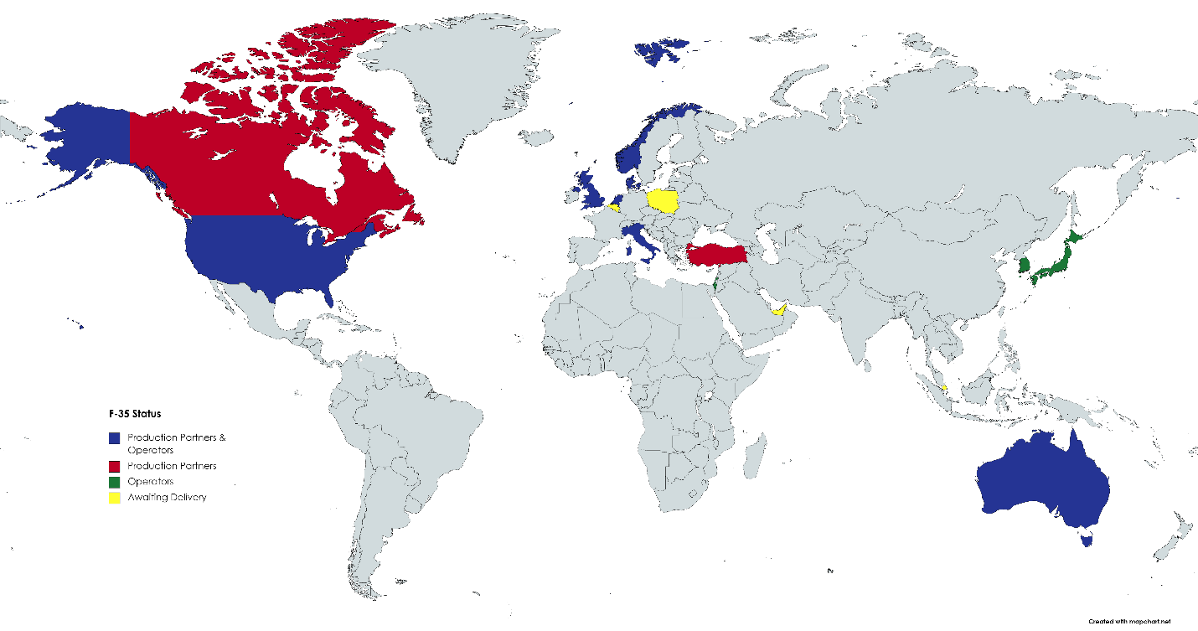

Intended for export the F-35 has been offered and delivered to many of the program’s key military allies. Canada, while a production partner, has yet to commit to the purchase of F-35’s, and Turkey’s potential procurement ended with their deployment of the Russian S-400. Canada’s hesitancy to purchase the F-35 stems from domestic political opposition, primarily among Prime Minister Trudeau’s Liberal party. Trudeau has long cited discontent with the F-35’s growing cost, a lack of transparency and a lack of contracting competition.
The F-35 has proved a valuable geopolitical inducement for the U.S. As the only 5th generation fighter for sale globally the U.S. can offer unmatched stealth and air superiority to worthy clientele. To ensure a potential buyer is a fitting recipient of the F-35, the U.S. Congress passed the “Secure F-35 Exports Act of 2021” which grants Congress potential veto power over exports. The United Arab Emirates was induced into dropping support for the Saudi led war in Yemen and into normalizing relations with Israel in part due to the prospect of an F-35 sale. In contrast, Saudi Arabia, a more historic military ally of the U.S. has been unable to secure a contract for F-35’s largely due to human rights violations and their actions with Yemen. The prospect of purchasing state of the art F-35’s is highly appealing to potential suitors and the U.S. holds considerable leverage as the only exporter of 5th generation fighters. Should Saudi Arabia suddenly find an immenent demand for 5th generation fighters the United States could set significant pre-conditions on a sale, as previously demonstrated with the U.A.E. Globally, the impact of this advantage will likely subside when Russia begins exporting the Su-57, though production difficulties have created an unclear production timeline. Furthermore, speculation about the claim of the J-20 as a genuine 5th generation stealth aircraft and China’s hesitancy to export may provide the U.S. with a prolonged export monopoly.
Russia’s Su-57 has faced significant challenges in development and could face a competitive and limited export market. Russia’s comparatively tiny economy places them at a distinct disadvantage compared to the U.S. and China, the other two nations to produce 5th generation fighters. The majority of Russia’s Su-35 client states would likely fail to justify the more expensive Su-57. China has invested heavily in domestic production, particularly with the J-15 and J-20. Indonesia, like India, has been pressured to avoid continued purchases from Russia. As the U.S. provides billions in military aid to Egypt they can mount considerable pressure, limiting the prospect of acquiring the Su-57. Well outside the U.S. orbit, potential buyers often lack the financial means to purchase and maintain a significant number of Su-57’s, such as: Venezuela, Algeria, Libya, Syria, Malaysia, and Turkey.
China’s inability to export 4th generation fighters and unwillingness to export the J-20 likely indicate continued long-term U.S. supremacy in the export of advanced fighters. China would face issues similar to those of Russia when targeting foreign nations for exports. China has a limited cadre of military allies with the means to afford and maintain advanced aircraft. While China’s recent efforts diplomatic efforts have been immense, their recent soft-power efforts have failed to yield substantial military partnerships. Loans and infrastructure projects have increased economic and business ties. In contrast, political, cultural, and military ties have been more difficult to manufacture.
Potential buyers of Chinese fighters are limited on both economic and political grounds. While Pakistan proved a successful partner for the JF-17, they are unlikely to generate strong demand for 5th generation fighters, unless India acquires superior technology first. A long-standing alliance with North Korea and growing partnerships with Thailand and Myanmar constitute a small but growing list of potential suitors. Even among the limited suitors the ability to finance purchases for the Chinese J-15 or J-20 is miniscule compared to China’s own domestic demand. China’s concerted efforts to improve their global image may well be aided by ambitious efforts at vaccine diplomacy and the funding of foreign infrastructure, but their soft power still lags far behind that of the United States or EU.
The production and export of modern fighter jets offers significant insight into geopolitical flashpoints and shifting political trends. The partnerships formed by the export of modern fighters last decades, and serve to entangle nations for better or worse. Turkey’s inclusion in the F-35 program and the presence of F-4’s in Iran demonstrates the implications of failed relationship with long term partners. While the inertia of existing military sales and ties have helped limit Russian influence in Egypt, India, and Indonesia. The replacement of outdated Russian fighters throughout eastern Europe signifies the final step-in long-term commitments towards the west. While nations such as South Africa, Indonesia, and Finland long pursued non-alignment, generating demand for European sourced 4th generation fighters, the end of the Cold War has been a boon for U.S. exports of the F-16. While Russia continues to offer Sukhoi fighters their customers are increasingly under pressure from western sanctions. Meanwhile, the United States is able to offer the world’s most advanced fighter craft, generating immense influence and leverage on prospective buyers. China’s increased domestic production and technological advances reflect their growing economy while the lack of exports reflects lagging soft power. The production and export of 4th and 5th generation fighters illuminate geopolitical trends and necessitate extreme caution for both buyer and seller.

