Check, or Checkmate?
By: Gregory Ayres https://globalaffairswithgregayres.com/ 7/22/2021

The primacy of air dominance is evident globally across modern intra-state conflict. The pinnacle of air dominance remains the modern, 5th generation, fighter jet. Presently, only 4 such models exist, though United Aircraft Corp, the lead Russian fighter manufacturer, recently displayed a new prospective model, the Checkmate. (Also called the Su-75)
5th Gen Fighter | Manufacturer | Introduction to Service | Quantity Produced
F-22 | Lockheed Martin (USA) | 2005 | 186
F-35 | Lockheed Martin (USA) | 2015 | 665
J-20 | Chengdu Aircraft (China) | 2017 | 150
Su-57 | United Aircraft – Sukhoi (Russia) | 2018 | 12
Su-75 / Checkmate | United Aircraft (Russia) | *2030 | *
*Estimated
While United Aircraft Corp has struggled to manufacture Su-57’s at scale, and struggles with reliability issues, they have moved forward with a mock-up Checkmate model. Russia has struggled to find export partners for the Su-57, an issue the Su-75 seeks to address. Without export sales, the complete cost of production, and development, falls on Russia, a nation which is accustomed to regular export revenue from military equipment sales. Attempts to sell the Su-57 to China, Brazil, India, and the United Arab Emirates have all failed or stalled. While official production is years away, the model presented is notably different from the Su-57.
 | Su-57 | Su-75
Unit Cost | $100,000,000 | $27,500,00*
Effective Range | 3,418 miles | 1,864 miles*
Length | 72 feet | 64 feet*
Engine(s) | Dual Thrust Vectoring | Single Thrust Vectoring

The most important differences are related to cost, range, and size. Given the vast expanses of Russia’s territory, the expansive range of the Su-57 was a practical necessity. In turn, increased range requires increase fuel capacity, and concurrently size. The smaller, more nimble, single engine design of the proposed Su-75 would yield both shorter range and lower cost. The reduced range is an acceptable trade off for geographically smaller nations, which prioritize regional threats.
The Su-75, with the nickname “Checkmate” is being launched with the intention of securing a broad export base. The primary concerns with the only other 5th generation fighter to be exported, the F-35, are the purchasing and maintenance costs. The F-35 program’s international coalition of manufacturing partners has failed to control costs, with overruns regularly reported and passed on the purchasers. The rising costs have played a significant role in Canada’s decision to delay purchasing F-35’s, despite participating in their construction. The Su-75 is intended to target potential buyers which are politically excluded from purchasing the F-35 or are offput by its cost, and have distinctly different needs than those serviced by the Su-57.
Marketing presentations for the Su-75 indicated United Aircraft Corporation is targeting India, Vietnam, Argentina, and the United Arab Emirates for export. Each nation represents a significant challenge from a seller’s perspective.

India:
India, in search of 5th generation fighters to replace an aging fleet of Mig-29’s, remains a potential customer for the Su-57. While initial plans for co-production fell apart, a purchasing option remains available. Pressure from the United States, the threat of CAATSA sanctions, and concerns over production quality stalled Su-57 co-production. India has since re-entered the market for modern fighters, as they continue to explore options such as the F-15EX, F-18, Saab 39 Gripen, Eurofighter Typhoon, and Su-35. India has historically maintained a mixed fleet of fighters, including European, Russian, and American models. India is also investing heavily in their domestic military manufacturing base, with plans to expand the Tejas range. Given India’s territorial expansiveness, and desire to project power deep into the Indian Ocean and South China Sea, the Su-57 remains a better theoretical match for India’s needs.

Vietnam:
Given Vietnam’s far more limited defense budget, the prospect of a significantly more economical 5th generation fighter represents a promising opportunity. Within the rapidly militarizing South-East Asia, Vietnam seeks to maintain parity and protect territorial interests which extend into the South China Sea. Vietnam’s longstanding “3-Nos” policy has left them untethered by military alliances and foreign entanglements. With a fleet of aging Russian and Soviet produced fighters Vietnam has fallen behind regional competitors such as the Philippines, Singapore, China, and India. Given Vietnam’s more modest military budget, their lack of foreign military allegiances, and limited geographic size, they represent possibly the most promising destination for Su-75 exports. While Vietnam has steadily increased their arms imports and defense spending, their limited economic size precludes large scale orders.
Argentina:
Border disputes constitute the majority of Argentina’s military threats in a relatively peaceful region. English arms embargoes, dating back to the Falklands War, have severely complicated Argentina’s arms imports. England has historically sought to exercise veto power of their allies’ sales to Argentina. Argentina may seek to purchase the Russian Su-75, as it would constitute a major advantage over their neighbor’s 4th generation fighters; Chile’s F-16’s and Brazil’s Saab 39 Gripen. The loss of the Falkland Island’s is a painful memory for the Argentine’s, though an attempt at invasion appears increasingly unlikely.
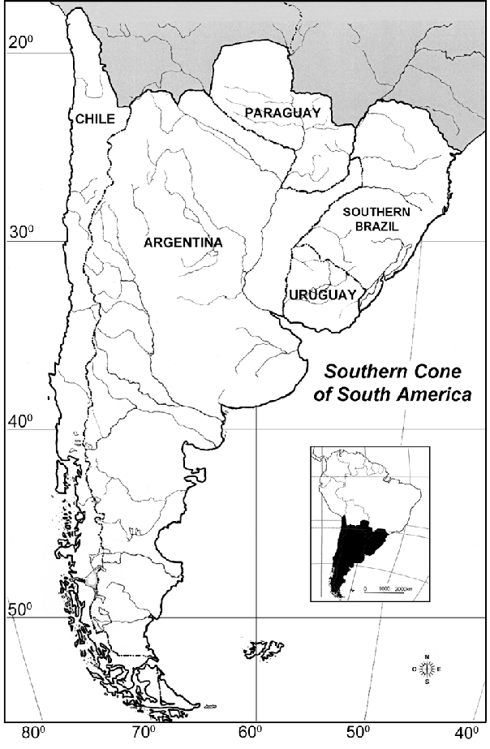
Falklands Islands / Islas Malvinas
Argentina’s extremely modest defense budget, approximately $3 Billion, presents a considerable financial obstacle. Any sizeable purchase, alongside prolonged maintenance costs, would greatly strain the budget of a nation known for financial turbulence. While geographically expansive, Argentina faces known threats, very near their borders. This limits the impact of the Su-75’s reduced range, while the reduced cost presents welcome savings. While the Su-75 would better suit Argentina’s needs, their regional political situation, economic and political turbulence, and limited defense budget mean they are an unlikely destination for the Su-75.

United Arab Emirates:
Perplexingly, the U.A.E featured heavily in the marketing pitch for the Su-75. The U.A.E. was granted access to the F-35 program, and ordered 50 units, in January of this year. The proven success of the F-35, and enormous financial commitment, make the U.A.E a very unlikely destination for the Su-75. Furthermore, the U.A.E.’s recognition of Israel signified a major transition in international relations for the Middle-East and further binds the U.A.E. to the United States. While the Su-75 may better meet the Emirati’s needs, given their small geography, and exclusively regional threats, continued partnership with the United States outweighs the benefits of future Su-75 imports.

Egypt:
Seeking relative neutrality, Egypt has long maintained a diverse fleet of fighters. Egypt’s current Air Force includes Russian manufactured Su-35’s, American F-16’s, and French 4th generation fighters. With continuing orders for the Su-35 and Rafale, the immediate funds for purchasing the Su-75 will be limited. Furthermore, a significant portion of Egypt’s military funding comes from the United States, which would oppose any potential Su-75 purchase at the highest levels. With a defense budget of approximately $4 billion, the potential cost savings of the Su-75 over the F-35 and Su-57 play a significant factor. Patrolling a more limited area, Egypt appears better suited to the purchase of the proposed Su-75. As fighter jet procurement is a highly political process, the political ramifications of purchasing the Su-75 must be considered, as Egypt continues to balance competing global powers, and works to maintain a semblance of regional peace. The Su-75 is an ideal fit for Egypt but political ramifications present a major obstacle, and an advance to 5th generation technology may be unpalpable for Israel, the regions leading military power.
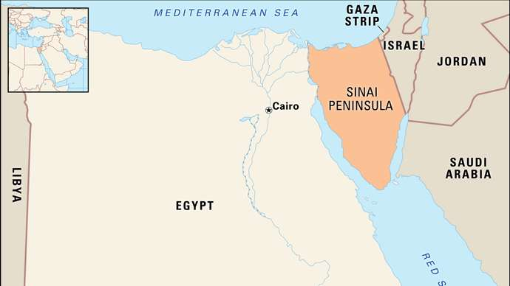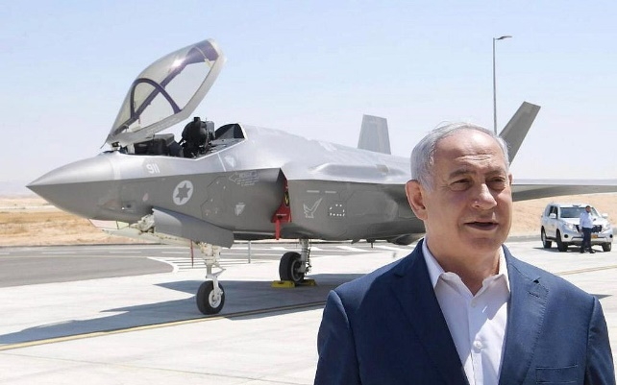

Indonesia:
Similar to Egypt, Indonesia has long sought to balance military ties, as such they operate both F-16’s, Su-30’s, and have the Su-35 on order. Given the Indonesia’s vast territorial expanses the limited range of the Su-75 is a major negative, Indonesia is over 3,200 miles wide, from east to west, and Indonesia regularly operates in the expansive Indian Ocean and South China Sea. Indonesian interests and military demands are too expansive for the smaller Su-75. While Indonesia possess sufficient economic might to purchase the Su-75 in large numbers, compared to other potential suitors on this list, the longer-range Su-57 remains the more ideal fit. As Indonesia’s primary military concerns remain China’s growing naval influence, and internal terrorist threats, growing their partnership with Russia may be counterproductive. The majority of nations aligned against Chinese naval expansion utilize U.S. sourced military hardware, with uniformity increasing collaborative operational efforts.

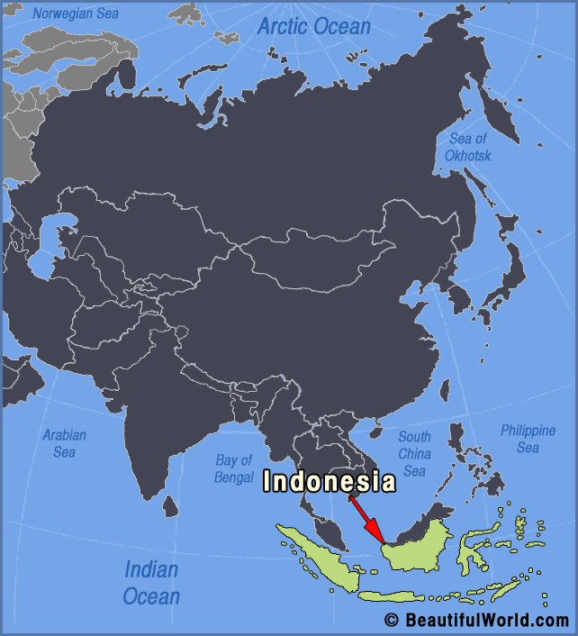
Indonesia’s considerable territory and the diverse array or regional threats make the short-range Su-75 (Checkmate) a poor fit for their security needs.

Interoperability, and efficient collaboration with allies against growing Chinese naval influence in the region remains a core concern for Indonesia.

While the Russian government and United Aircraft Corporation have sought to model the Su-75 for export success many factors serve as major obstacles. Political alignment with Russia, and consequentially, antagonism of the United States serves as a major hindrance for potential exports. While the reduced cost of the Su-75, compared to the Su-57, is a major incentive, many nations cannot accommodate the severely reduced range of the smaller Su-75. Russian setbacks and failures with the Su-57 have further complicated matters and damaged Russian manufacturing prestige. An expanded view of potential export destinations encounters increasing obstacles. Algeria, having recently ordered the Su-57, lacks necessary funding in the near term for further orders. South Korea is moving ahead with domestic models, and is politically non-viable. While many other potential suitors, such as Venezuela, Iran, Syria, and many African nations lack the necessary financial resources to purchase and maintain such an advanced aircraft. European and American 4+ generation fighters remain cheaper alternatives to the Su-57 and F-35, and fit many nations requirements. Despite the ambitious marketing pitch, the global market for the Su-75 appears severely limited, even before production begins.

You can view United Aircraft Corporations unveiling of the Su-75 here:
https://www.youtube.com/watch?v=icbPyrVCb_g

