Cyber Crime in the Modern World
The Federal Bureau of Investigation’s mission to protect the American people and uphold the Constitution of the United States is increasingly complicated by the presence of state sponsored foreign actors, particularly cyber-criminals. Of the 120 individuals on the FBI’s Cyber Most Wanted, only one is a U.S. citizen. The FBI is being tasked with pursuing criminals which have been charged with infringing upon the rights of American citizens or U.S. based corporations, while in most cases having never physically entered the United States.
Visualizing Cyber-Crime
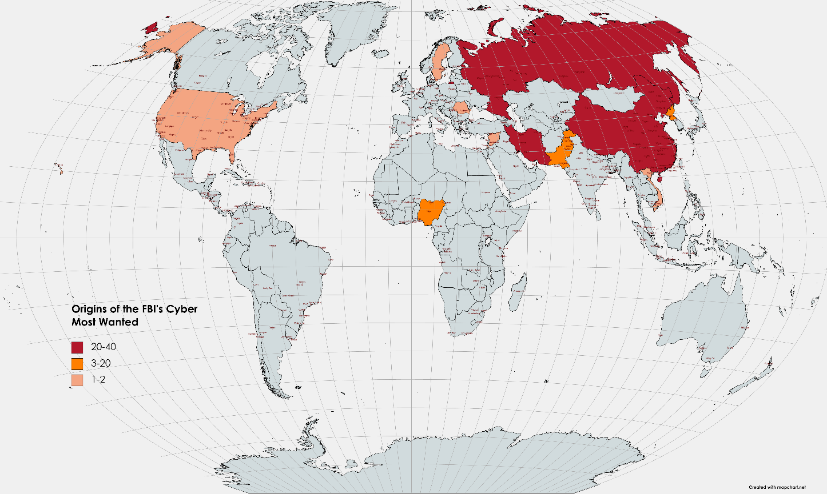

State Sponsors of Cyber-Crime
International adversaries such as Iran, Russia, and China dominate the listing of wanted cyber-criminals. In most cases the wanted individuals work directly for their host nations security and military, or have by contracted by their government. Within Russia, the GRU and FSB were heavily involved in coordinating and contracting workers to perpetrate attacks on U.S. electronic systems. In Iran the IRGC also plays a significant role in conducting and coordinating attacks on the U.S. government as well as American companies and individuals. In contrast, perpetrators from Nigeria, Romania, Vietnam, Sweden, Pakistan and the United States lacked the formal protection of government support. In total, 70% of the individuals on the FBI’s Cyber Most Wanted list were either contractors for or employees of foreign security services.

Impact on Diplomacy
In the relatively new domain of cyber-space the laws and regulations for individual, corporate, and state actors are largely undecided. While many western nations agree to a set of core principals this does not extend to nations which operate outside of or at the fringes of the western world. The limited participation of the Budapest Convention and politicization of the United Nations have left gaps in the global enforcement of cyber-crime. China has long been notorious for their disregard for foreign corporation’s intellectual property rights. Iran has regularly been at odds with the United States and the western world following the Islamic Revolution of 1979. Russia is increasingly cast as a kleptocracy and continues to oppose the current western led global order. North Korea, under the fanatical leadership of the Kim dynasty, has historically used cyber-crime both for financial profit and as a means of accessing restricted technology. In contrast Pakistan and Nigeria host rapidly growing populations and economies with relatively weak government controls. Their presence on the list largely denotes their populations economic needs, and the government’s inability to effectively police and constrain illegal activity within their borders. Both Pakistan and Nigeria rely on external support and cooperation, albeit in increasingly difficult political climates.
The nations sponsoring the largest volume of cyber attacks against the United States are each regional powers vying for greater control. While Russia and China are more integrated into the globalized economy Iran predominantly interacts through the sale and refinement of their petroleum products and the funding of military proxy groups within the region. The United States has engaged in negotiations with China on countless fronts in recent decades, and long struggled to illicit meaningful change in their regulation of cyber-attacks. The Chinese government, through the PLA, plays a major role in coordinating and conducting cyber-attacks on U.S. targets. Furthermore, China possesses the ability to prevent or prosecute such activities; an ability not as prevalent in both Nigeria and Pakistan. The sponsoring of such attacks makes the issue political, drawing cyber-attacks into government negotiations across a variety of concerns. As the United States discusses and negotiates territorial rights in the South China Sea, human rights concerns, the future of Taiwan, and international trade, the issue of cyber-crime persistently influences and impacts decisions. While certain issues may appear to be negotiated as stand-alone items, all negotiations are inextricably linked to the greater relationship.
Russia’s interference in both the 2016 and 2020 elections in the United States brought the issue of cyber-attacks to the political forefront. While Russian interference in U.S. elections remains consistent within the general theme of Russian foreign policy under Vladimir Putin, it denotes both an escalation and a widening of Russia’s available foreign policy tools. While cyber-attacks have existed since the dawn of the internet the proliferation of state sponsored attacks on the United States represented a broadening of the conflict with Russia. The United States and Russia remain at odds over Russia’s military interventions in South Ossetia, Crimea, Syria, and Libya. Russia has acted defiantly in their perceived interests, with cyber-attacks representing a new cost-effective solution. The GRU and FSB are the primary sponsors of cyber criminals within Russia and Putin’s open defiance on the issue can be added to the list of tense negotiating points with the west. As with Syria and Libya, Russia’s cyber capabilities ensure they have a seat at the table as future outcomes and standards are negotiated. President Biden’s most recent meeting with Vladimir Putin resulted in only an agreement to hold future negotiations, and a simple understanding of retaliation and red-lines. However, tensions have continued to rise following the attacks on Colonial Pipeline and JBS Foods.
The Biden administration remains adamant on returning to the JCPOA, which the United States left in 2018. Negotiations in Geneva, while centered on the JCPOA, will inevitably cover the breadth of Iran’s relationship with the United States and include concerns related to the support of proxies such as Hezbollah, arms shipments to Venezuela, and state sponsored cyber-crime. The Iranian Revolutionary Guard Corp (IRGC), continues to conduct and contract cyber-attacks against the United States, an offensive act which further complicates nuclear negotiations. Iran’s sponsor of cyber-attacks against the United States, much like their arms shipments abroad, represent both an obstacle and key bargaining chip in a potential agreement with the United States.
While China, Russia, and Iran remain at odds with the United States many nations have assisted in the capture and prosecution of wanted cyber-criminals. While five members of the GozNym gang remain at large in Russia, the other five members were caught within Europe. Notably, both Moldova and Bulgaria assisted in the capture and prosecution of the Russian based gang, despite both nations’ strong economic ties to Russia and their shared history of the Soviet era. While a global consensus on cyber-activity is growing, nations which politically oppose the United States such as China, Russia, and Iran remain outside the scope of recognized cyber-activity.
Cyber-attacks by both individuals and state actors will likely continue to grow as a threat for the United States. Privately conducted cyber-attacks are on the rise and ransom-ware attacks are predicted to cost $1 trillion in 2021. State sponsored cyber-attacks remain practically useful for China as they seek to capture advanced western technologies as they seek parity with the United States and Europe. North Korea continues to view cyber-attacks as a feasible source of revenue. Russia utilizes cyber-attacks as a cost-effective method of interfering and generating influence abroad. Iran utilizes cyber-attacks to shape foreign narratives and as a source of income in an economy which has been greatly impacted by sanctions, Covid-19, and tense relations within their region. Notably, Iran has also been the victim of a famous cyber-attack, with Stuxnet delaying and damaging their nuclear facilities at Natanz. Israel is widely suspected of conducting the attack, in coordination with the United States.
Challenges Ahead
Regulating online conduct and building an international consensus remains a challenge for the United States. While many nations cooperate and coordinate with the FBI and DOJ, those nations at odds or openly hostile to the United States will remain a challenge. As the FBI is limited to their domestic jurisdiction, the prosecution of all but 1 of the FBI’s Cyber Most Wanted are subject to ongoing U.S. relations with foreign nations. Before this June’s meeting between Biden and Putin the White House clarified that any potential “swap” of cyber criminals was off limits. Cyber-activity is but one in plethora of disputes in which expectations are low and progress limited.
While progress may appear difficult, the United States ability to combat attacks remains world leading. It should be noted that nations such as Cuba and Venezuela, whose governments openly despise the United States, are absent from the list. Smaller nations or territories such as Palestine and Syria represent relatively small cyber-threats and have proven incapable of coordinating attacks at scale. The United States, Sweden and Vietnam all appear on the list due to perpetrators of financial crimes such as fraud and theft. Bjorn Daniel Sundin, accused of fraud for his role in Innovative Marketing Inc., resides in Sweden, a nation which does not extradite to the United States in the case of computer crimes. Sweden signed on to the Budapest Convention in April but has yet to proceed with an extradition, highlighting the limitations of existing international agreements.
Looking Ahead
Securing extradition treaties and partnerships with foreign nations will remain a challenge, especially in the new and rapidly evolving theater of cyber-crime. The Budapest Convention of 2001 remains the only legally binding treaty of global scale, yet it remains flawed even amongst signatories. The United States has found limited success in working within the UN Convention against Transnational Organized Crime (UNTOC) and the Organization of American States (OAS). The prospective of a broader and more comprehensive international agreement through the United Nations remains muted due to high levels of opposition amongst permanent members of the Security Council.
The growing preeminence of state-sponsored attacks presents a unique and formidable challenge as asymmetric tactics have proliferated. Though solace may be taken in the continued growth of U.S. defense and the limited number of intrusive states, the prospect of a coming Cyber Cold War remains ominous. The largest offenders, particularly China, are cracking down on internal violators, while sponsoring attacks abroad, effectively weaponizing their cyber-capabilities. While a limited number of states are willing or able to conduct this new type of state sponsored cyber-crime an escalation to cyber-warfare would represent a thematic shift for the world.

