Drafting a G-30

By: Gregory Ayres & Jose Antonio Garcia
Global Affairs with Greg Ayres
https://globalaffairswithgregayres.com/

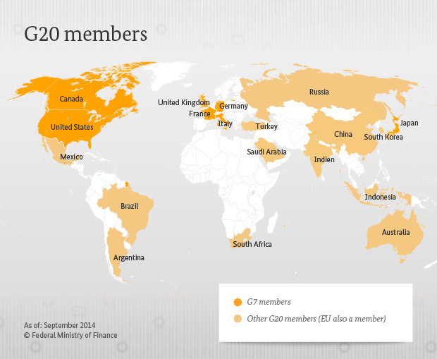
What is the G-20?
The G-20, originally created in 1999, is an offshoot of the G-7. In an attempt to better represent the global community and developing nations, this second organization of 19 nations and the European Union was formed. The G-20 expanded the geographic scope of the original G-7, further increasing the economic might of its membership. The G-20 accounts for nearly 85% of total global economic output, and 80% of all international trade occurs between its members. Recently, it also led and endorsed a global tax agreement, intended to implement a standardized base-line corporate tax of 15%. An expansion to a G-30 could serve to broaden the stakeholder base through the inclusion of regular invitees’ or disturb organizational consensus. In pursuit of the former politics must be considered.

The G-20 has the following stated objectives:
- Policy coordination between its members in order to achieve global economic stability, sustainable growth
- Promoting financial regulations that reduce risks and prevent future financial crises
- Modernizing international financial architecture

The creation of the G-20 yielded a comprehensive organization that could better fulfill its broad economic objectives. However, while the expansion to 19 member states and the European Union created a broader, and more global organization, many geographical areas remain underrepresented, and anomalies are present. The name G-20 suggests membership for the 20 largest global economies; however, this was not the case upon inception, nor is it true today. In 1999, Saudi Arabia was admitted to the G-20, a position they would qualify for today, as they possess the 20th largest economy in the world. However, with a GDP of $161 billion in 1999, they were chosen ahead of larger economies in Europe and Asia. South Africa, the 42nd largest economy today, also ranked outside the top 20 in 1999, though it was the largest African economy at the G-20’s inception.

In 1999, as today, seven of the 20 largest economies by GDP are within Europe. Therefore, a strict economic interpretation of a “G-20” would yield a disproportionate European membership, an issue addressed at inception by omitting Spain, Switzerland, and the Netherlands. While the inclusion of the European Union goes some way towards providing them with representation the nexus is limited. This is particularly true in the case of Switzerland, which despite strong ties to the European Union, is not an official member. For these reasons, strong grievances are harbored by the three aforementioned excluded European nations. As G-20 membership is not purely based on economic size, membership is inherently political. A simple list of the 20 largest national economies of 2020 would include no African or South American nations.

A ranking of the world’s 20 largest economies highlights the absence of Spain, the Netherlands, and Switzerland from the G-20.

The inclusion of Argentina, the largest of all South American economies, provides geographic diversity. Argentina had a GDP of $388 billion in 2020, ranking 32nd in the world. However, it is the continued inclusion of South Africa that is more controversial. With a GDP of $302 billion in 2020 it is less than half the size of Saudi Arabia’s economy, and with a ranking of 42nd globally, it is by far the smallest economy within the organization. Furthermore, as opposed to its position as the largest economy in 1999, today South Africa stands as the third largest economy in Africa, falling behind Nigeria and Egypt respectively. Moreover, Nigeria’s population is nearly four times that of South Africa, with an economy nearly 50% larger. Geographically, Egypt can represent both Africa and the Middle-East, and possesses a rapidly growing population. While South Africa possesses the most stable currency of the group, a more advanced economy, and is more widely integrated into trade, they have been surpassed in overall size. The continued inclusion of South Africa highlights the fixed and political nature of G-20 membership.

Taking political considerations into account, drafting an additional 10 nations to create a larger and more diverse G-30 presents a unique challenge. An expansion provides the opportunity to greatly increase geographic diversity, more accurately reflect modern economic realities, and address grievances held by excluded states. However, expanding the organization will generate additional struggles, and animosity, from newly excluded nations. Efforts must also be made to ensure a basis for consensus, as a broader but more divided G-30 would detract from the organizations mission.

The G-20 has regularly invited nations as guests, a move which has ameliorated some animosity amongst larger economies and broadened the geographic scope of meetings. Spain, the 14th largest economy in the world, has long been invited as a “permanent guest”. However, these moves underscore the highly politicized nature of membership and invitations. For example, countries such as Taiwan and Hong Kong remain inadmissible for political reasons. Non-democratic nations on the fringes remain contentious, even as larger authoritarian states such as China and Russia are welcome within the G-20. China has remained an integral member of the G-8, and only Russia’s recent foreign territorial interventions have seen them excluded from the revised G-7.

As an academic exercise, we have conducted a draft, with 10 spots available. The goal being to include those nations which would best aid in pursuit of the current G-20’s stated goals.

We will be alternating selections and providing brief explanations for each nation’s inclusion.

The first pick in the G-30 expansion draft goes to Jose Garcia.

#1) United Arab Emirates (Jose)
The first and foremost explicitly stated objective of the G20 is to “[coordinate] policy between its members in order to achieve global economic stability”. As such, elevating the United Arab Emirates to permanent member status would both increase the forum’s geographic diversity though the addition of a second Middle Eastern state, and provide a grander stage for the resolution of policy divergence intimately intertwined with “global economic stability”. The UAE’s presence within OPEC and the GCC yields considerable influence in global energy markets and the nation serves as a banking and financial hub within the region. Given the recent political volatility of OPEC and the GCC, a place in a G-30 adds an additional platform for economic cooperation and standardization. As the 34th largest economy in the world, the UAE carries sufficient economic weight, and diplomatic power. Lastly, as a major financial hub for the global petroleum economy their inclusion solidifies forthcoming resolutions on corporate taxes.

#2) Spain (Greg)
As the G-20’s lone permanent guest, and largest economy to not make the G-20, Spain topped my pre-draft chart. Spain is home to the world’s 14th largest economy, $1.278 trillion in 2020. With the intent of the expansion being to increase the scope and diversity of the organization, adding 10 non-European nations would have otherwise diluted Europe’s representation. Spain has struggled economically since the 2008 financial crisis and faces long term issues with demographics and export competition; however, their economic size and political stability have made them my first selection.

#3) Chile (Jose)
A stalwart economy classified as high-income by the World Bank, Chile is amongst the most prosperous states in South America, specifically standing as the continent’s third largest. It enjoys robust returns from a historically healthy tourist industry, copper and lithium in its mining industry, and salmon in its fishing industry. A three-time G20 invitee, elevating Chile to permanent member status in a G30 may even feel like a formality, and would once again increase the forum’s geographic diversity though the addition of a third South American state. A longtime innovative force in trade liberalization and finance Chile is a natural fit in an increasingly globally oriented G-30.

#4) Israel (Greg)
Returning to the theme of diversification, Israel is a welcome addition to the G-20. Home to a growing advanced economy, Israel boosts representation in the Middle-East, previously only represented by Saudi Arabia. The introduction of Israel, the world’s 30th largest economy, would realistically necessitate some political balancing in this expansion. A democracy home to many high-tech industries, Israel is a significant stakeholder in the establishment of future financial standards and reconstruction efforts within their region. Israel’s capacity for development spending and strong rule of law earns them my second selection.

#5) Nigeria (Jose)
Whilst South Africa stood as the largest economy in Africa at the initial formation of the G20 in 1999, this is simply no longer the case. As previously mentioned by my colleague, South Africa is now in fact the third largest economy in the continent, falling behind Nigeria and Egypt. A GDP of $429 billion in 2020 ranks Nigeria as 27th largest economy in the world, already comfortably falling within a hypothetical G-30 simply composed of the 30 largest. With a rapidly growing population and strong levels of economic growth Nigeria is well positioned to rise even higher on global economic rankings. Elevating Nigeria to permanent membership in a G-30 would serve to increase, rectify and contemporize African representation in the forum.

#6) Egypt (Greg)
The introduction of Israel seemingly necessitates the introduction of another Middle-Eastern state. Despite Egypt’s recent struggles with democratic transitions of power and human rights, they remain best placed to politically balance Israel’s inclusion. Egypt is on relatively good diplomatic terms with Israel, boasts the 35th largest economy in the world, and is a significant player in regional reconstruction efforts. Egypt regularly saw annual GDP growth rates averaging nearly 5% in the years before Covid-19, despite considerable political turmoil. High levels of growth should see Egypt justify their inclusion in a G-30 in the relatively short term, through a projected ascension to top 30 economy status.

#7) Thailand (Jose)
After current permanent G20 member Indonesia, Thailand stands as the 2nd largest economy in Southeast Asia, and 8th largest in the whole of Asia. An eager adopter of economic reforms from international financial institutions such as the World Bank, Thailand has developed a highly-globalized economy that saw consistent growth over the course of several decades, dating back to 1960. Today, it is commonly pointed to as an international development success story. Elevating Thailand to permanent member status in a G-30 would provide a platform for it to further grow into an even larger regional player than it already is, benefiting the Asian region as a whole.

#8) Switzerland (Greg)
My second European selection, Switzerland, is fully deserving of a place in a G-30, as they are not a member of the European Union. Lacking representation through the EU, Switzerland is included due to their leading role in financial regulations and development of financial architecture. Famed for their discretion and secrecy in financial affairs. Switzerland is a major stakeholder in the establishment and standardization of financial policies. Their inclusion could ensure compliance with forthcoming corporate tax standardization, a potential issue given their predisposition to financial secrecy. Again, Switzerland’s inclusion maintains Europe’s share of representation during the expansion to a G-30, while providing a place for the world's 18th largest economy.

#9) New Zealand (Jose)
Standing as one of the most globalized economies in the world – as a result of its reliance on international trade – New Zealand rightfully earned an invitation to the 2021 G20 Rome summit. Nonetheless, elevation of New Zealand to permanent member status, would serve to mitigate regional underrepresentation in the G-20, currently only permanently represented by Indonesia. For example, issues and topics debated in the Asia-Pacific Economic Cooperation (APEC) forum could vicariously be spoken for in the G20 through Prime Minister Jacinda Arden, who currently chairs APEC. Lastly, New Zealand also conspicuously stands as the only member of the Five Eyes intelligence alliance not included in the G20. Already standing as a historically value-added member of a global security forum, New Zealand surely stands to be a value-added addition to a global economic forum.

#10) Netherlands (Greg)
My final European addition, and the last remaining top 20 economy, the Netherlands finds a place in the G-30. Like Switzerland, the Netherlands is a robust democracy with a highly developed economy and is highly integrated into global trade and finance. While they are represented through the European Union’s place in the G-20, they maintain Europe’s proportional position within the newly formed G-30. This consistent level of European representation would likely be necessary to generate sufficient support for the expansion.

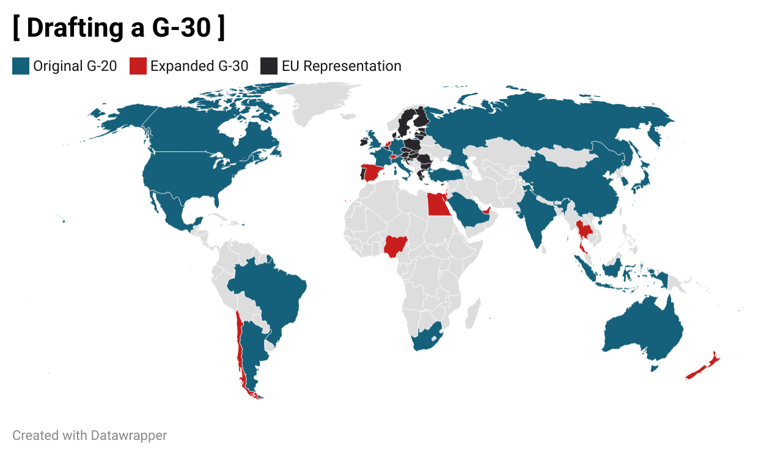

Notably, a number of larger economies have been bypassed in this draft. Taiwan, technically the 21st largest economy in the world, does not possess a genuine path to entry. The inclusion of Taiwan or Hong Kong as individual entities would be completely unacceptable for China. Iran’s relations with the west present a major obstacle, alleged state sponsored criminal and terrorist activities prevent their admission in the near term. Though Iran possesses the 22nd largest economy and is a regional military and cultural power their hostile relations with the west preclude an invitation. The desire to diversify membership prevents the addition of more major European economies such as: Poland, Sweden, Belgium, Austria, Ireland, and Norway. Growing Asian economies such as the Philippines, Singapore, Malaysia, and Bangladesh remain outside the world's 30 largest economies despite individual merits.

The inherently politicized nature of G-20 membership means that while an expansion to a G-30 can address some existing membership issues, a G-30 merely shifts the disputes over membership instead of eliminating them. Membership would certainly remain controversial. While the Spanish may see this expansion as a grievance addressed, the Poles may hold a legitimate grievance at their omission. An expansion also does not address the permanent nature of membership, meaning guests would continue to be in included at annual meetings.
Economic Snapshot 2020: The Expanded G-30
Draft Selection | Nation | GDP (Billions $) | ($) GDP / Capita | Debt as % of GDP | Global GDP Ranking
1 | United Arab Emirates | 354.28 | 43,103 | 27 | 34
2 | Spain | 1,278.21 | 29,600 | 95 | 14
3 | Chile | 252.76 | 14,896 | 32 | 43
4 | Israel | 402.64 | 43,592 | 73 | 30
5 | Nigeria | 429.42 | 2,229 | 31 | 27
6 | Egypt | 361.85 | 3,019 | 29 | 35
7 | Thailand | 501.89 | 7,806 | 49 | 26
8 | Switzerland | 747.43 | 81,993 | 39 | 18
9 | New Zealand | 209.33 | 42,084 | 41 | 50
10 | Netherlands | 909.50 | 52,331 | 49 | 17

Our hypothetical expansion to a G-30 yielded a diverse array of new member states. New Zealand, while the smallest economy to be included, scored well in GDP per Capita and Debt as a % of GDP. Spain, the largest economy to be included incorporates a middling GDP per capita and struggles with long term debt obligations and demographics, despite political stability and a globalized economy. Egypt and Nigeria, the poorest nations to be added on a per capita basis, are well placed for growth and increase representation for Africa and the developing world. Each nation brings unique benefits and challenges to an expanded G-30, though the inclusion should benefit the existing mission goals.

