From Farm to Finance
By: Gregory Ayres https://globalaffairswithgregayres.com/ 7/16/2021

The rising cost of food is evident everywhere we look, from your neighborhood grocer to the nightly news. As consumers, we are highly attuned to food prices; we purchase staple items regularly, and the abundant options keep us attentive to prices. Particularly, following the outbreak of the Covid-19 pandemic, and subsequent economic responses, the prices for staple food items has grown greatly. This presents a dilemma for consumers, but a potential boon for producers and food exporting nations. An examination of 6 major agricultural commodities demonstrates their outsized growth in comparison to the Consumer Price Index (CPI), a standard measure of inflation.

Who & How to Benefit?
Taking data from June 16th, 2019 and 2021, price increases were calculated for commodities, and compared to the 6.27% inflation recorded in the CPI over the same time period. Agricultural commodity prices have risen across the board, and far exceeded CPI measured inflation. These price increases represent increased costs for consumers, but potentially increased profits for farmers. An examination of agricultural commodity exporters can identify the top beneficiaries of these outsized price changes.
Exporting high levels of increasingly profitable agricultural commodities in 2020 necessitated not only the continuation of a successful agricultural sector, but also effective government policy for combatting Covid-19. National responses varied greatly, and successful Covid-19 policies and responses were vital for the continued operation of the agricultural sector, and related industries. Successful government responses provided for the continued and reliable access to industrial equipment, labor, chemicals and fertilizers when feasible.
The most territorially expansive nations hold a distinct advantage in agriculture, though the presence of high-quality arable land is equally important. Technologically innovative farming techniques, and a shift to both higher quality and upmarket products, have allowed smaller nations to build robust export networks.

Population and Innovation
The presence of the Netherlands and Belgium demonstrate the impact of technologically advanced agricultural methods and modern farming techniques. Exports, notably rely on production exceeding domestic demand, a challenge for some of the worlds most populous nations, such as India and China. Populous nations generate proportionally higher agricultural production, though strong domestic consumption limits exports.
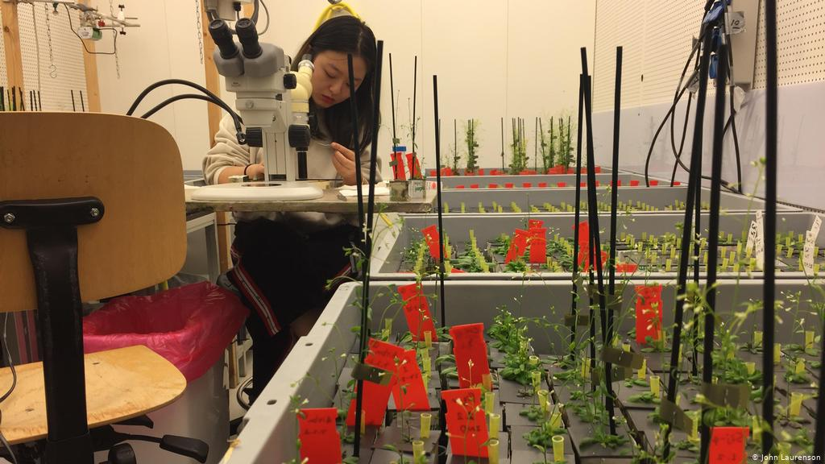
Vertical farming techniques and innovations in water management contribute to the Netherlands export dominance.

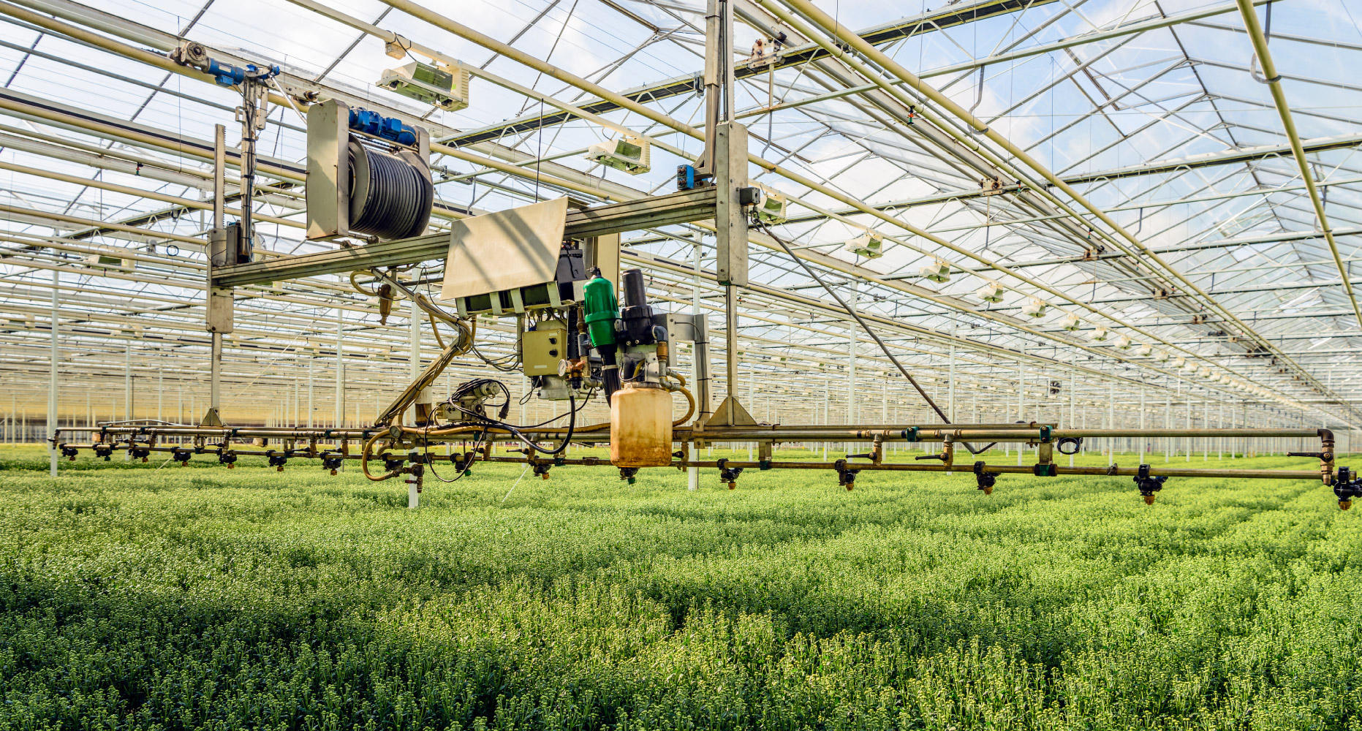

National Export Rankings
As the examined commodities are among the largest in the agricultural sector their top exporters stand to gain disproportionately. By ranking the top 10 exporters for each commodity the largest beneficiaries are made apparent. Consistently ranking within the top 10 for multiple commodities denotes diversification, and protection form the negative volatility of individual crops or livestock. The United States dominance within the rankings is evident, as are the positions of Argentina, Canada, and Russia. Only the United States ranks as a top 10 exporter for each of the examined commodities.
 | Soybeans | Corn | Wheat | Rice | Lean Hogs | Live Cattle
1 | Brazil | United States | Russia | India | Spain | Brazil
2 | United States | Argentina | United States | Thailand | United States | Australia
3 | Argentina | Brazil | Canada | Pakistan | Germany | United States
4 | Paraguay | Ukraine | France | United States | Canada | India
5 | Canada | France | Ukraine | Vietnam | Denmark | Argentina
6 | Uruguay | Romania | Argentina | China | Netherlands | Netherlands
7 | Ukraine | Hungary | Australia | Myanmar | Brazil | New Zealand
8 | Netherlands | Serbia | Germany | Italy | Belgium | Canada
9 | Russia | South Africa | Kazakhstan | Brazil | France | Ireland
10 | Benin | Bulgaria | Poland | Cambodia | Mexico | Uruguay

Commodity Exporter Strength
Calculating an average score, based on the positions for each nation across the largest commodities, illustrates those nations with the most to gain from rising agricultural commodity prices. Cumulative ranking scores, (Green), reflect diversity export performance and overall strength. Vaccination administration percentages, (Red), are used as a proxy to measure the effectiveness of a nations Covid-19 response. Capitalizing on high agricultural commodity prices requires strong performance in both categories in the graph above. Strong responses from Canada, Spain, and the Netherlands, represent increased opportunities. In contrast, the ineffective responses by nations such as Brazil and Russia represent opportunities lost.
The United States dominance across sectors scores them significantly higher than Russia and Spain, which are present in far fewer categories. The Netherlands ability to place in three categories is admirable given their limited geographic size. Jamón Ibérico, and other upmarket pork goods secured Spain’s place as the world’s top exporter of Lean Hogs. Geographic and climatic conditions also factor greatly into the type and efficiency of agriculture. For example, Russian dominance in wheat exports cannot be easily translated to corn or rice production at similar levels of efficiency. The diverse array of climates in the United States contribute to the nation’s strong performance across categories, and their top position in Cumulative Score metric.
Financial Markets & Covid-19
The long-term impacts of Covid-19, as well as the subsequent lockdowns and economic stimulus are yet unknown. In the short-term, inflation has followed the unprecedented levels of monetary and credit expansion. Increased levels of inflation have been felt across the majority of sectors, and commodities such as lumber have experienced unprecedented volatility. Examining the largest of agricultural commodities eliminated the higher levels of volatility experienced in smaller market-cap and niche products.
Price increases reflected on international exchanges are not fully absorbed by the productive nations, as transportation and logistical costs often rise in parallel. Furthermore, the recent rise of oil and petroleum prices has increased the input costs for farmers, fuel and fertilizer prices typically rise alongside their petroleum bases. National governments individual responses to Covid-19, and the subsequent economic fallout, have greatly impacted national economic performances. Access to credit, comparative currency valuations, trade restrictions, and regulations on labor are all key factors in the success and profitability of a nations agricultural sector.
With agricultural prices outpacing inflation, increased profits from agricultural exports are accessible to those nations which most effectively managed their Covid-19 response. The United States, though cautious in their vaccine testing and deployment has since emerged as a world leader in pandemic response. The early champions of Covid-19 response, Taiwan, South Korea, and Japan, are notably absent from the list of top agricultural exporters. Inversely, Brazil has struggled disproportionately with the health impacts of Covid-19. Agricultural exporters with effective responses to Covid-19, have, and will, continue to benefit greatly from rising agricultural commodity prices.
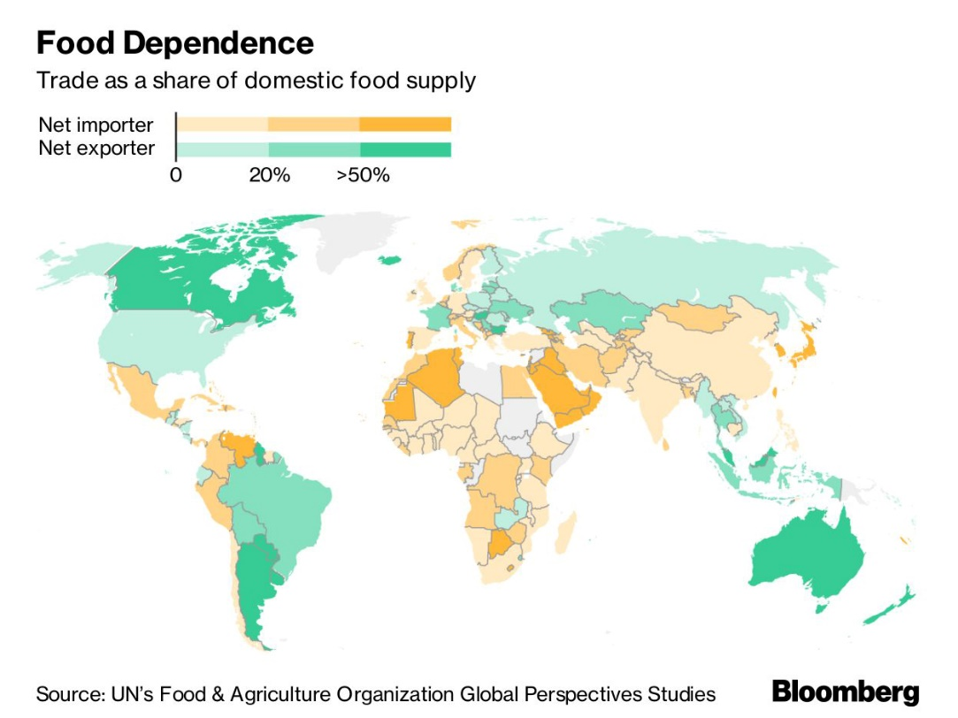
Just as the major food exporters stand to gain from agricultural commodity prices outpacing inflation, food importers experience rising prices as a cost. Most notably, the Middle-East, North-East Asia, and pockets of Africa, which rely heavily on food imports, are set to face food prices increases amidst an ongoing pandemic.

