The Complexities of Diplomacy at Sea: Part II
By: Gregory Ayres https://globalaffairswithgregayres.com/ 7/22/2021

In my prior article, The Complexities of Diplomacy at Sea, I explored the options available to the United States in the face of a potential shipment of Iranian arms to Venezuela. I entertained 5 potential options available to the Biden administration.
- Allow the Iranian ships to deliver weapons to Venezuela
- Negotiate the return of Iranian warships to Iran
- Increase sanctions on Iran and Venezuela
- Interdict the Iranian vessels
- Seize the cargo and Iranian vessels
The necessity for choosing a course of action grew as the Makran and Sahand sailed around the Cape of Good Hope. However, with over 6,000 miles of ocean between the Iranian vessels and Venezuela there was no immediate pressure for a response. Eventually, the Markan and Sahand continued north along the African coast, before holding position temporarily off the coast of Senegal. Notably, Senegal is directly adjacent to the opening of the Caribbean Sea.
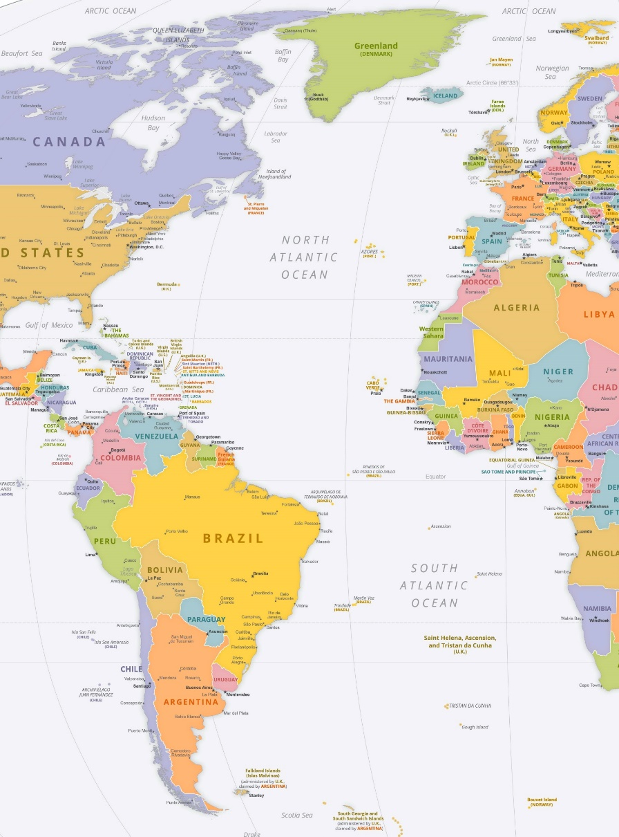
The Markan and Sahand’s position off the coast of Senegal on June 15-17th increases the possibility that the primary purpose for their deployment was negotiation.
Operating as a bargaining chip, the Iranian vessels could be used to influence negotiations with the United State,s over issues within the Middle-East, notably Syria and Iraq.
President Biden directed airstrikes against Iranian backed positions near the Iraq + Syria Border on June 27th.
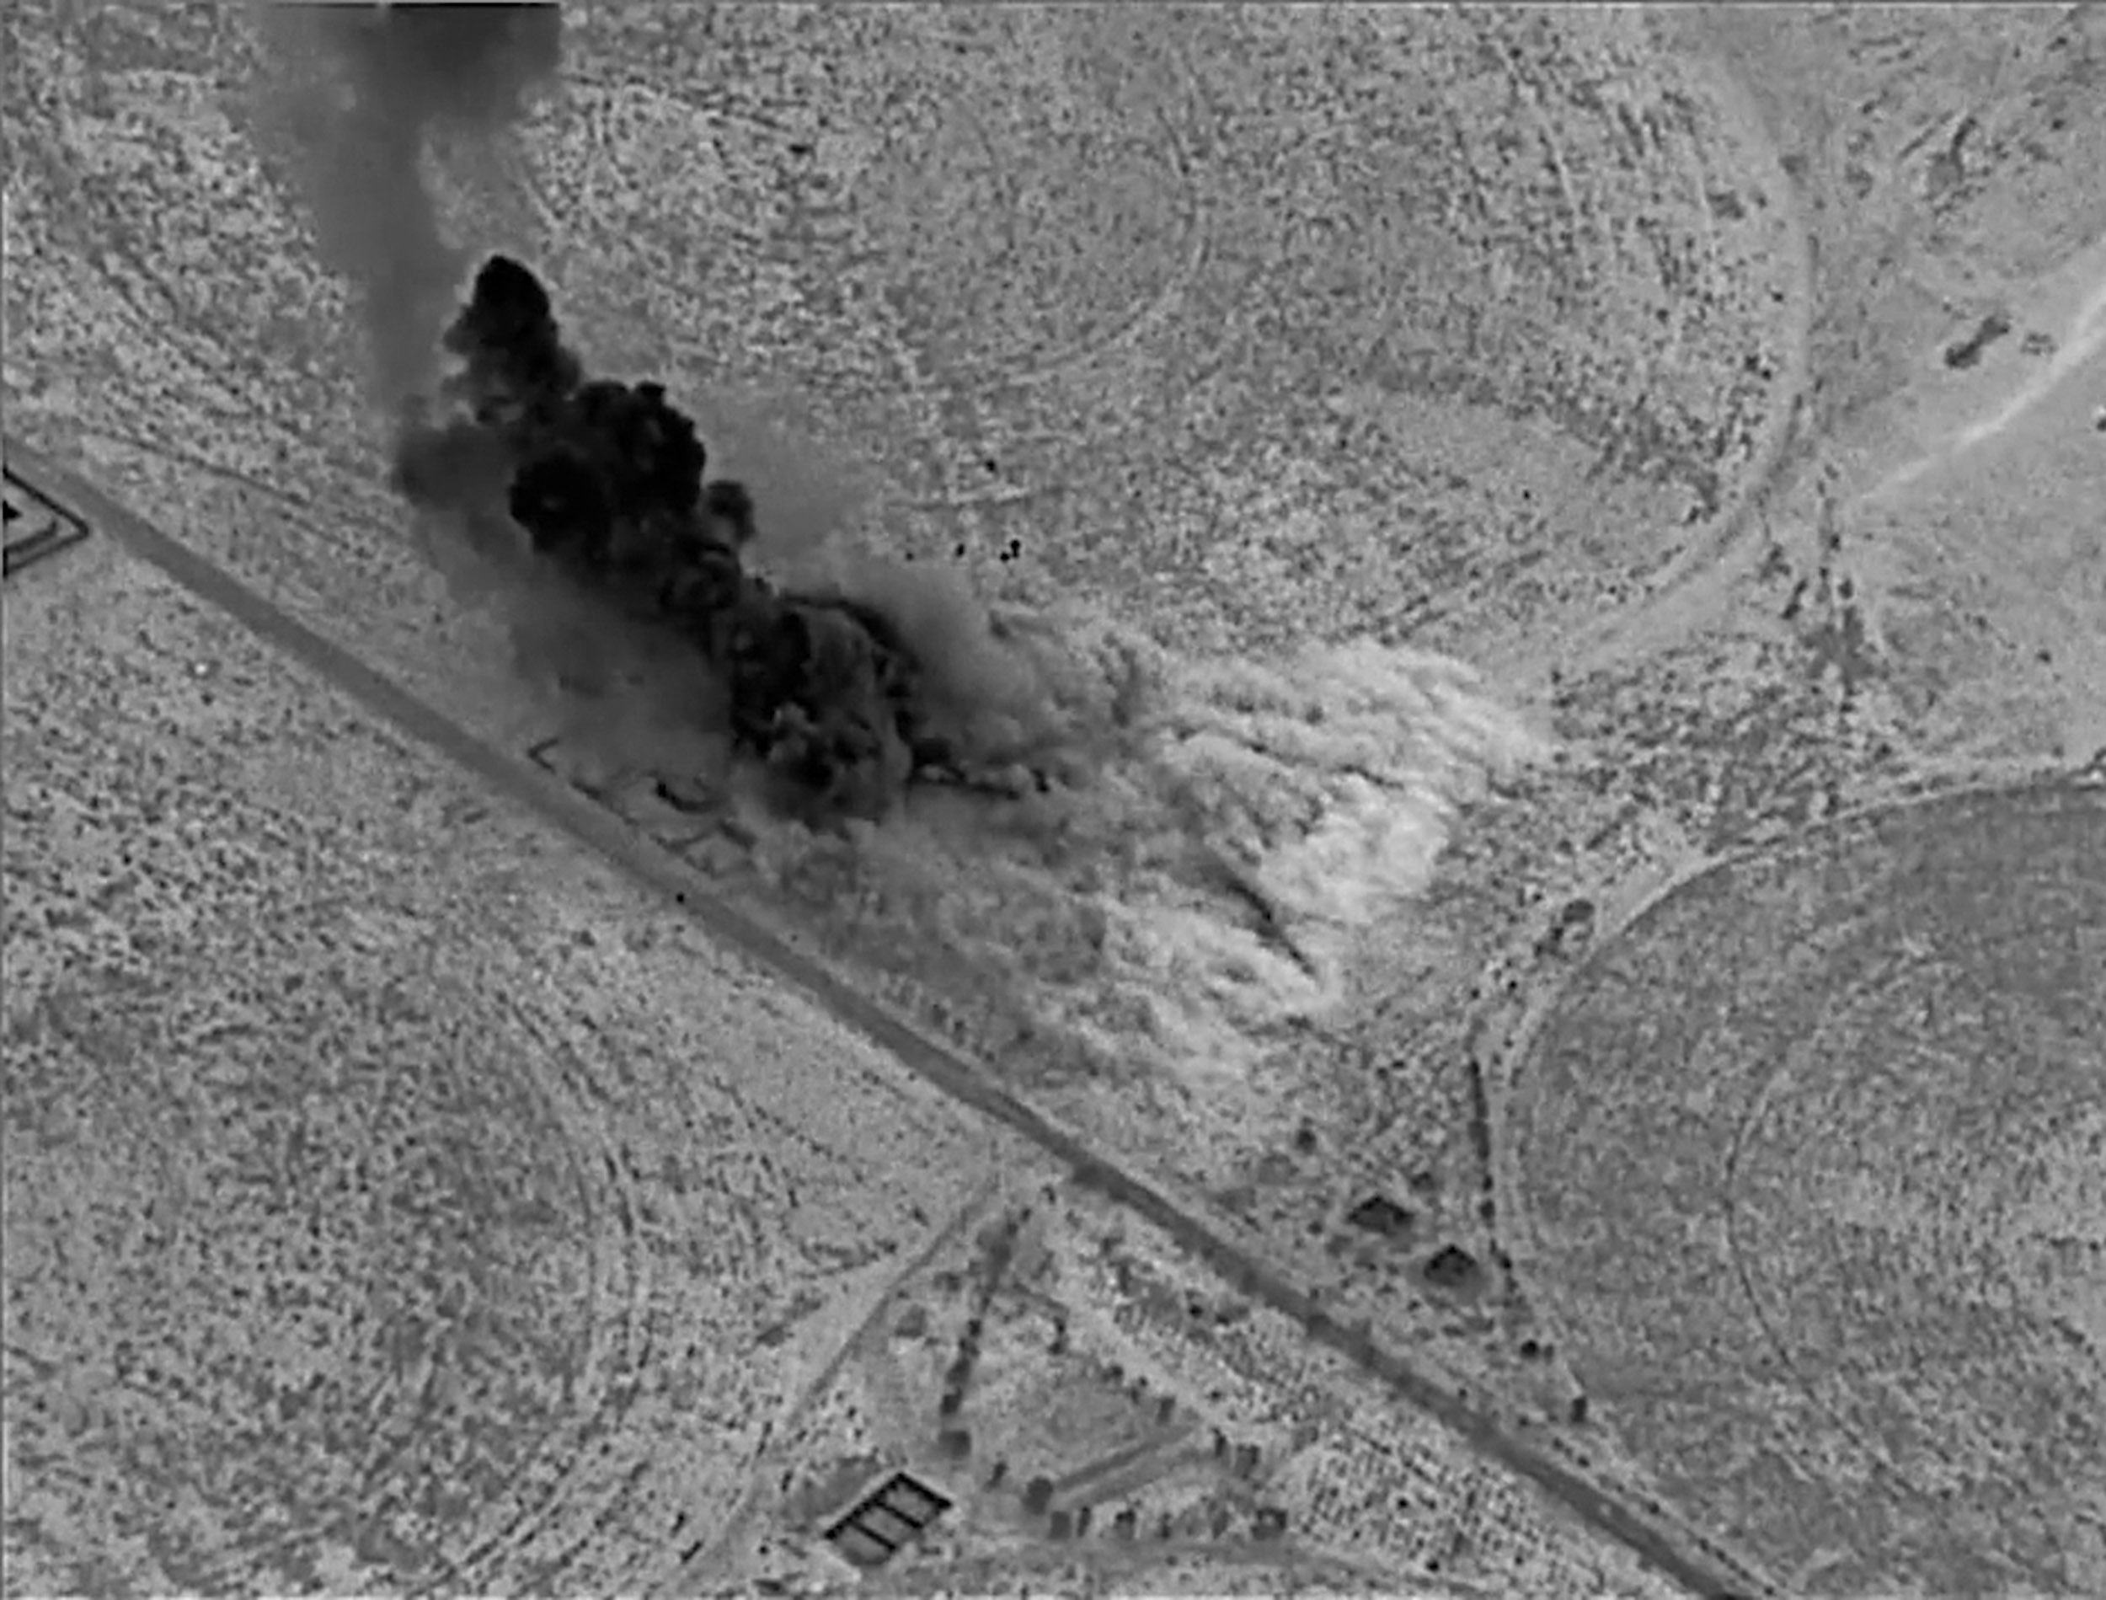

Given the Biden administration’s continued strikes against Iranian militias, and Iranian backed forces, the impact of the Makran and Sahand appears limited. Following the killing of IRGC leader Qasem Seleimani, in January 2020, the United States and Iran have regularly engaged in limited and intermittent retaliatory strikes. A relative period of calm followed Biden’s February airstrikes, which targeted Iranian militias with links to Hezbollah along the Iraqi border.
The temporary lull end when Biden struck Iranian militias on June 28th. Targeting facilities in both Iraq and Syria, the airstrikes occurred amidst ongoing negotiations to return the United States to the JCPOA (Iranian Nuclear Deal). Biden has long maintained that he wishes to negotiate a return to agreement, which originated during the Obama administration. However, the landscape has shifted considerably since the signing of the JCPOA. The UN Security Council is increasingly divided, as Russia continues to antagonize western interests, and China seeks to assert greater influence globally. Within the Middle-East the formal establishment of ties between Israel and the United Arab Emirates reflects the growing anti-Iranian sentiment within the region. Broader unity among the opposition Sunni-Arab states further isolates Iran. The destitute conditions in many of their potential partners reflects a weakened negotiating position, just as Iran’s neighbors coalesce around a perceived Iranian threat.
The most recent tracking imagery shows the Iranian vessels off the coast of northern France. Speculation over their appearance in a Russian naval parade off St. Petersburg persists, despite the increasingly tight timeline. Sailing over 12,000 nautical miles purely to participate in a naval parade is highly unreasonable. From an Iranian perspective the cost and risk inherent with the deployment are incompatible with the impact of a show of relatively meager force in a Russian naval parade. The cargo is unfitting, and participation in a naval parade would not justify the days off lingering off the coast of Senegal.
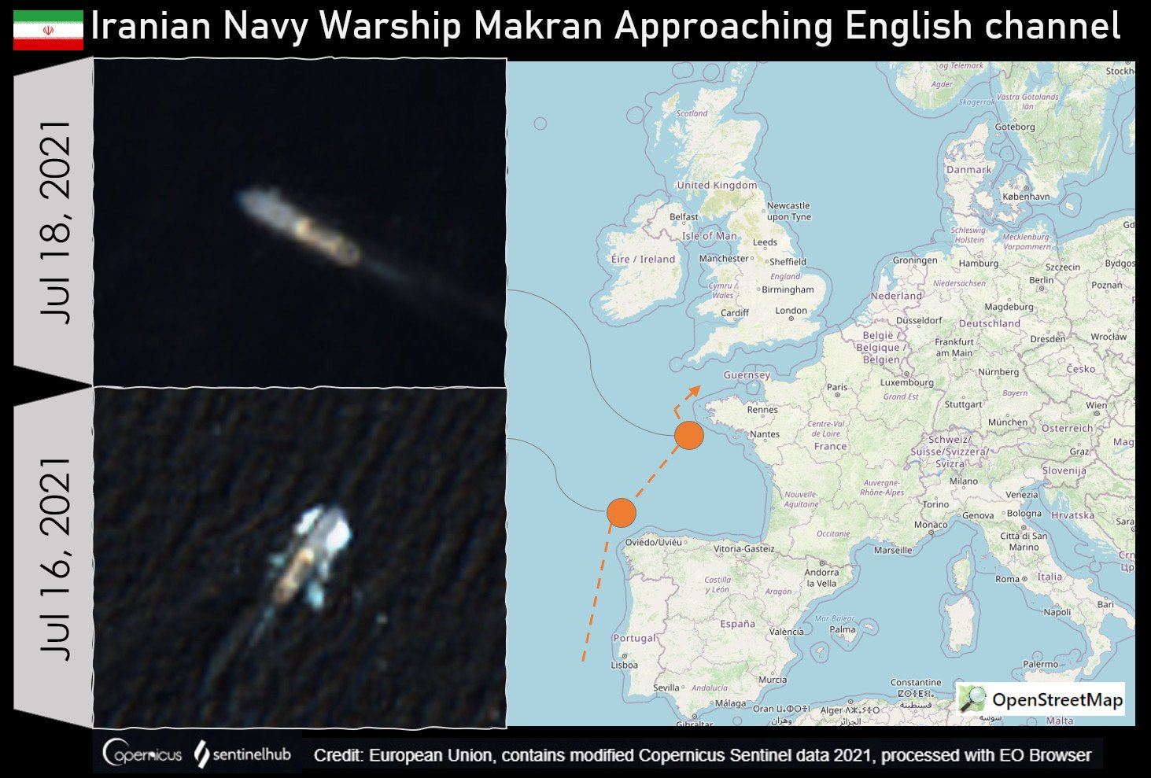
Traversing the English Channel would signify intent to potentially reach St. Petersburg.
By continuing north of the Strait of Gibraltar, the potential delivery of fuel or arms to Syria or Lebanon can be dismissed.
Reaching St. Petersburg would entail a 24,000 nautical mile round-trip journey for the Makran and Sahand.

At their current rate of travel, arriving in St. Petersburg by the 25th of July, for the Russian Naval Parade, stands as a diminishing possibility.

Given the Makran’s delay off of Senegal, and its cargo of 7 fast attack boats and fuel, the deployment was certainly undertaken with diplomacy in mind. The multi-month journey has demonstrated Iranian naval capability, which has long struggled to operate outside of the Persian Gulf, Arabian Sea, and Indian Ocean. Deploying the Makran as a bargaining chip has likely failed, as the threat of delivering arms or fuel to Venezuela, Syria, or Lebanon has not deterred the Biden administration from striking Iranian backed forces in Iraq or Syria. The Makran’s journey, though a step forward for the Iranian Navy, does little to offset the growing determination of their regional enemies. While the end destination, and final mission of the Makran and Sahand remain unknown, their role as a bargaining chip has likely already failed.

