A Taliban Administration
By: Gregory Ayres https://globalaffairswithgregayres.com/ 8/22/2021

The whole-scale administration of a nations’ internal affairs goes far beyond establishing military control. While the Taliban have recaptured the majority of Afghanistan, following the United States military withdrawal, the prospect of governance remains distant. During the United States 20-year occupation, the internationally recognized government, which collapsed under Ashraf Ghani, failed to effectively govern even with foreign military and financial support. Corruption was rampant, services were inadequate, and an independent formal economy failed to take hold.
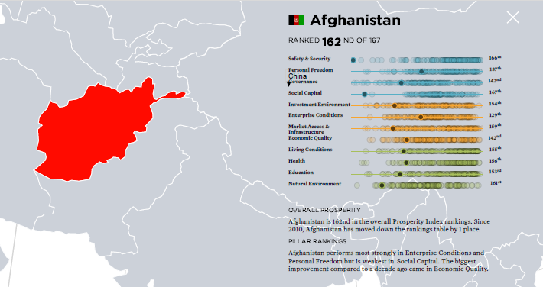
Afghanistan ranks 162nd of 167 nations in Overall Prosperity. Scoring second to last in Safety & Security and last in Social Capital.
Legatum Prosperity Index 2020
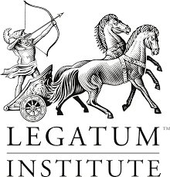

As Taliban leaders such as Mullah Abdul Ghani Baradar return to the country, seeking to form a government in Kabul, the military conflict appears won, but the bureaucratic challenge is just starting. Abdul Ghani, the Taliban’s political leader, acknowledged the forthcoming challenge, as he stated “We must meet the challenge of serving and securing our nation, and giving it a stable life forward.” The Taliban’s track record for bureaucratic administration, dating back to their 1996-2001 rule is deplorable. Afghanistan was one of the least efficient and most poorly developed nations in the world. Something 20 years for foreign occupation and investment has done little to change.
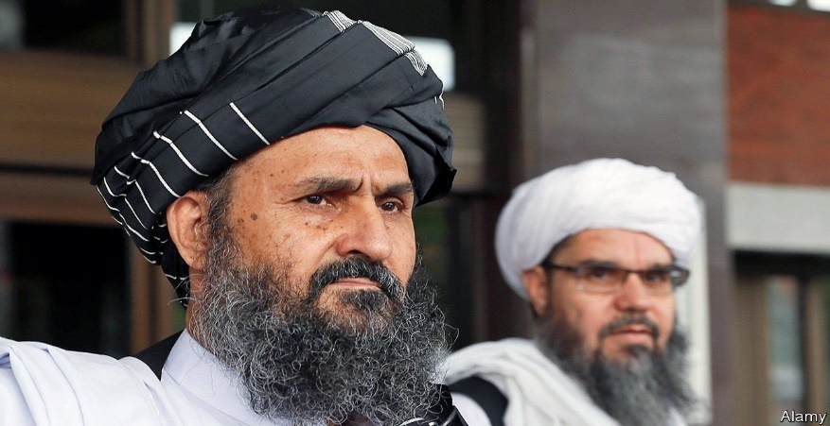
The Economist / Alamy (2021)
“We must meet the challenge of serving and securing our nation, and giving it a stable life forward.”
Mullah Abdul Ghani Baradar (Political Leader)
Taliban Leadership
Hibatullah Akhundzada: Supreme Commander
Mullah Abdul Ghani Baradar (Political Leader)
Mohammed Yaqoob: Military Leader
Sirajuddin Haqqani: Deputy, Haqqani Network Leader

Much of Afghanistan’s shortcomings are structural in nature. Home to some of the worlds most difficult geography, large scale infrastructure projects are prohibitively expensive and often practically infeasible. Afghanistan does not possess significant oil or gas reserves, unlike many of the central Asian republics. Agricultural production is hampered by inefficient irrigation systems and a lack of supporting infrastructure. The lack of a strong national Afghan identity is perhaps the largest deficit incurred by Afghanistan’s geographic remoteness. The predominance of ethnic, religious, and familial identities eroded efforts to create national military and police forces.
If the Taliban are to govern successfully, they will need to deliver economic growth, public goods and services, and security. Should these governance goals prove too lofty, they will turn to the coercive use of force to remain in power. The abject violence of Taliban rule is already being felt by the Afghan people, recently, targeted killings of those whom supported the western backed Ghani government began as the U.S. military withdrew towards Kabul. Limited protests have been reported within Afghan cities, as citizens protest the Taliban takeover. While Taliban spokesman’ have professed a desire for an inclusive government, which will respect citizens’ rights, these claims are betrayed by the groups past and present actions.
The Taliban’s unity has long been centered upon an opposition to foreign powers and strict adherence to religious and cultural practices. In their efforts to combat foreign powers, they have allied with the United States against the Soviets, and became the worlds largest heroin producer to fund their fight against the Americans and their allies. The Taliban has long been flexible out of necessity, however, with no foreign powers left to fight, they are faced with the task of governance. The Taliban have proven themselves military, though are poorly prepared to govern. Improved governance would call for:
- Providing for Domestic Security
- Stimulating and Managing Economic Growth
- Providing Basic Services
- Building and Maintaining Infrastructure
Each of these governance goals requires substantial funding, and were only sparsely achieved with nearly $100 billion in foreign aid over the last 20 years. With the United States, IMF, EU, and many other nations completely cutting their aid to Afghanistan the Taliban will have to rely on tax revenues and new allies. China, Russia, and Pakistan are the nations most likely to contribute economically to a Taliban government. Chinese aid will likely be attached to assurances of non-interference with the Uighur population and access to minerals. Russian aid, likely to be predominantly military aid, would arrive as part of Putin’s broader promotion of a multi-polar world. Pakistan’s tumultuous relationship with Afghanistan and the Taliban will be tied to security guarantees.
Relying on an almost non-existent formal economy, with endemic poverty, is unsustainable. Afghan government revenues totaled $2.5 billion in 2020, allowing for a public expenditure of less than $65 per person. The formal economy and tax revenues simply cannot finance a functional Afghan state. In recent years the World Bank estimates that over 75% of Afghanistan’s revenues were foreign developmental and military aid. The Taliban is then faced with an onerous dilemma. The Taliban will either have to significantly grow the formal economy, or expand their illicit operations. ISIL’s reliance on extortion, kidnappings, theft, and smuggling proved insufficient, even as they controlled significant oil reserves and a wealthier base population. While ISIL provides a proximate comparison, they evidenced the crushing power of broad international trading sanctions, and the infeasibility of exorbitant tax rates and purely illicit trade.
The Taliban generated $1.6 billion in 2020, mostly from narcotics, extortion, illegal mining, and foreign donations. While the Taliban has long publicly postured themselves against the cultivation and use of drugs their resurgence has largely been funded by the cultivation of poppies and export of heroin. Afghanistan now accounts for over 90% of global heroin production, and this position generates considerable leverage, as Iran, China, and the EU all have considerable interests in preventing an expansion of heroin exports. However, narcotics represent the most feasible source of funding for a Taliban attempt at governance.
While the Taliban has professed a level of acceptance towards previous government employees and administrators, large scale retention of public employees will be extremely difficult. As evidenced by scenes from the Kabul airport, and the departure of senior government officials, the flight of talent and wealth from within Afghanistan is overwhelming and urgent. The Taliban, like many insurgent groups turned governors before them, will struggle to populate public agencies with competent employees. While instances of improvement do exist, this largely stems from increase motivation, often backed by threats of violence. The deterioration of Afghanistan’s education system and the enormous amount of administrative functions which were aided by now departed foreign workers will further complicate the Taliban’s attempt at governance. ISIL demonstrated a certain level of competence in sanitation and the provision of electricity, largely through the re-employment of existing workers. While many services have never really existed, both the formal economy and narcotics trade will rely on a functional banking system and infrastructure maintenance.
Drug kingpins from Pablo Escobar to El Chapo, and the fictional Tony Montana have all struggled with banking. While the Taliban will control the Afghan banks, the establishment of an effective banking system is necessary to protect and account for, both tax revenues and drug profits. The Taliban will also need a formal banking sector to facilitate government payments for imports of any significant scale. Access to foreign currencies and trade will depend on a banking sector which has suffered immensely from corruption, and now nearly global financial sanctions.
Formal domestic trade will also require sufficient financial infrastructure. Roads, bridges, airports, and dams are sizeable projects requiring complex long term budgetary planning. These projects are vital for both the formal economy and drug cultivation. With scant highways, limited navigable rivers, no ocean access, and restricted air travel, transportation is a nightmare in Afghanistan. Moving goods such as fuel, food, and drugs within and outside of Afghanistan is slow, expensive, and troublesome. Whichever economic route the Taliban follows, infrastructure will be required to facilitate economic growth. However, it should be noted, that even with a robust U.S. security presence and billions in foreign infrastructure aid, few projects were successfully completed, painting a grim picture for a prospective Taliban government.
With Afghanistan’s history being fully considered, the Taliban is unlikely to facilitate formal economic growth, maintain the nations sparse infrastructure, or generate normal tax revenues. The Taliban will condense the proposed list government of services to a ruthlessly violent version of rule-of-law and a provision of security that more closely resembles rule by warlords or drug-lords. The Taliban’s 1996-2001 rule will likely serve as a near exact template for the forthcoming attempt at governance. The 21st century spin will be the export of heroin and competition for religious recruits with ISIL and other splintered terrorist organizations. Unaccountably violent policing, infrastructure limited to basic roads and irrigation, and a spartan Ministry of Finance may be the only pillars of government that exist at a national level. The quality of life for Afghan citizens will almost inevitably decline.
The Afghan people will face many hardships in the years to come under Taliban rule. Public health and education will suffer, trade will collapse, and violence will return to previous levels. It should be noted that even during the relative security provided by U.S. forces in the latter years, the Afghan government failed to significantly increase the quality of life for citizens. The United States collective patience with Afghanistan had long run its course, with public approval for troop deployments falling consistently for nearly a decade. The abrupt departure of the Ghani government, and territorial resurgence of the Taliban have caught many off guard, though they reflect the longstanding situation on the ground. The Afghan government, even with foreign billions and security forces failed to significantly improve the quality of life for Afghans or build a national identity which could be supported by the military or police. The United States, with wayward and evolving strategic objectives expanded the scope of their mission beyond their level of commitment in terms of both blood and aid. Faced with stagnate, and later declining progress, the United States enacted a withdrawal that was years in the making.
Things will get worse before they get better, the Taliban is well positioned military to remain in power, and foreign aid will now likely be replaced with foreign bombs. The Biden administration has committed to remaining active militarily within Afghanistan, without ground forces; necessitating a regular aerial presence. China’s commitment to investing in Afghanistan could prove a decisive factor, as they are the lone state within the regional with the financial might capable of propping up basic infrastructure and services. Chinas has faced occasional public backlash from their One Belt One Road projects, notably in Sri Lanka and Pakistan. However, the lack of public accountability within the Taliban could further facilitate bribes and extractive contracts without the worry of an independent press or democratic elections. Though any partnership between Afghanistan and China would be rooted in practicality as opposed to ideological harmony.
The Taliban’s forthcoming attempt at governance will likely resemble their previous stint in power, or that of conditions present in ISIL’s caliphate, or civil war era Sierra Leone. The typical breadth of public goods and services will not be provided, and government actions will be limited to the provision of security and illicit trade. The Taliban is in no position to practically eliminate their narcotics trade, with crops brining in up to $1.5 billion annually. The creation of a brutal narco-state is likely underway in Afghanistan as the limited trained bureaucracy hopes and waits for freedom at Afghanistan’s airports.

