Allies on Edge
By: Gregory Ayres https://globalaffairswithgregayres.com/ 8/3/2021

The United States boasts a truly global network of allies and partners, in pursuit of a variety of economic, security, and societal goals. These relationships arrive out of historical or societal links, such as the United States alliance with the United Kingdom. Economic interests are core motivators in the United States relationship with Mexico and Saudi Arabia. Alliances and partnerships centered around security are often more complex, involving a 3rd party in the relationship, coalescing around a shared threat. The United States security relationships reached unprecedented heights during the Cold War, however, following the collapse of the Soviet Union, some of these relationships have struggled to adapt.
In the direct aftermath of the Cold War, NATO found renewed purpose in the protection of vulnerable persons, and the prevention of genocide, in the former Yugoslavia. American military allies joined campaigns in Iraq and Afghanistan, focusing on international terrorism. Following the drawdown of the wars in Iraq and Afghanistan, new threats came to the forefront. Iran’s nuclear ambitions, Russian irregular warfare, and Chinese territorial ambitions have become the driving factors in the United States security partnerships.
Cold War Alliances
United States Cold War allies colored blue.

NATO members in dark blue.

Communist & Warsaw Pact nations in red.
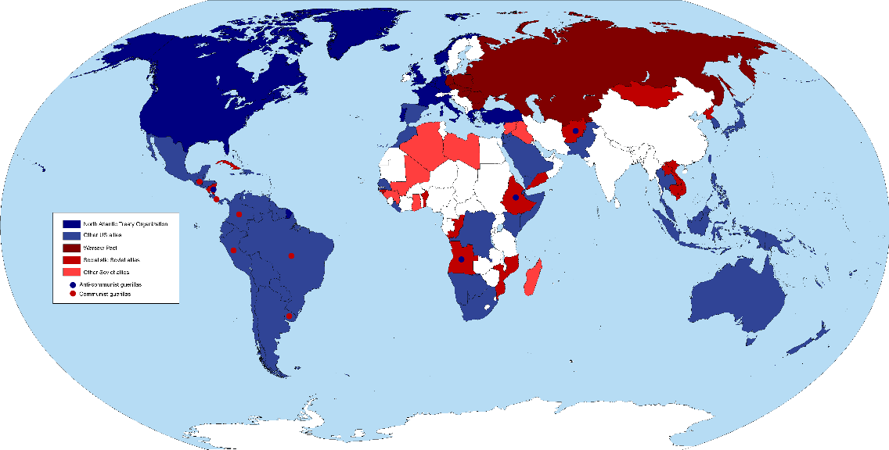

Recently, Turkey and the Philippines have wavered significantly as allies. Turkish president Erdogan has strayed significantly from core American security interests within the region. Turkey, a full NATO member, was a vital contributor to the United States Cold War coalition against the Soviets. Incirlik Air Base has proved vital for American operations in Iraq and Syria, and Turkey initially participated in the F-35 program, developing components for the advanced 5th generation warplane. The Philippines have long struggled with their colonial history, complicating their international relations. Following independence from the United States in 1946, the Philippines signed a Mutual Defense Treaty in 1951, and remained a key military ally throughout the Cold War. Subic Bay and Clark Air Force Base were uniquely vital installations for American military operations within the region and broader Pacific. Both facilities closed in the 1992, having lost relevance following the collapse of the Soviet Union, as political support for the presence of foreign militaries collapsed.
The Philippines overcame their complicated, and often painful, history of colonization, as they welcomed back American forces in 1998 following provocative Chinese territorial claims within the region. Anti-colonial sentiment perished in the face of a new, more powerful, foe. The six-year absence also caused significant economic disturbance, as the local economies surrounding Subic Bay suffered greatly. As the Philippines’ security focus shifted throughout the 1990’s the United States returned. Duterte, the Philippines’ current president, has shocked audiences on many occasions, and is prone to erratic shifts in policy and position.
The Philippines has, for decades, courted international support and American military ties, to combat Chinese territorial claims in the South China Sea. The Visiting Forces Agreement has been regularly renewed, typically without incident, since 1998, however, in 2020 Duterte announced his intention to withdraw from the agreement. This comes after his 2018 statement, “I need China. More than anybody else at this point, I need China”. While China is in fact the Philippines largest trading partner, the United States, and its Indo-Pacific military allies, constitute the bulk of the Philippines international trade.

Following months of threats and delays, Duterte renewed the Visiting Forces Agreement on July 30th, 2021. The fear of Chinese military expansion, based upon territorial claims found illegitimate by The Hague, has prompted an about-face from the divisive Philippine president. Support for the United States has remained strong within the Philippines for years, reflecting not only intra-governmental but societal ties between the nations. Despite recent institutional degradation, the Philippines remains significantly more similar to the United States as opposed to the more authoritarian communist China.
While public support for the United States, within the Philippines, has fallen in recent years, particularly in comparison to China, the United States remains the more favored partner. China’s economic and military rise present both an opportunity and a threat to the Philippines, a duality perhaps manifested in Duterte’s quest for a more independent foreign policy. Strong security ties with the United States remain valuable and popular within the Philippines, as underlying economic ties and security threats have helped the relationship survive both China’s rise and Duterte’s erratic policy shifts.

Filipino support for the United States wavered under the Trump Administration. The renewal of the VFA last week’s signals potential improvement under Biden.
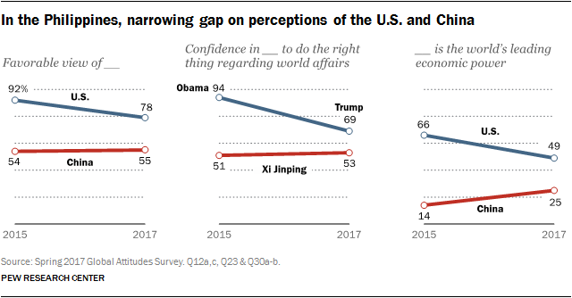

Turkey’s relationship with the United States is perhaps even further damaged. Structural security shifts, alongside personal differences, have created a broader divergence in strategic goals. Erdogan, like Duterte, was popularly elected as president, and has regularly made authoritarian and anti-democratic moves to consolidate power. Erdogan accuses the United States of backing the 2016 coup, which incited chaos throughout the nation, and saw the military mobilize into the nation’s largest cities. Turkey holds positions in stark contrast to the United States in both Syria and Libya. While the United States has sought to empower and enable Kurdish fighters, as allies in the fight against ISIL and Bashar Al-Assad; Erdogan views the Kurdish militias as terrorists, and a primary threat.
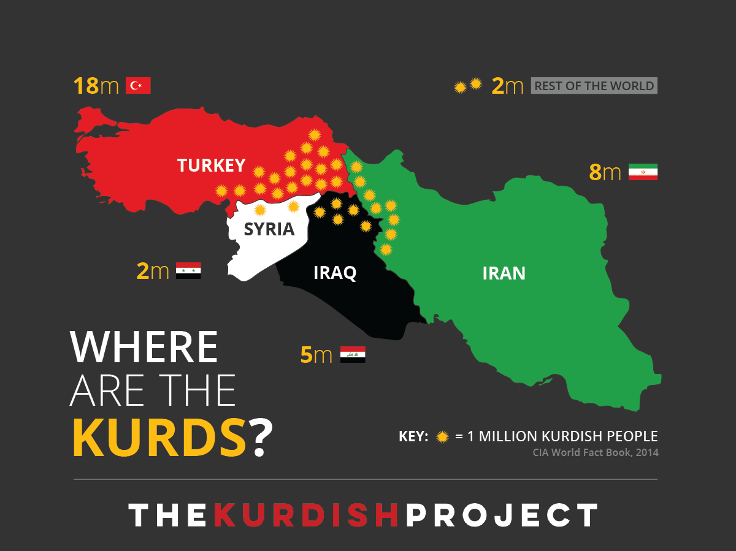

Ethnic Kurds are a minority in Turkey, Syria, Iraq, Iran, and Armenia. The United States allied with Kurdish militias in the ground campaign against ISIL. Support for a Kurdish state has largely been subdued by Turkey, which views the Peshmerga and PKK as terrorist organizations. The Kurds have a difficult history as an oppressed minority group within the region.
Despite sharing a long history of security cooperation, the perception of a shared threat has eroded ties between the United States and Turkey. In fact, Turkey is pivoting to greater military ties with Russia. Turkey’s purchase of the S-400 missile defense system was an inflection point in bilateral relations, causing the United States to remove Turkey from the F-35 acquisition list, which in turn influenced Turkey to pursue ordering Russian fighters. Both nations once stood jointly in opposition to the Soviet Union, however, currently Turkey is warming relations with Russia. Russia has increased its power projection in the region through troop deployments in Syria, the re-establishment of a naval base at Tartus, influence in the Caucuses and its annexation of Crimea.
While the presence of a painful colonial past, and volatile leadership were overcome in the Philippines, by the emergence of a shared threat, the path to repairing relations with Turkey appears more fraught. Turkey and the United States do not share a perceived military threat which could be used to unify their missions. The United States has prioritized the defeat of ISIL, the removal of Assad, and the combatting of Russian influence within the region. Erdogan view’s the United States support of Kurdish groups, utilized in the campaign against ISIL, as hostile to Turkish security; Turkey is home to a significant Kurdish minority. Turkey also supports an opposing coalition in Libya and has expressed concern over the lasting presence of American troops in the Middle-East. Turkey has yet to view expanding Russian influence within their region as a substantive threat.
The deterioration of the American – Turkish alliance is in part a reflection of NATO’s success. The immense pressure NATO was able to impose on the USSR eventually contributed to the collapse of the shared threat. Turkey has now emerged as a regional military leader, superior in capability to its neighbors, except Israel. Turkey has maintained relatively amicable relations with Israel, despite popular disapproval, as both nations supported Azerbaijan in the recent conflict in Nagorno-Karabakh. As the threat landscape within Turkey’s region evolves, Erdogan will inevitably adapt his alliances, partnerships, and relations.
Historic military ties tend to have immense inertia, and breaking relations can be very costly. Continued alignment with Russia, particularly on military terms, would likely mean the further imposition of sanctions by the United States, and potentially a broader European coalition. Turkey maintains a fleet of almost exclusively American fighter jets and aircraft, a situation that amplifies the impact of military sanctions. Breaking form the United States and NATO would impose a significant technical, financial, and operational burden on the Turkish military. Reflecting this reality, Turkey has amplified their calls for domestically produced weapons systems, though the current financial climate is ill suited to such expensive endeavors.
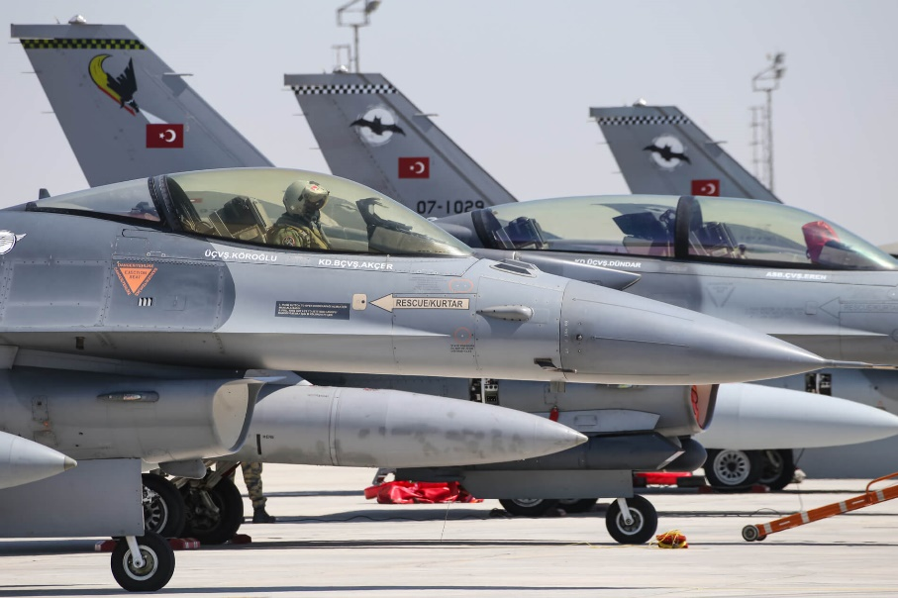
Turkey operates 241 F-16’s, as well as 48 F-4E’s. Turkey’s NATO membership has provided access to American and European military equipment. Initiating a shift towards domestically produced, or Russian / Chinese produced material would be both expensive and time consuming. The purchase of the S-400 system from Russia, as well as the 2016 attempted coup, have significantly damaged intra-military relations between Turkey and the United States.

Turkey holds disputes with Greece, and other neighbors, surrounding territorial and sea claims, as well as over the control of Cyprus. With such a diverse array of security concerns, and serving as the land bridge between Europe, Eurasia and the Middle-East, Turkey’s international relations are inherently complex. The emergence of a new shared threat within the region could prove to realign Turkey and the United States. The personal relationship between Erdogan and the United States remains a key inhibitor, although popular support for the United States sharply following the 2003 invasion of Iraq. The United States withdrawal from Afghanistan, potential departure from Iraq, and diminishing presence in Syria present potential opportunities for improved public support within Turkey. While public support for the United States has remained under 30% since the beginning of the 2003 Iraq war, the end to American participation in regional conflicts may increase favorability.
The return of American forces to the Philippines highlighted the role of public support and shared security threats in repairing military ties. Even as Duterte and Erdogan verbally lash out against the United States, the protective security of official military ties, the benefits of increased trade, and popular support provide sufficient motives to overcome personal differences. If the United States seeks to repair its relationship with Turkey, they may learn from experiences in the Philippines, employing a strategy based on weathering tempestuous rulers, focusing on shared security threats and bolstering popular opinion.

