A Disaster Risk Management Analysis of California’s 2020 Wildfires Season:
The impact of Covid, Climate, and Uncertainty.

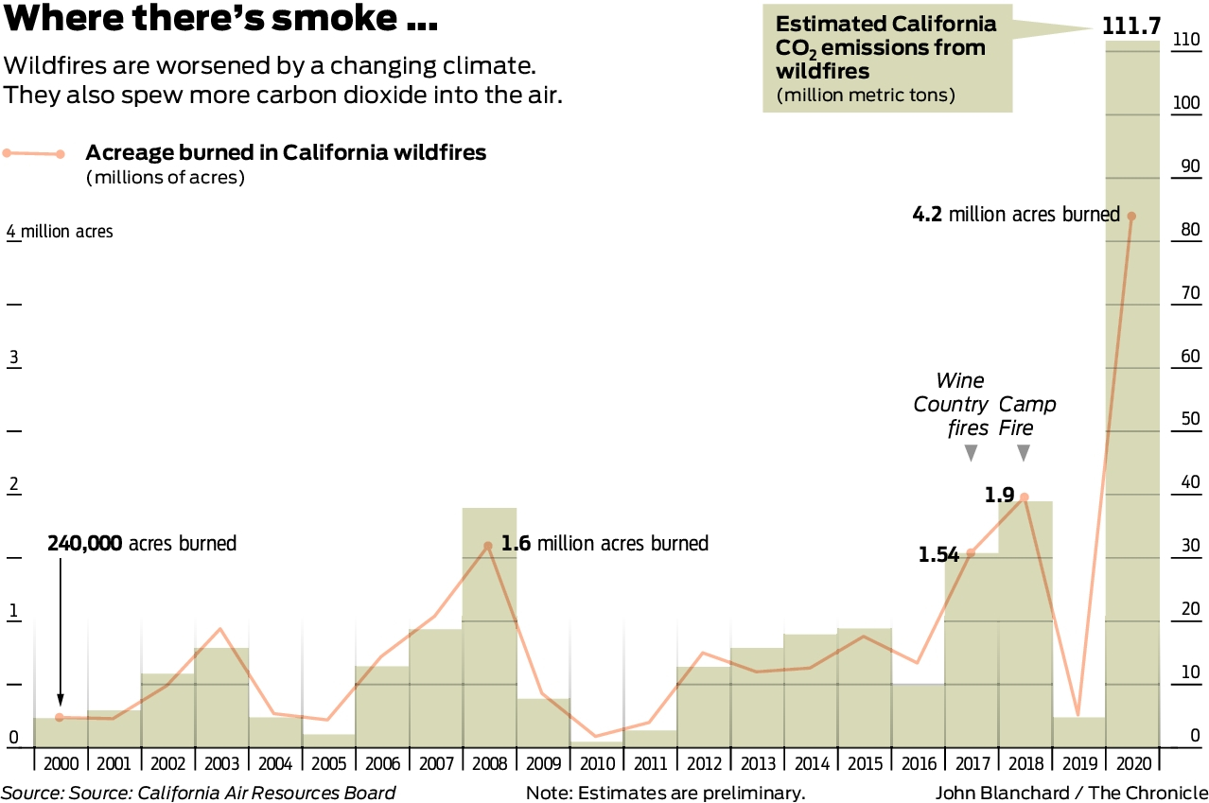

Abstract
This paper will explore the existing risk drivers, exposure, vulnerabilities and outcomes of California’s wildfires. An investigation of the policy challenges revealed the impact of Covid-19, as the state failed to adapt at pace under the pandemic’s uncertainty. Covid-19 brought harsh impacts on the economically disadvantaged; exposing local limitations. California suffered proportionately compared to neighboring states, but misrepresentations by Governor Newsom were seized upon early by the media. The media effectively used publicly generated data to provide transparency, with voters eventually holding the governor accountable in an unsuccessful recall. The ongoing recovery effort, buoyed by access to federal funds and a resurgent economy position California well, allowing for budget increases and the application of adapted best practices following the lessons learned throughout 2020. California continues to rely heavily on a mitigation strategy focused on fuel clearing, an effort which requires considerably more effort and attention.
Introduction
Thesis Statement
Failure to adapt risk reduction strategies to Covid-19 and the increasing risk profile presented by urban expansion and climate change resulted in California’s devastating 2020 wildfires.
California experienced the most severe and expansive wildfires in their modern history in 2020, an unprecedented disaster which overwhelmed California’s response efforts. Human action and resultant environmental changes have both expanded and amplified the risk of wildfires in California. Although California has faced the threat of fires throughout its history, modern fire management policies insulate the state from disaster most years. Urban expansion, climate change, insufficient prescribed burns, and the outbreak of Covid-19 served as compounding risk drivers, while failures to adapt and prepare resulted in California’s most expansive wildfire season in modern history.
Background
The summer wildfire season in California predates the state's modern development, with the state's climate and natural fauna creating an environment prone to expansive and prolonged fires. When limited in scale California’s wildfires provide ecological benefits, clearing underbrush, increasing the water supply, and killing vegetative diseases. (CAL-FIRE 5425) Wildfires frequently occur in a cyclical pattern, as underbrush burnt in one season is unavailable to fuel fires the following season, notably the modest 2019 season should have served as a strong warning of an increased risk profile for 2020. The cyclical nature of wildfires and the trend of more expansive wildfires are represented in Figure 1. (Sullivan) The general increase in total acreage burned within California demonstrates the dual independent threats posed by both an expansion of total risk and an increase in risk exposure as rural lands are developed.
Climate change, grossly exacerbated by human action, has greatly increased the risk posed by wildfires within California. The length and increasing propensity for drought conditions, stronger summer winds, and desertification of major water resources constitute broad policy failures to reduce the risk posed by wildfires. While global emissions drive climate change, California has failed to adapt at pace to these new climate realities. Figure’s 2 and 3 demonstrate the rise in California’s average temperature over recent years, and the expansion of drought conditions throughout the prone summer months.
The arrival of Governor Gavin Newsom in 2019 represented a continued focus on wildfire mitigation, response, and recovery. Following the expansive 2017 and 2018 wildfire seasons Newsom ran on a Democratic platform, which strongly featured climate change adaptation and forest management. Newsom called for an $96 million increase into the state forestry management service (CAL-FIRE), and strongly promoted increased federal collaboration and mitigation strategies including increased prescribed burns, also known as “fuel clearing”. Wildfires continuously generate political attention due to their yearly occurrence and their broad impact on the state. The burden and responsibility for reducing the risk and impact of wildfires falls primarily on the state and local governments. Wildfires require immense, coordinated, politically driven action, as they are simultaneously a disaster management issue, health security issue, and economic issue.
Strong economic growth in California, as displayed in Figure 4, has allowed for regular increases to the CAL-FIRE budget. The ability to increase spending on CAL-FIRE was however negated by the state’s constrictive response to Covid-19. Despite numerous campaign promises to increase wildfire prevention funding, over $150 million was cut from CAL-FIRE in 2020 as Covid-19 sparked economic and political turbulence throughout the world. (Rodd) Existing funding was undercut by an inability to fully deploy the existing workforce as state mandates kept many employees at home. Newsom further overstated the efforts of CAL-FIRE, declaring that 90,000 acres of fuel land were cleared, while official state data showed less than 12,000 acres. Despite California’s strong economic growth, an increase in available funding, and political promises for improved mitigation, the state entered the 2020 season severely underprepared. (Tribune) California failed to adjust to the emergent Covid-19 pandemic, as lockdowns and workforce shortages emerged as new risk drivers, inhibiting previously successful mitigation methods. The reduction of CAL-FIRE’s budget further reflects the perpetual funding gap, even as wildfire prevention targets remain low. CAL-FIRE has never cleared more than 64,000-acres of fuel in a year, well short of the 100,000-acre annual target, and even further behind the 1,00,000 acres proposed by state environmental scientists. (Rodd)
Risk Drivers
California experiences two regular sets of risk drivers, however, with Covid-19’s arrival in 2020, the total risk profile was elevated to an unprecedented level. In recent years, California has experienced elevating risk due to climate change; increased temperatures, prolonged droughts, and stronger winds, all of which contribute to the risk of destructive wildfires. California’s rural expansion further increases the risk of destruction, as the state's growing population settles increasingly prone areas and strays further from the state’s preventative and protective infrastructure. As shown in Figure 5, much of California’s rural expansion has occurred in the central zone, residents are moving to increasingly at-risk areas in search of affordable housing. The resultant trade off secures cheaper housing, as prices are discounted by increased risk.
Exposure
Californians’ exposure to risk increases with rural development, particularly in the forested central zone. California and the surrounding states are all exposed to the risk of wildfires, as winds push smoke and fire seamlessly across state borders. While California faces risk from many disasters, the exposure to smoke affects the entire populace, while earthquakes and droughts are more acute. The population and businesses of the state and region are uniformly exposed to the medical and economic impact of smoke. Exposure to the fires themselves is more limited, as demonstrated in Figure 7, with the central valley’s facing the highest levels of exposure. Within these regions exposure remains variable, factors such as proximity to water sources and construction materials greatly impact risk exposure at the local and individual levels. Physical structures such as homes, buildings, and infrastructure are immobile, and face greater levels of exposure; however, resilient construction techniques offer greater protection.
The increasing rates of climate change and rural expansion yield a growing exposure to wildfires. Californians are exposed to the direct flames of wildfires but also the smoke, decreased air quality presents an immediate health threat, and broadens the exposed population well beyond the fires themselves. Figure 6 shows the dispersed impact of wildfires, as smoke covers the entire south-western United States. Residents throughout the region are exposed directly to the health effects of the wildfires smoke, as well as to the economic and environmental impacts. California’s exposure to wildfire’s is consistently increasing due to globally driven climate change. While rural residents near forested areas face the highest levels of exposure, satellite imagery reveals the true scope of the region’s exposure to wildfires, further signifying the need for broad and inclusive solutions.
Vulnerability
The presence of Covid-19 greatly exacerbated California’s vulnerability to wildfires. As a result of uncertainty, the CAL-FIRE budget was cut and controlled burns were severely reduced. The combination of smoke and Covid-19 presented an elevated risk to individual health beyond historical norms, as both vectors primarily impact the respiratory system. Nearly 2.5 million Californian’s have been diagnosed with asthma, a plight only worsened by smoke and a global pandemic. (CDC)
Residents in vulnerable areas were asked to evacuate, an issue further complicated by Covid-19. California continued to operate “congregate centers” under state control, though many residents were housed in nearby hotels and motels. (Rocha) The use of congregate shelters further exposed those seeking shelter to Covid-19, as large gatherings within confined areas were a known risk factor at the time. Precautions were taken, including a reduction in occupancy, health screenings, and revised dining procedures. The revised health procedures with congregate centers outline the acknowledged risks assumed by the state, wildfires and Covid-19 required antipodal responses. The ability to relocate to hotels was determined at the municipal level, and many poorer communities were not able to provide this option, instead exposing residents to increased risk of Covid-19. Less affluent individuals and communities experienced greater vulnerability during the 2020 wildfire season as traditional evacuation centers presented new forms of risk.
Fragility
California’s fragile systems were exposed in 2020. California’s evacuation strategy was historically effective, only to be exposed to the emergent threat of Covid-19. Prescribed burdens faced man-power limitations for the first time as a result of Covid-19 and subsequent state policies. Economically disadvantaged communities were exposed to greater risk as they evacuated, and the fragility of evacuation funding was exposed. Each of these three systems suffered unique and unprecedented challenges related to Covid-19. Covid-19 exposed new limitations and flaws, as well as an inability to rapidly adapt government strategies and policies.
Prescribed burns are immensely labor intensive, and Covid-19 exposed the fragility of the current wildfire prevention strategy. Arriving in the United States in February of 2020, Covid-19 produced a wave of emergency policy responses, including broad restrictions on labor. Consequently, only 12,000 acres were cleared in advance of the 2020 wildfire season. (Rodd) The reliance on labor intensive prevention methods exposed the fragility of California’s current disaster risk management (DRM) strategy.
The fragility of California’s municipality-led evacuation and shelter strategy was also exposed. The flexibility of local level response, a typically effective strategy, was unable to adequately protect evacuees from the emergent threat of Covid-19. (Rocha) Wealth disparities at the municipal level generated unequal protection, as residents of wealthy cities were provided with separate rooms in hotels, while the relatively economically fragile communities suffered greater risk exposure in congregate centers. California’s economically fragile communities faced greater risk exposure, a consequence of an evacuation strategy which failed to adequately adapt to Covid-19 or provide equally for the state's most fragile populations.
Susceptibility
California’s risk drivers create an increasingly susceptible environment, as the impacts of climate change and rural development have outpaced efforts to mitigate and respond to wildfires. Endemically susceptible, California’s inability to meet prescribed burn targets leaves the state exposed to an increased probability of destructive wildfires. Longer droughts, prolonged elevated temperatures, and stronger winds have increased the length of California’s wildfire season. This leaves less time to execute the state's labor-intensive mitigation strategy centered around prescribed burns. Climate change is exacerbating the state's deficit of fuel clearing by elongating the fire season.
California remains susceptible to considerable economic damage as a result of rural development. The increased development of California’s central forests increases the susceptibility of economic losses, as both structures and businesses are threatened. California is also susceptible to economic and health damages posed by smoke and air pollution stemming from fires in neighboring states. Wildfires in Oregon, Nevada, Idaho, and Colorado have all contributed to California’s air pollution. Figure 8 demonstrates the regional threat of smoke and air pollution, to which California is susceptible. Distinct from fragility, California’s susceptibility is driven by enduring factors which have existed and will only grow in coming years. California will be increasingly susceptible to wildfires, structure loss, economic loss, and the general danger posed by wildfires.
Risk
Wildfires, as a natural hazard, are occurring at higher rates in California, due to risk factors such as climate change and rural development. California is broadly exposed as fires occur in a broader geographic range and the resultant smoke spreads throughout the region. The development of wildfire prone rural areas and underlying health conditions contribute to an elevated vulnerability. The risk of wildfires escalating to natural disasters increases alongside each of these factors. California’s capacity to mitigate risk is in relative decline, as a result of increased exposure, vulnerability, fragility, and susceptibility. Rural development exposes a growing segment of the population, health and economic conditions leave many vulnerable, the fragility of the fire mitigation workforce presents a new challenge, and California remains susceptible to climate change and regional wildfires. The risk of natural disaster is following an upward trajectory, an unfortunate reality encapsulated well in Figure 1.
Historical Comparison
Wildfires have wrecked an increasing amount of damage on California in recent years, with Figure 1 representing their growing impact on the state's forests. The arrival of Covid introduced new challenges in 2020, disrupting historically successful measures such as evacuations and relocations. The inability to clear sufficient fuel in the lead up to the 2020 season represented a historical low-point, with only 12,000 acres cleared, compared to the decade average of 70,000. (CALFIRE 5425) While the total acreage burned by wildfires in 2020 was a record high, the wildfires did not destroy as many structures as 2018. (Smith) The loss of structures reflects the state to which CAL-FIRE is overwhelmed, as firefighting efforts place greater focus on the preservation of structures as opposed to undeveloped forest. Recent years have seen historically unprecedented destruction in terms of total structures, as viewable in Figure 9. The release of smoke, which rises proportionately with acres burned, reached an all-time high in 2020, with over 110 million metric tons of C02 released into the atmosphere, Figure 10 reflects the rise in CO2 and corresponding threat to public health. (Blanchard) These increasingly worrisome trends reflect existing climactic and development drivers as well as the impact of Covid-19 and subsequent political miscalculations.
California experiences wildfires at similar levels to many surrounding states, with regional wildfires from the 2020 season represented in Figure 11. Oregon, the most direct peer comparison for California, suffered similarly unprecedented wildfires in 2020. This reflects the regional failures in mitigation and response, signifying a broader inability to adapt to Covid-19 and subsequent impacts. Political failures in California were not isolated, as Oregon similarly failed to reach prescribed burn targets. Oregon experienced the most destructive wildfires in recent history in 2020, an outlier year illustrated in Figure 12. Historical and regional comparisons reflect the shared fates of the United States western states and the worrying trend of increased wildfire hazards.
Discussion & Findings
Response
The scale and destruction of California’s 2020 wildfires reflect long term vulnerabilities, the emergence of Covid-19, and political miscalculations. While little was known about Covid-19 in the early months of the pandemic, workforce regulations issued by Gov. Newsom greatly reduced the preventative fuel clearing measures and paved the way for a costly wildfire season. This decision prioritized the risks of Covid-19, which were not fully understood at the time; with most criticisms relying on the benefit of hindsight. While the states mitigation efforts were largely politicized, the result of an increasingly politically divided national populace, response efforts received broader approval.
CAL-FIRE is a leading model for effective fire management policies, but struggles to operate at the necessary scale due to budgetary limitations and an inability to match the pace of risk drivers such as climate change. CAL-FIRE and the national government conduct effective operations, including clearing fuel, creating resilient infrastructure, informing the public, and disseminating best practices to residents for wildfire resilience. The inability to rapidly adapt procedures for evacuations and wildfire mitigation reflect the level of uncertainty posed by Covid-19, and the enormous burden placed on CAL-FIRE to adapt on short notice in an incomplete information environment. The inability of NGOs or neighboring states to develop and implement more effective policies reflects the immense challenges faced in 2020.
Recovery
California’s response to the fires was strong, deploying all of the state's 14,000 firefighters, and eventually expanding to a surge capacity of 18,500 in the fall. Increasing the workforce by 32% in three months, from August to October, California responded admirably when required, despite failing in the early months of the pandemic, under high levels of uncertainty. The recovery effort is ongoing; however, California’s strong economic growth and the abundance of federal relief funding open ample opportunities for a robust and resilient recovery. The scale of 2020’s wildfires will also provide a form of protection in the coming years, as burned forest is less susceptible in the immediate future, providing hope for a multi-year recovery unperturbed by similarly destructive seasons.
Public Policy Challenges
California’s long history of wildfires propelled CAL-FIRE towards its present status, where it serves as a model for best practices in fire mitigation and response. CAL-FIRE executes projects effectively and with a high degree of professionalism, the increasing devastation incurred by wildfires is regularly the result of a rapidly changing climate, practical financial limitations, geographic impediments, and the arrival of Covid-19. California is a global leader in environmental conservation and the reduction of greenhouse gases; however, global CO2 emissions are the primary drivers of global warming. Rural development, the result of a growing population and California’s dynamic economic growth is similarly difficult to curtail.
Policy failures contributed to the devastation experienced in California’s 2020 wildfires, a reduction in mitigation spending and accepted risks surrounding Covid-19 left the state poorly prepared. The reduction in CAL-FIRE spending and Covid-19 are directly linked, the high levels of uncertainty and panic surrounding Covid-19 in the early months of the pandemic in the United States froze spending in many states. Under scientific and medical uncertainties Newsom opted to insulate firefighters from the risk of contracting Covid-19 through restrictive executive orders. The consequence of this decision was the gross reduction in fuel clearing.
The housing of evacuees and provision of services to affected residents was conducted in a relatively uncoordinated manner given California’s history and expertise. Evacuation efforts and the provision of basic efforts were led by municipal governments, with the assistance of NGOs such as the Red Cross. While the state government leads efforts on fuel clearing and data collection, evacuations and the provision of food and shelter are responsibilities largely left to cities and NGOs. Local governments and NGOs lack the financial resources of the state government, leading to an unequal distribution of resources. This is best epitomized by the availability of hotels for evacuee housing, a relative luxury, practical only for the wealthiest municipalities. Responding in real time to wildfires and a concurrent pandemic presents immense public policy challenges, as high-stakes decisions must be made quickly, often with incomplete information. California responded well at the state level, particularly when considering the lack of information regarding Covid-19, this is reflected in the lack of a superior response among neighboring states.
Stakeholders
With expansive exposure due to smoke and uncontrolled fires, the entire population of California are stakeholders; due to their economic and health interests. Smoke from fires within California, and those across the region, negatively impacts air quality, increasing health risks and negatively impacting businesses. Smoke from fires can spoil agricultural crops and halt tourism, while damages and business losses are picked up by insurers and the state. (Marcus) The residents of California are the primary stakeholders in the 2020 wildfires, as they suffer the most during the disaster and inevitably hold power over political actions taken towards DRM. Thom Porter, the director of CAL-FIRE, was appointed to his post in January of 2018, replacing the previous governor’s appointee. (Gabbert) Statewide gubernatorial elections have a strong impact on CAL-FIRE leadership, as citizens of California express their political power, a right befitting their status as the primary stakeholders.
Governor Newsom, Thom Porter, and the state government are secondary stakeholders. As citizens of California, they face the direct impact of wildfires, and through their positions of power they play a vital role in the state’s mitigation, response, and recovery efforts. With this influence comes the responsibility for effective action and communication.
Outside of government, NGOs such as the Red Cross play a supplementary role in responding to California’s wildfires. The Red Cross was primarily active during the response phase of the disaster, as the organization is ill equipped to lead mitigation efforts such as the clearing of fuel, implementation of resilient building codes or creation of resilient infrastructure. The Red Cross provided 932,000 meals, provided for over 450,000 nights worth of hotel stays, and conducted over 60,000 home health contacts. (Red Cross) The Red Cross was active throughout the region, and coordinated a vast network of affiliated charities and organizations.
Private industries within California rely heavily on effective government led wildfire mitigation, response, and recovery. Agriculture is particularly susceptible, due to the expansive farming tracts and fragility of crops such as wine grapes, a $43 billion industry annually. California, famous for its high-end wineries, requires stable climatic and atmospheric conditions; increased temperatures, smoke pollution, and flames can destroy wineries crops. (Marcus) Wildfires can also damage soils and the loss of a crop represents significant losses due to the time invested in raising a mature field. The damage caused by smoke is not immediately evident, as vintners may not perceive damage for months, creating systematic uncertainty which negatively impacts their businesses. (Alley) Private enterprises hold considerable economic interests within the state, with wildfires posing the greatest risk to agriculture and tourism.
Accountability
Accountability for the 2020 wildfires expansion into a regional disaster fell primarily on Governor Newsom. Due to inaccuracies regarding the number of completed CAL-FIRE mitigation projects and a gross overstatement of the total acres of fuel cleared in advance of the 2020 season Newsom saw a relatively steep decline in his approval rating, as reflected in Figure 13. The California legislature experiences a similar decline in approval, however approval ratings for both stabilized at a floor of approximately 50%. California’s state politics, and voter base, which lean heavily Democrat make absolute accountability difficult, as many elected officials hold safe party seats, making successful challenges from Republicans unlikely. Californians’ theoretical ability to hold elected officials accountable is high, due to the strength of the United States democratic voting system, however the realities of California’s state politics cripple the probability of large-scale political turnover. The elimination of term limits for state assembly members further reduced the ability of voters to hold representatives accountable, visible in the turnover trendline in Figure 15.
Newsom’s misrepresentation of the facts regarding the mitigation efforts, and subsequent decline in approval rating served as fuel for a state-wide recall effort. Newsom would eventually defeat the recall attempt in the September 2021 election, garnering 62% of the vote. Elevated voter turnout for an off-year election, 58%, suggests an increase in accountability. (Baldassare) Newsom’s misrepresentation and missteps produced a recall election and the relatively high voter turnout, demonstrating the growing importance of disaster risk management to voters.
California’s powerful Democratic party has controlled state government at all levels since 2010. Following 2012 changes to the state constitution, term limits for members of the state assembly were removed, decreasing the probability and instances of turnover. This presents a major obstacle to political accountability, as citizens' ability to remove legislators is diminished. This impedes the public policy process, as existing policies are entrenched by incumbent politicians. The contrasting trends of increasingly devastating wildfires and diminished turnover are reflected in Figure 15.
Role of the Media & Transparency
As CAL-FIRE is a state run agency with regular and standardized reporting requirements, transparent data for state mitigation and response efforts are readily accessible at regular intervals. This data transparency was used by state and local media to hold Governor Newsom accountable for hyperbolic and inaccurate statements regarding the state’s fuel reduction projects. NPR California and CapRadio led independent investigative efforts which exposed Newsom’s false statements. (Rodd) Both new organizations relied on CAL-FIRE data reported in May of 2020 on mitigation efforts that occurred before the start of the 2020 wildfire season. The resultant media coverage negatively impacted Newsom’s approval ratings. The $150 million reduction in CAL-FIRE’s budget further eroded public support. (Rodd) Local, state, and national media organizations utilized publicly generated data to effectively provide transparency to Californians. This transparency eventually manifested itself in the gubernatorial recall vote and political accountability for Newsom.
Conclusion
California suffered historically expansive wildfires in 2020, propelled by climate change, rural development, and a limited ability to adapt to Covid-19. CAL-FIRE, typically a paragon of best practices, operates effectively but fails to meet the necessarily lofty fuel clearing targets, a situation which was further exacerbated by the health uncertainties posed by Covid-19. The accelerated growth of risk drivers, current mitigation deficit, and external factors suggest continued high levels of vulnerability for California.
Effective public policy options for mitigation, response, and recovery are in effect, but remain underfunded, particularly in the case of fuel clearing. Covid-19 exposed existing fragilities within California’s response procedures, offering less for the economically disadvantaged. The threats to health, social cohesion, and economies generate a wide assortment of stakeholders, many of which work collaboratively and effectively. CAL-FIRE was able to ramp up employment to surge capacity, and NGOs integrated well with local municipalities to provide care and housing. The media utilized transparent state data to hold Governor Newsom accountable, allowing voters to demand accountability and call for increased action. As the risk and exposure to wildfires increases, funding and political will must regain lost ground if California is to properly manage the risk posed by wildfires and protect its residents.

Works Cited
“2020 Wildfires.” Www.redcross.org, www.redcross.org/about-us/our-work/disaster-relief/wildfire-relief/2020-wildfires.html#:~:text=California. Accessed 11 Dec. 2021. (Red Cross)

Alberts, Elizabeth Claire. “'Off the Chart': CO2 from California Fires Dwarf State's Fossil Fuel Emissions.” Mongabay Environmental News, Mongabay , 18 Sept. 2020, https://news.mongabay.com/2020/09/off-the-chart-co2-from-california-fires-dwarf-states-fossil-fuel-emissions/. (Alberts)

‌ Alley, Lynn. “Can Grapes Be Protected from Wildfire Smoke Taint? | Wine Spectator.” Wine Spectator, Wine Spectator, 6 Mar. 2020, www.winespectator.com/articles/could-vintners-protect-grapes-from-wildfire-smoke. Accessed 11 Dec. 2021.

Aschwanden, Christie, et al. “Why California's Wildfires Are so Destructive, in 5 Charts.” FiveThirtyEight, FiveThirtyEight, 16 Nov. 2018, https://fivethirtyeight.com/features/why-californias-wildfires-are-so-destructive-in-5-charts/. (Aschwanden)

Baldassare, Mark. “The Recall Election and California’s Political Future.” Public Policy Institue of California, Public Policy Institute of California, www.ppic.org/blog/the-recall-election-and-californias-political-future/. Accessed 8 Dec. 2021.
Beckwith, Jack, et al. “When and Where Are Wildfires Most Common in the U.S.?” The Data Face, The Data Face, Nov. 2018, thedataface.com/2018/11/public-health/wildfires-map. Accessed 11 Nov. 2021. (Beckwith, Jack, et al.)

Bureau of Economic Activity. “GDP by State.” Bea.gov, United States Government, www.bea.gov/data/gdp/gdp-state. Accessed 7 Dec. 2021. (BEA)

Blanchard, John “California Wildfires Emitted a Huge Amount of Carbon Dioxide This Year. How Much of a Problem Is That?” San Francisco Chronicle, 4 Dec. 2020, www.sfchronicle.com/california-wildfires/article/California-wildfires-emitted-a-huge-amount-of-15775044.php. (Blanchard)

‌ Board, Editoral. “Q&a with Gavin Newsom, Candidate for California Governor.” San Diego Tribune, San Diego Tribune, 5 Oct. 2018, www.sandiegouniontribune.com/opinion/commentary/sd-utbg-governor-candidate-newsom-20181005-htmlstory.html. Accessed 4 Dec. 2021. (Tribune)

CALFIRE. “Benefits of Fire.” CAL-FIRE, 2019. (CALFIRE 5425)

“Death Toll Rises in US as Wildfires Continue in West Coast States.” BBC Americas, BBC, 13 Nov. 2020, www.bbc.com/news/world-us-canada-54130785. Accessed 19 Nov. 2021. (BBC)

Duginski, Paul. “Dry Conditions in California Continue to Expand, but Will March Rains Dent the Drought?” Los Angeles Times, Los Angeles Times, 13 Mar. 2020, https://www.latimes.com/california/story/2020-03-12/dry-conditions-in-california-continue-to-expand-but-will-march-rains-dent-the-drought. (Duginski)

‌ Gabbert, Bill. “CAL FIRE Director Thom Porter Announces His Retirement.” Wildfire Today, Wildfire Today, 15 Nov. 2021, wildfiretoday.com/tag/thom-porter/. Accessed 8 Dec. 2021. (Gabbert)
‌ Isaacs-Thomas, Isabella. “California's Catastrophic Wildfires in 3 Charts.” PBS, Public Broadcasting Service, 14 Sept. 2020, https://www.pbs.org/newshour/science/californias-catastrophic-wildfires-in-3-charts. (Isaacs-Thomas)
Marcus, Kim, and Mitch Frank. “Wildfire Scorches Thousands of Acres in Sonoma Wine Country | Wine Spectator.” Wine Spectator, Wine Spectator, 24 Oct. 2019, www.winespectator.com/articles/wildfire-scorches-10-000-acres-in-sonoma-wine-country. Accessed 11 Dec. 2021. (Marcus)

Most Recent Asthma State Data. 2019, www.cdc.gov/asthma/most_recent_data_states.htm. (CDC)

‌Moving East: California’s Population Growth. California State Association of Counties, www.counties.org/csac-bulletin-article/moving-east-californias-population-growth. (Counties)
‌ Rocha, Damon Arthur and Angelaydet. “‘A Culture Shift’: How California Evacuation Centers Are Dealing with Fires and COVID-19.” USA TODAY, www.usatoday.com/story/news/nation/2020/08/21/california-evacuation-centers-wildfires-amid-coronavirus/3408582001/. (Rocha)

Rodd, Scott. “Newsom Misled the Public about Wildfire Prevention Efforts Ahead of Worst Fire Season on Record.” CapRadio, Capital Public Radio: University of Sacramento , 23 June 2021, https://www.capradio.org/articles/2021/06/23/newsom-misled-the-public-about-wildfire-prevention-efforts-ahead-of-worst-fire-season-on-record/. (Rodd)

Smith, Joshua. “Newsom’s $1-Billion Wildfire Plan Favors Logging over Homeowners, Critics Say.” LA Times, San Diego Tribune, 30 Apr. 2021, www.latimes.com/environment/story/2021-04-30/newsom-california-wildfire-plan. Accessed 7 Dec. 2021. (Smith)

Sullivan, Brian K. “Record Number of Acres Have Burned in California with Worst of Season Still to Come.” BloombergQuint, Bloomberg Inc. , 9 Sept. 2020, https://www.bloombergquint.com/onweb/california-s-worst-wildfire-season-ever-is-about-to-get-uglier. (Sullivan)

Urrutia, Doris Elin. “Satellites Monitor California Wildfires from Space .” Space.com, Space, 10 Sept. 2020, https://www.space.com/california-wildfires-satellite-photos-september-2020.html. (Urrutia)
“Welcome to the California State Assembly | Assembly Internet.” Www.assembly.ca.gov, www.assembly.ca.gov/. (Assembly)
‌

‌

Appendix
Figure 1: (Isaacs-Thomas)
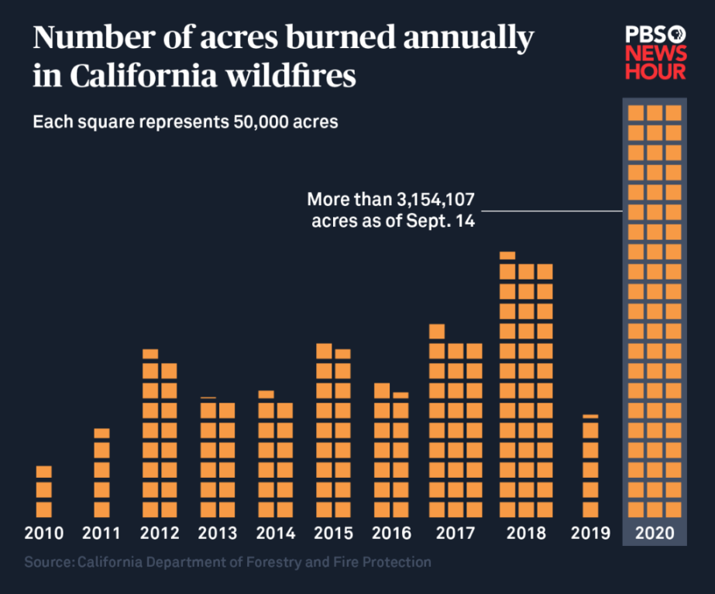

Figure 2: (Ascwanden)
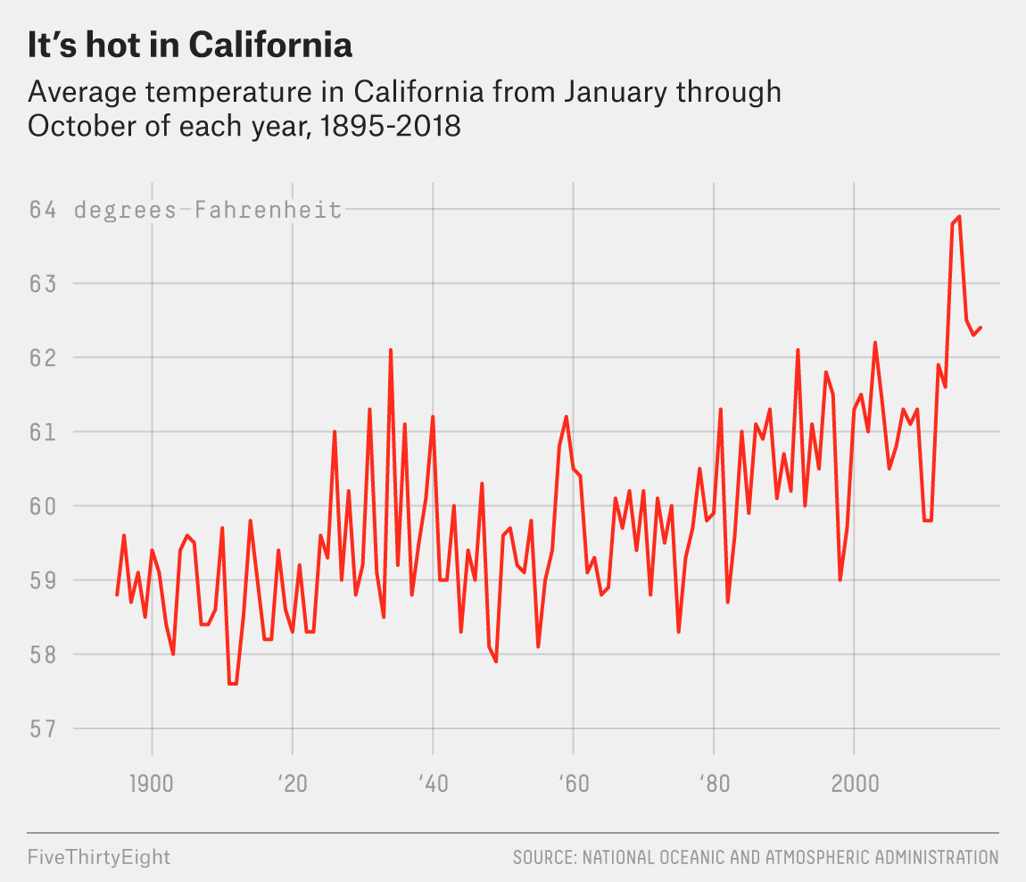

Figure 3: (Duginski)
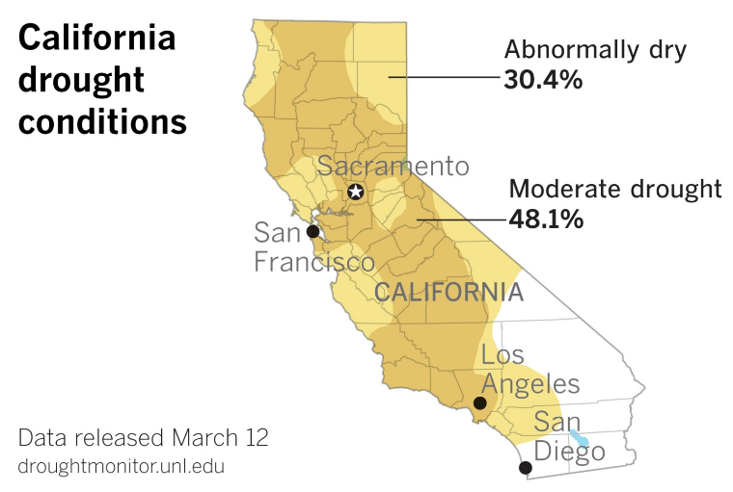
Figure 4: (BEA)
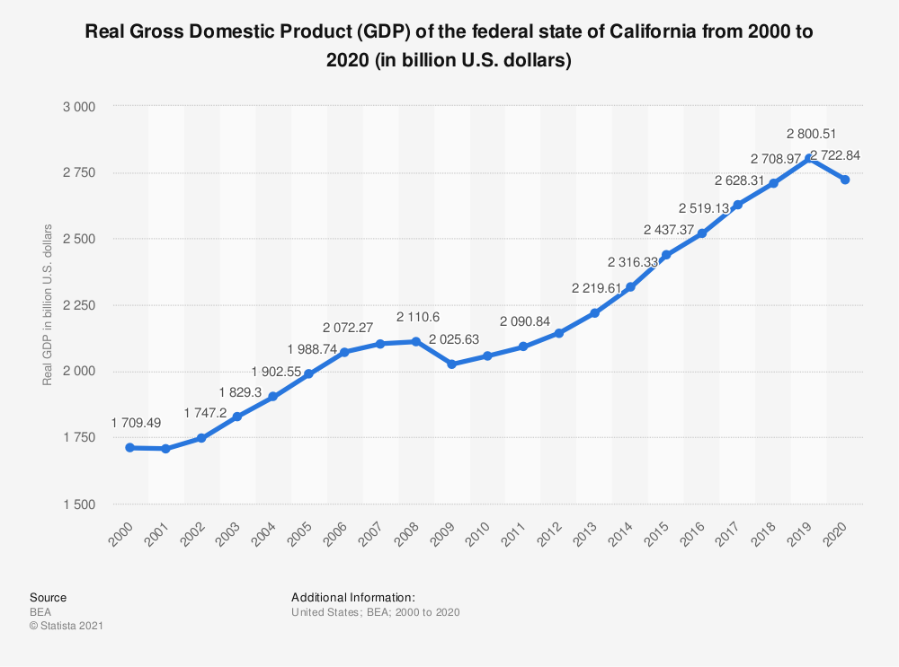

Figure 5: (Counties)
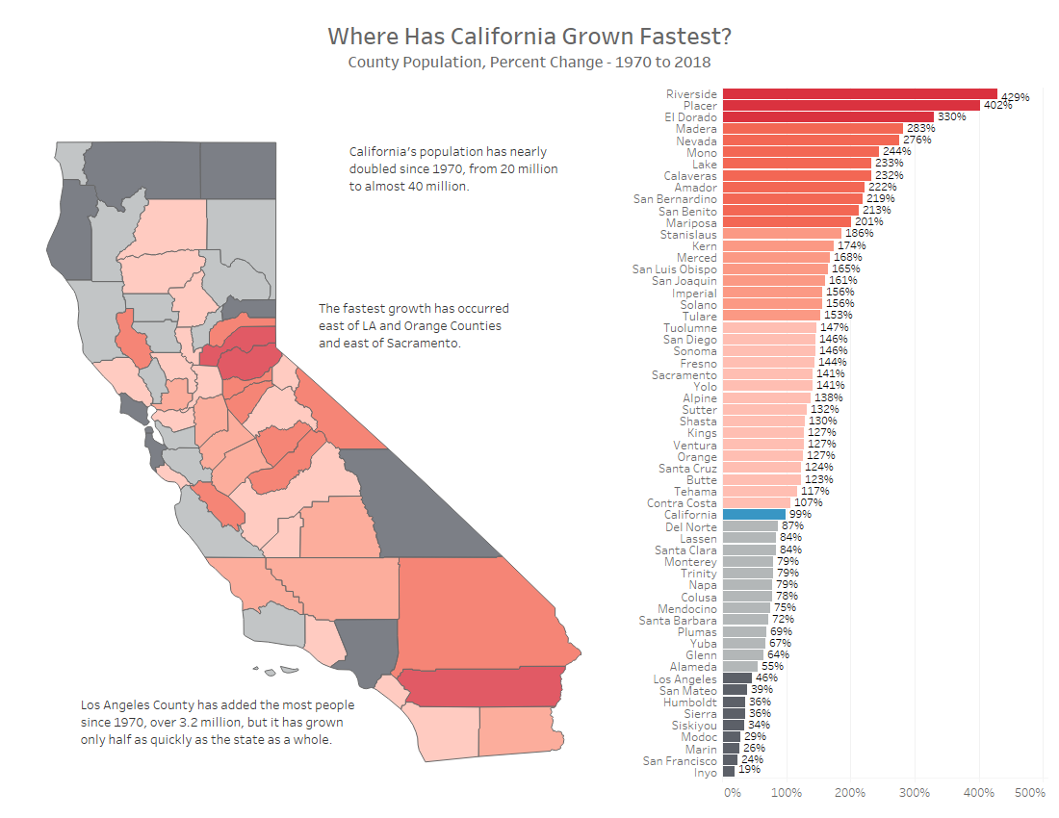
Figure 6: (Urrutia)
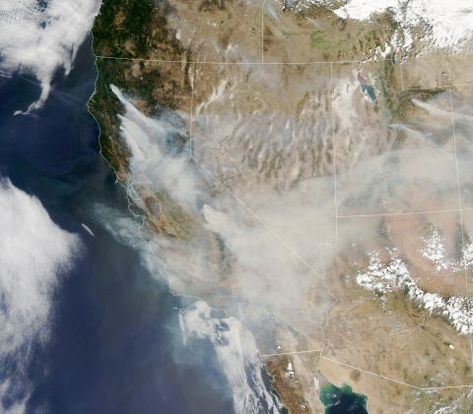
Figure 7: (Alberts)
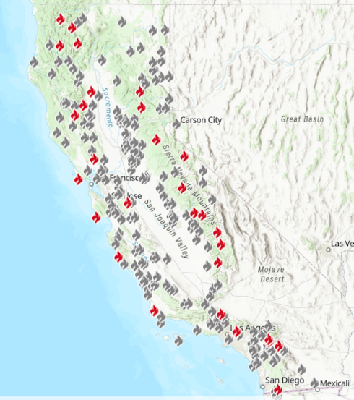

Figure 8: (Beckwith, Jack, et al.)
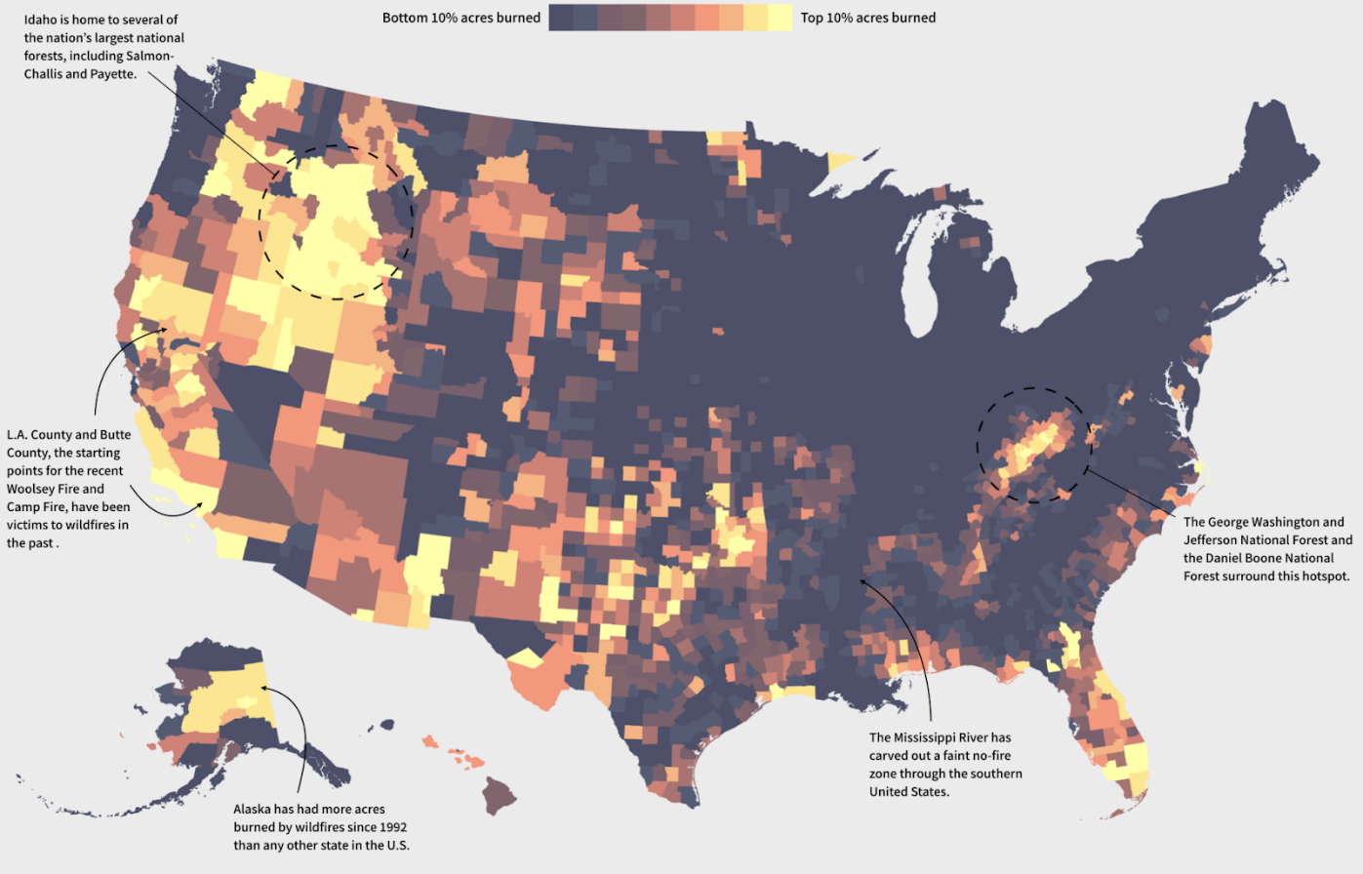

Figure 9: (Smith)
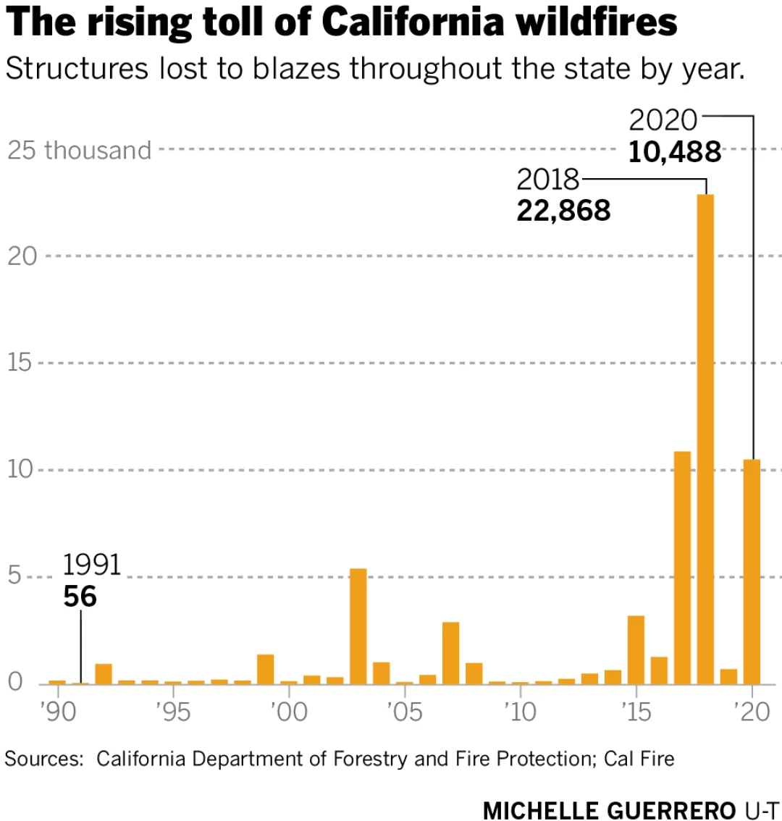

Figure 10: (Blanchard)

Figure 11: (BBC)
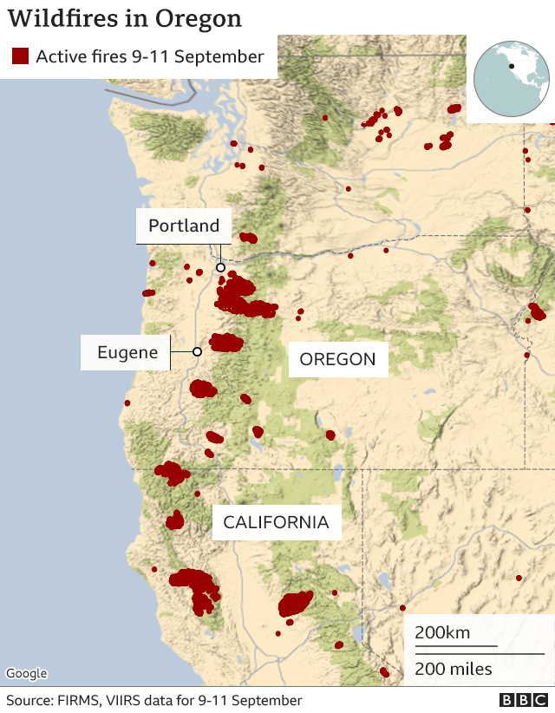
Figure 12: (Gabbert)
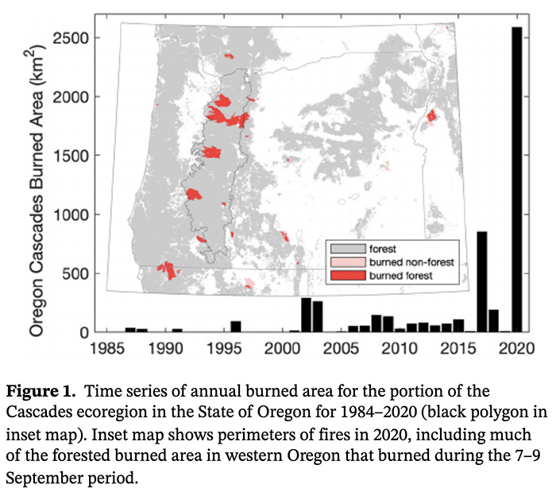
Figure 13: (Baldassare)
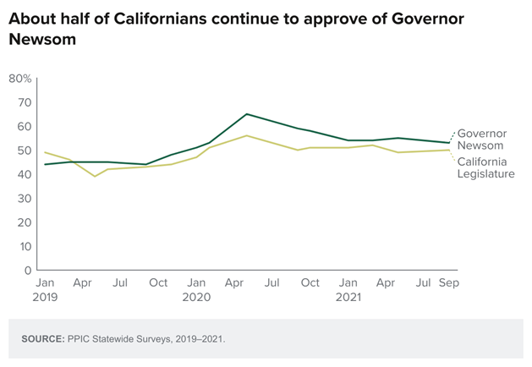

Figure 14: (Assembly)
