Vibrio cholerae: A Global Health Security Challenge for the United States

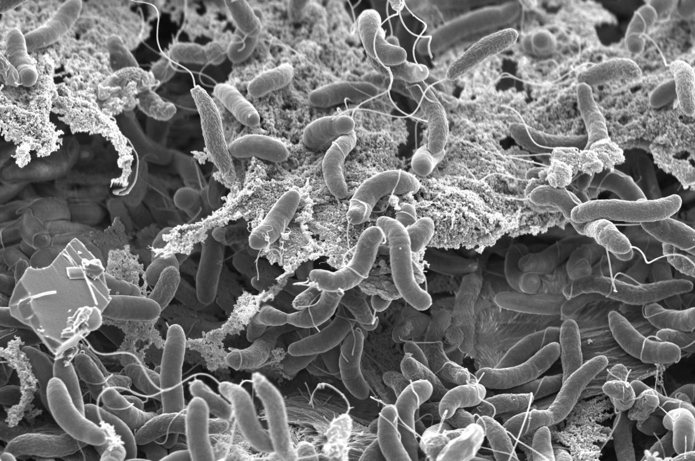

By: Gregory Ayres
Editor: Gustavo Perez
According to the WHO, Vibrio cholerae is an acute diarrheal disease, which if left untreated can kill victims through dehydration within hours. (WHO1) The bacterium Vibrio cholerae is present naturally within multiple aquatic environments, but most major outbreaks are the result of improper sanitation and the contamination of water supplies. The colloquial term cholera refers to multiple proteobacteria which contain the cholera toxin, however only two serogroups O-1 and O-139 have generated outbreaks in humans. Cholera has subsided as a health threat in most developed nations in recent decades, though seven global outbreaks have occurred, spanning from the early 1800’s to the 1970’s. (NCBI1) When Cholera is detected, oral rehydration solutions provide a relatively simple treatment, while in more severe cases the use of intravenous solutions is required. Cholera vaccines have existed with increasing effectiveness since 1855, with three modern vaccines being deployed to hot-spot areas by the WHO, at a per unit cost ranging from $.10 to $3.99, with prices largely dependent on transportation costs. (BMC1)
Cholera is primarily present today due to compromised water and sanitation infrastructure in developing nations, and through the contamination of seafood along the Gulf Coast of the United States. The United States faces these dual threats and requires a coordinated response to address both potential sources of outbreak. The risk posed by migrants or travelers from endemic areas remains the most prominent, as cases derived from shellfish remain comparatively rare, as noted in Figure 1. While only two variants of Vibrio cholerae are known to cause widespread human infection, the broader family of bacterium should be monitored and controlled to identify and prevent an expansion of the existing threat. A more expansive contamination of seafood along the Gulf Coast and the contamination of water systems through the arrival of foreign travelers constitute the primary threats to the U.S. population. The consequences of a broader outbreak, while relatively easy to address medically, could be hindered by confusion over symptoms and unequal access to healthcare. Cholera poses a serious medical threat, rapidly dehydrating victims; and misdiagnosing the ailment or avoiding care could prove fatal.
As cholera is highly transmissible once within a water supply the consequences of flawed health security policy are dire. Globally, 2021 estimates for the total number of cases reach as high as 4 million, with an estimate of up to 143,000 deaths. (WHO1) Both threats represent genuine challenges to U.S. global health security goals, with the arrival of infected travelers, or mutated strains of cholera serving as the vehicles of transmission. Accordingly, the travel and movement of persons, seafood, and water to the United States will require increased monitoring. To compound these efforts, both direct and complementary actions should be taken abroad, to reduce the global burden of cholerae, and the potential for import to the United States. While domestic cases remain low, global cases remain in the millions annually, necessitating a proactive global health security strategy from the United States in an increasingly globalized world. Figures 2,3 & 4. demonstrate the high levels of travel and migration to the United States from nations currently suffering cholera outbreaks.
Multiple lines of effort are required to improve the existing cholerae health security parameters. An expansion of initiatives both domestically and abroad are required to increase the United States cholera security. The following lines of effort are proposed:

Lines of Effort
- Secure global funding for international tracking and research of cholera and related bacteria.
- Increase domestic screening and testing protocols for international travel and cargo.
- Heighten domestic testing and security of water infrastructure.
- Heighten research into existing Gulf Coast cholera strains and promote public awareness.
The current threat landscape necessitates a global approach, applied through the proposed lines of effort. Global funding, primarily donations from developed nations, are required to fund the tracking and research of cholera in endemic areas. Each of the nations with existing cholera outbreaks require substantial financial and scientific assistance, foreign contributions are required to supplement these developing economies; given that each endemic nation has a per capita GDP below $2,200. (WB1) The Global Task Force on Cholera Control (GTFCC) was created by the World Health Organization in 2013, with a projected annual budget of $1 million per year, but this budget would need to be increased to reduce the international threat and mitigate the United States exposure to international travel and cargo. (WHO2) Increased funding and scientific support to the GTFCC will require global support and application. Fostering the elimination of cholera in developing nations reduces the risk of bacterial travel, via both humans and cargo, reducing the threat globally and directly for the U.S. Engaging in stricter travel and transportation controls will better insulate the U.S. from foreign sourced cholera. The global threat environment, magnified by increased global trade and travel, must be met by the U.S. at its borders. Eliminating cholera at its source and preventing its spread to the U.S. demonstrate the global nature of the threat and highlight the need for a global health security strategy.
- Secure global funding for international tracking and research of cholera and related bacteria.
The WHO estimates as many as 4 million cases of cholera occur each year, a figure which far exceeds the reported cases, represented in Figure 2. (WHO1) This reflects the lack of global reporting and tracking infrastructure. With over 102,684 reported cases, Nigeria is experiencing a distinct rise in both cholera cases and deaths, a situation largely attributed to the compounding effect of COVID-19. Local incidences of cholera, and the potential for international spread are impeded by the lack of domestic funding and insufficient foreign funding. The International Federation of Red Cross and Red Crescent Societies are the primary international actors addressing cholera within Nigeria, their programs $303,187 annual budget has failed to limit local spread and the threat of international spread. (IFRCRCS) The reporting of cases, creation of sanitary water infrastructure, and monitoring of cholera bacterium are all underfunded within Nigeria, a nation without the requisite resources to prevent the spread of disease within a globalized world. The United States presently provides 62.5% of Nigeria’s international aid, and only 12% of this foreign aid directly targets health security. (Relief) A dramatic increase in funding is required to assist Nigeria in building and maintaining a cholera reporting and tracking network as well as sanitary water infrastructure. Re-focusing aid provides a meaningful pathway to address the global health security challenge posed by Cholera, as health security funding remains low at 12%.
Bangladesh is similarly plagued by cholera, as the GTFCC suspects considerable underreporting of cholera cases due to insufficient reporting and tracking infrastructure. (WHO2) Bangladesh experiences endemic cholera cases, frequently triggered by seasonal flooding which overwhelms the poor or often non-existent water infrastructure. Bangladesh represents an ideal case for an increase in international funding for cholera prevention and monitoring. Oral vaccines represent the most practical and cost-efficient solution to cholera in Bangladesh and the Bill and Melinda Gates Foundation is funding an international program for the domestic production of oral vaccines within Bangladesh. (WHO1) This effort will however require continued funding, with estimates indicating a minimum of 5 years until sufficient levels of inoculation are reached. Bangladesh reflects the positive impact global actors such as the United States and U.S. based private institutions can have on cholera abroad. Oral vaccines represent considerable economies, as they are 10 times cheaper than hospital visits. (BMC1) The cost-effectiveness of oral vaccines presents the opportunity for U.S. sourced loans. Up-front costs could be covered by the United States with short-term health and healthcare benefits providing the requisite savings for Bangladesh’s repayment.
Bangladesh and Nigeria are representative of the perils of cholera. High case numbers in densely populated urban and agricultural areas amplify the risk of more dangerous bacterial evolution. At present only two strains of cholera have presented a significant threat to humans, but the development of a new or more dangerous serogroup would greatly increase the risk factor globally. Securing global funding for the increased study, tracking, prevention, and reporting of cholera cases in endemic areas, such as Nigeria and Bangladesh, represents a first line of defense for U.S. health security. The reduction of the risk posed by cholera abroad translates to the reduced risk of more dangerous serotypes or the importation of the present threat.
- Increase domestic screening and testing protocols for international travel and cargo.
The threat of cholera posed to the United States from foreign travelers and imports is substantial. Cholera is able to thrive in water and can travel on hosts including uncooked seafood, dogs, and humans. (CFSPH) These items should be thoroughly screened and tested upon arrival to the United States. International points of entry, including both cargo facilities and travel hubs should increase screening measures for cholera. As foreign ports transmitting cargo and persons to the United States far outnumber domestic points of entry, the burden for inspection falls greatly upon the United States. The arrival of the O-139 variant from Asia via contaminated cargo or individuals would compound the current domestic threat posed to the United States. Bacterial cultures, PCR tests, stool samples and a “dip-stick” test are all viable methods for detecting cholera. Of these, the “dip-stick” test provides the highest specificity, 100%, and can be conducted in as little as two hours. (NCBI2) Following a 2010 cholera outbreak in Haiti, the International Maritime Organization instituted advanced protocols for the recycling of ballast waters in container ships, following the transport of contaminated water from Port au Prince to the Gulf Coast in the ballasts of ships. (USNLM) Increased testing of port waters, cargo, and passengers are vital for insulating the United States from global sources of cholera. The two surges in cases shown in Figure 1 reflect the comparatively larger threat of importing cholera from abroad. The 2005 peak is related to damaged infrastructure as a result of Hurricane Katrina, while the impact of Haiti’s 2010 earthquake and subsequent travel to the United States resulted in a proportionally larger domestic case load. The collection and dissemination of more advanced cholera statistics at an international level, as previously proposed, would allow the United States to more effectively screen incoming individuals and cargo for cholera.
- Heighten domestic testing and security of water infrastructure.
Compromised water infrastructure from Hurricane Katrina was the source of the 2005 cholera outbreak along the Gulf Coast. With climate change driving rising global temperatures and increasingly frequent hurricanes the threat posed by cholera from compromised infrastructure remains high. Increasing the security and resiliency of domestic infrastructure would provide greater health security to vulnerable populations in hurricane prone areas. Bangladesh represents the worst-case scenario, where limited infrastructure is regularly overwhelmed and seasonal flooding creates an endemic cholera situation. In order to mitigate the rising sea levels, rising temperatures, and more frequent hurricanes the United States will need to increase the security and resilience of water infrastructure and corresponding facilities. (WHO2) Increasing the physical resiliency and strength of existing infrastructure is a costly endeavor, and can be aided economically in the near term with more expansive testing of water supplies.
The United States has largely evaded the 7th cholera epidemic, through the implementation of comprehensive and secure water infrastructure. This infrastructure must be maintained and improved to meet the growing threats posed by globalization and climate change. The poisoning of residents in Flint, Michigan, the outbreak of cryptosporadium in 1993, and Giardia lambila in 2011 demonstrate the necessity of secure, resilient, and regularly tested water infrastructure. (USNLM)
- Heighten research into existing Gulf Coast cholera strains and promote public awareness.
While the United States experiences far fewer cases of cholera as a developed nation, there is a substantial impact on communities which do suffer outbreaks. During the 2011 cholera outbreak in Apalachicola Bay in Franklin County, Florida, caused by oysters, the local fishing industry was shut down, depressing the entire local economy. (Adlerstein) Joint efforts by the public and private sector are required to better inform the vulnerable public about the risk of cholera from seafood and more extensively study the existing strains in the Gulf of Mexico.
Increasing funding into Gulf Coast cholera strains is both a global and public health security necessity. The National Science Foundation, Centre for Disease Control, and the Food and Drug Administration need to increase research intensity for the detection of cholera in seafood products, to identify bacterial changes, and to assist the local wildlife and fish services in testing vulnerable waters. A comprehensive cholera testing initiative is required, encompassing the testing of both seafood products and seawater. The recommended three-prong approach will allow local officials to find the root cause of potential outbreaks and to ensure that the local officials can adequately support public health. The first joint action is to precisely identify which seafood products are carrying cholera, allowing for further investigation, and if necessary, the removal from local markets. Testing local bacteria samples will also be required, as detecting mutations or the arrival of new serotypes could amplify the existing threat landscape.

The local fish and wildlife service will be required to test the water regularly, providing protection to the local fishing industry, local communities, and economies. Improved federal funding facilitates the identification of cholera strains, and allows scientists to identify and map genetic and geographic changes.
A public awareness campaign will be required at the state level, educating the population on the risks posed by contaminated and uncooked seafood. A comprehensive campaign would include announcements, public postings, social media posts, and word of mouth from medical professionals and business establishments. A public-private partnership would assure maximum exposure and education, allowing for multiple strategies across multiple target audiences. Public awareness campaigns provide cost-effective benefits at the local level and can serve as templates for global outbreaks.
Conclusion
Each proposed line of effort contributes towards a desired end state with a significantly lower cholera risk profile. The two major risk sources, domestic incidences of cholera within the Gulf Coast and the arrival of cholera from endemic areas are addressed in accordance with a comprehensive global health security strategy for the United States. Global actors are solicited to deploy financial resources, technological capacity, and share information, all to reduce the global risk of cholera, a bacterium which has spread to cause global epidemics six times previously. These policies promote a U.S. strategy of comprehensive resilience, incorporating the prevention of cholera globally, the mitigation of cholera’s ability to move globally, and an ability to recover from local outbreaks.
The desired end state promotes health security across the United States and particularly along the Gulf Coast. In accordance with the proposed lines of effort, the population of the United States is better protected from outbreaks of cholera, the arrival of foreign bacteria, and better informed and equipped to handle local outbreaks. Economic security is provided for the fishing, tourism, and hospitality industries along the Gulf Coast, as cholera outbreaks threaten these industries' direct livelihood. Increased screening further protects foreigners and foreign goods, as point of entry tests can detect cholera during the 1-5 day incubation period, vastly decreasing the possibility of hospitalizations. International efforts with increased foreign funding and technical aid further promote public health globally.
The promoted end state delivers not only improved health security for the United States but also to nations suffering endemic cholera or those underreporting cases. Limiting this 7th cholera epidemic to the existing scale, and preventing a global outbreak will require a global effort. Internationally sourced funding for vaccines, infrastructure, and reporting have proven cost effective and serve as progressive avenues for both developed and developing nations to mutually pursue global health security. The desired end state, resulting from the proposed lines of effort, will deliver greater economic stability, infrastructure resiliency, and health outcomes for not only residents of the United States but at-risk populations globally.

Works Cited
Adhikari, Sandesh. "Worldwide Drop in Cholera Cases - WHO." Public Health Notes. 19 Jan. 2020. Web. 02 Dec. 2021. (WHO3)
Adlerstein, David. "Oyster Outbreak a First for Mild Strain of Cholera." Food Safety News. 12 May 2011. Web. 02 Dec. 2021. (Alderstein)
Batalova, Jeanne, and Kira Monin. "Refugees and Asylees in the United States." Migrationpolicy.org. Migration Policy Institute, 08 July 2021. Web. 03 Dec. 2021. (Migration)
Chakraborty, Subhra, Munirul Alam, Heather M Scobie, and David A Sack. "Adaptation of a Simple Dipstick Test for Detection of Vibrio Cholerae O1 and O139 in Environmental Water." Frontiers in Microbiology. Frontiers Media S.A., 29 Oct. 2013. Web. 02 Dec. 2021. (NCBI2)
"Cholera Worldwide Overview." European Centre for Disease Prevention and Control. 26 Nov. 2021. Web. 02 Dec. 2021. (ECDC)
"Cholera." Cholera: Fast Facts. The Center for Food Security and Public Health at Iowa State University, June 2006. Web. 02 Dec. 2021.(CFSPH)
"Cholera." World Health Organization. World Health Organization. Web. 02 Dec. 2021. (WHO1)
"GDP per Capita (current US$)." World Bank Data. Web. 02 Dec. 2021. (WB1)
Ilboudo, Patrick G., and Jean-Bernard Le Gargasson. "Delivery Cost Analysis of a Reactive Mass Cholera Vaccination Campaign: A Case Study of Shanchol™ Vaccine Use in Lake Chilwa, Malawi." BMC Infectious Diseases. BioMed Central, 19 Dec. 2017. Web. 03 Dec. 2021. (BMC1)
Loharikar, A., A E Newton, S. Stroika, M. Freeman, K D Greene, M B Parsons, C. Bopp, D. Talkington, E D Mintz, and B E Mahon. "Cholera in the United States, 2001-2011: A Reflection of Patterns of Global Epidemiology and Travel." Epidemiology and Infection. U.S. National Library of Medicine, Mar. 2015. Web. 03 Dec. 2021. (USNLM)
Lopez, Anna Lena, Maria Liza Antoinette Gonzales, Josephine G Aldaba, and G Balakrish Nair. "Killed Oral Cholera Vaccines: History, Development and Implementation Challenges." Therapeutic Advances in Vaccines. Sept. 2014. Web. 02 Dec. 2021. (NCBI1)
"Nigeria Humanitarian Funding Overview." United Nations Office for the Coordination of Humanitarian Affairs. Web. 02 Dec. 2021. (Relief)
"Nigeria: Cholera Epidemic 2021." IFRC Go. The International Federation of Red Cross and Red Crescent Societies, 18 Aug. 2021. Web. 02 Dec. 2021. (IFRCRCS)
"Revitalizing the Global Task Force on Cholera Control (GTFCC)." WHO. Web. 3 Dec. 2021. (WHO2)
Appendix
Figure 1: Number of Cholera by Year, and by Source 2001-2011 (USNLM)
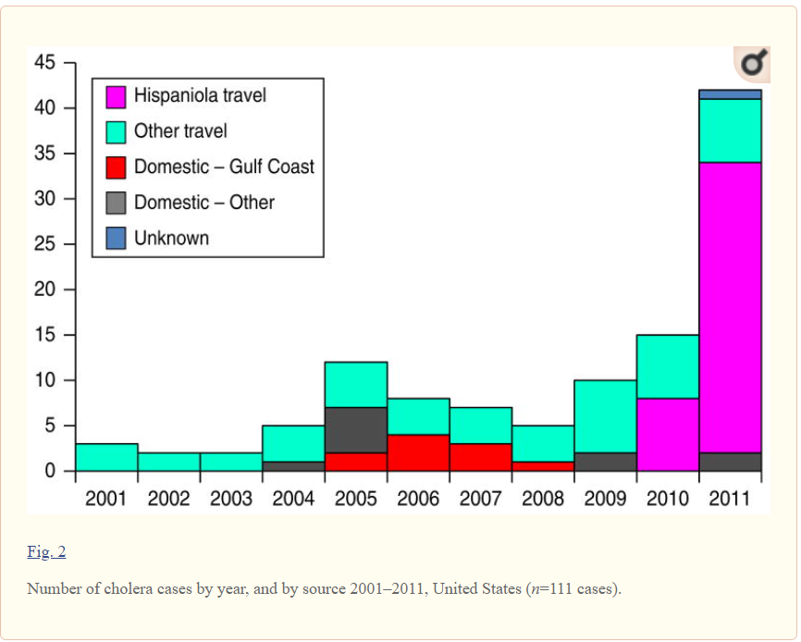
Year
# Of Cases

Figure 2: (ECDC)
 | 2021 Cases | 2021 Deaths
Benin | 259 | 9
Cameroon | 104 | 9
Democratic Republic of the Congo | 5,950 | 117
Ethiopia | 561 | 10
Kenya | 14 | 0
Mali | 11 | 4
Mozambique | 5,872 | 35
Niger | 5,469 | 159
Nigeria | 102,684 | 3,519
Togo | 17 | 4
Africa (total) | 120,941 | 3,862
Afghanistan | 900 | *
Bangladesh | 116,340 | 2
India | 1,751 | 1
Nepal | 885 | 4
Yemen | 1,5863 | 3
Asia (total) | 135,739 | 12
Global Total | 256,680 | 3,874
*= Unreported
Figure 3: 2020 Refugee’s to United States (Migration)
Nation | Total | % Of US refugees
Democratic Republic of the Congo | 2,868 | 24.3
Myanmar | 2,115 | 17.9
Ukraine | 1,927 | 16.3
Afghanistan | 604 | 5.1
Iraq | 537 | 4.5
Figure 4: Annual Cholera Cases and Mortality reported by year, 1989-2018 Globally (CFSPH)
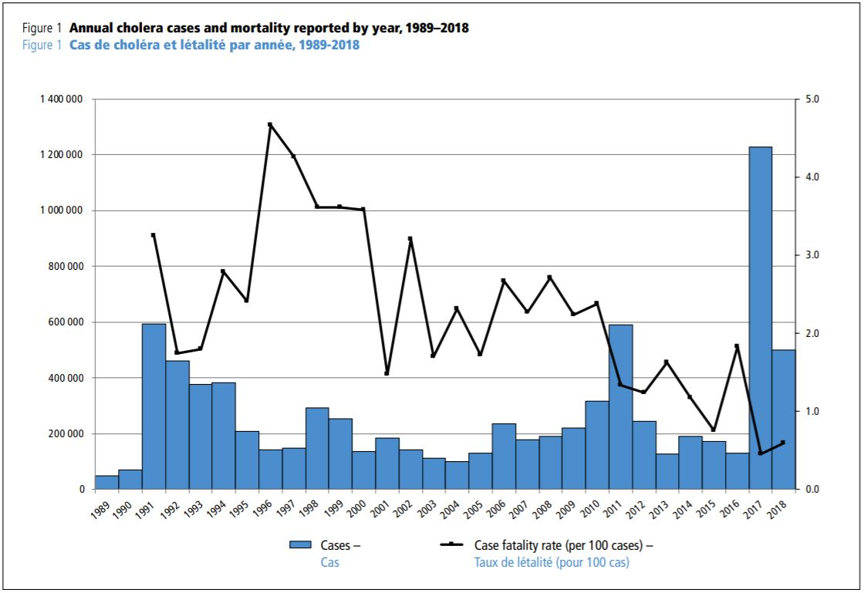
Year

