Operation El Dorado Canyon
Global Affairs with Greg Ayres

Who: Ali Chanaa, Verena Chanaa, Yasir Shraydi, Musbah Eter
What: Plastic Explosive IED attack on American military personnel
When: 5 April 1986 (0145 Local Time C.E.T) (0045 Zulu)
Where: West Berlin-Haupstrabe (La BELLE), West Germany
Why: Libyan Intelligence service plots retaliatory attacks on U.S. military personnel over territorial disputes and military engagements in the Gulf of Sidra.


The United States and East German governments successfully completed the intelligence cycle in 9 days, with cooperative diplomatic relations, shared loss, and intensive surveillance emblematic of the cold war contributing to the rapid retaliatory strikes of Operation El Dorado Canyon.
- Planning & Direction: Following the Libyan campaign of terror in the 1980’s significant intelligence assets were allocated to protect Americans and U.S. interests abroad. Libyan actions in years prior and “Libya Cable” prompt increased surveillance of Libyan intelligence assets.
    - (1981) Libya fired SAMs at an E-2C Hawkeye and F-14A’s in the Gulf of Sidra
    - (1981) Libyan assassination attempt and bombing of US Embassy (Khartoum) thwarted
    - (1985) Libyan attacks on European airports (Rome) (Vienna)
    - (1986) Gulf of Sidra II, Libyan’s fire on US Navy planes and vessels.
- Collection: US IC intercepts cable traffic from the Libyan Embassy in East Berlin. Transmission reportedly incriminates senior Libyan officials including Muammar al-Qaddafi.

- Processing: While operational details remain limited, the intelligence was processed, vetted, and approved. During German reunification Stasi intelligence would later verify the link between Libyan intelligence operative Musbah Eter, the Libyan Embassy, and the bombing of the La BELLE.

- Analysis & Production: The United States analyzed and produced final intelligence products based off of cable intercepts (SIGINT), Qaddafi’s speeches (HUMINT), and Libya’s recent aggression towards U.S. Naval assets in the Mediterranean. The attack was also in form with recent Libyan terrorist attacks; the attack on Rome involved similar plastic explosives and Libyan diplomatic staff.

- Dissemination: Intelligence which originated within the U.S. was, to a degree, shared with NATO allies in the United Kingdom, France, Spain, and Italy. Flight paths for Operation El Dorado Canyon had to be altered as France was “unconvinced” by U.S. intelligence, complicating flight plans. As FB-111’s were rerouted around Spain, with KC-10 tanker support, the sorties position was compromised by Maltese Defense Forces, whom alerted Libya in advance of the strike.
The U.S. IC moved rapidly to collect, process, analyze, and disseminate intelligence following the bombing that killed 2 U.S. Army Sergeants in Berlin. Given Libya’s direct attacks and sponsor of terrorism in the weeks and years prior the U.S. was astutely focused on Libyan operations within Europe. The loss of 2 Americans abroad and purported boasting amongst Libyan diplomatic staff likely expedited the intelligence process. Unfortunately, France did not fully concur with the final disseminated U.S. report, a potentially grave decision, as one FB-111 was lost during the mission, potentially due to the advance warning provided by Malta. The inclusion of allied or partner nations further complicates the intelligence cycle, and conclusions offered by one nation are not necessarily definitive within a coalition.

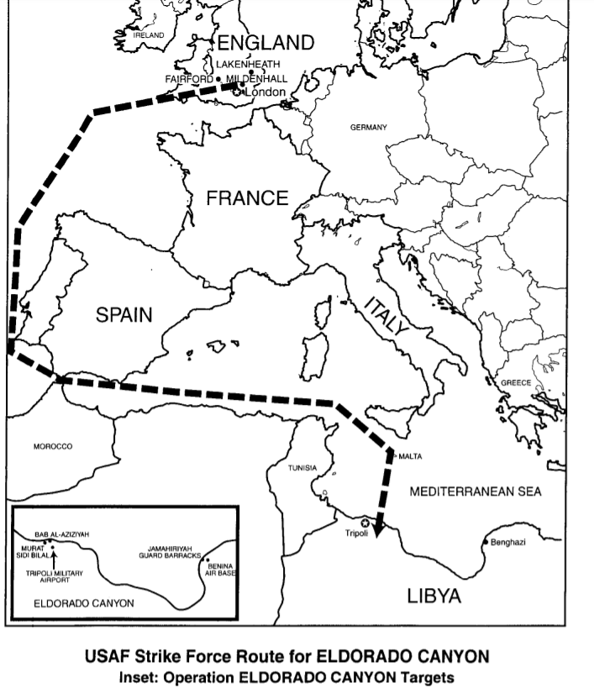
Imagery Credit: Judy G. Endicott
https://media.defense.gov/2012/Aug/23/2001330097/-1/-1/0/Op%20El%20Dorado%20Canyon.pdf

