Evolution and Pursuit of Cyber Security in Brazil
GS-23
MAGA: Cohort 10 Capstone

Gregory Ayres & Gabriela Jarquin

Sponsors:

Roya Gordon, Accenture

Alexander Perez-Pons, Florida International University

Executive Summary

This paper exclusively provides recommended government actions, which drive and empower non-governmental stakeholders towards greater societal cyber resilience. Analyzing Brazil’s cybersecurity legislative efforts informs perspective and identifies strategic weaknesses and limitations. An assessment of the strategic and organizational landscape guides recommended creation of a singular coordinating entity. Evaluating the current threat environment exposes the over-militarization of Brazil’s cyber strategy, neglecting the domestically driven threat actors. Incorporating global best practices from successful peers guides recommendations to resolve Brazil’s immature cyber strategy. Government action recommendations address Brazil's need for strategic realignment and structural reorganization. Seven final recommendations are made, scoring for pace, cost, and impact, informing relevant stakeholders.

Table of Contents

Executive Summary………………………………………………………………2
Table of Contents…………………………………………………………………3
Introduction……………………………………………………………………….4
Purpose……………………………………………………………………………4-5
What is Cyber Security…………………………………………………...………5-9
Stakeholders…………………………………………………………………..…..9-10
Resilience……..…………………………………………………………………..11-12
Evolution of Cyber Legislation/Strategies…………………………..……………12-22
Cyber Threat Environment……………………………………..…………………23-26
Cyber Strategy Snapshot………………………………………………….………26-27
Strategic Recommendations……………………………………………..………..28-38
Comparative Analysis…………………………………………………………….38-40
Appendix………………………………………………………………………….41-50
Works Cited…………………………………………………………..…………..51-58

Introduction
Brazil’s outsized exposure to cyber threats is a product of haphazard policy changes, flawed organizational structuring, and political instability. Brazil transitioned poorly through multiple cyber strategies while failing to reduce cyber-attacks, cyber-crime, and overall exposure. The complicated web of organizations which regulate, govern, prosecute, and defend Brazil’s cyber space have failed to produce meaningful progress towards securitization or cyber resilience. Cyber resilience represents the ideal strategic focus: insulating stakeholders from the turbulent nature of Brazilian politics. Resilient institutions have stable and clear jurisdictions, which mitigate the risk of intra-governmental conflict. Resilient legislation generates stability for private enterprise and citizens, enabling long term investments and strategic planning. Resilient infrastructure, both physical and digital, mitigates the damage to networks, data, institutions, companies, and individuals. The exponential nature of progress within the cyber-domain means absolute guarantees of security are implausible, necessitating a focus on the resumption of service, recovery, and deterrents. This paper makes seven precise recommendations for governance actions which build upon Brazil's existing cyber security strategy. The recommendations are scored according to pace, cost, and impact in Figure X.

Purpose

This paper modifies Brazil’s existing cyber security strategy, as outlined in Brazil’s 2020 National Cyber Security Strategy (E-Ciber), shifting towards a strategy centered on resiliency. Examining Brazil’s strategic history provides insight into the flaws of previous models and lends credence to the provided recommendations. Identifying stakeholders and interpreting the flawed understanding of the current threat environment reveal areas for strategic revision and improvement. Projecting current geopolitical and cyber trends into the future creates an insightful stress test for the proposed cyber-resilience recommendations and capitalizes on the lessons learned from Brazil’s past rigidly defined strategies.

What is cyber-security

Cyberspace is a transient domain consisting of the connections between digital devices. Great economic and societal benefits accompany growing interconnectedness, as personal computers, cell phones, and the internet of things are increasingly accessible and integrated within Brazil. These connections allow for the nearly instantaneous transfer of information and are deeply interwoven into modern life. Brazil’s embrace of cyber space was rooted in the economic opportunity, pursuit of efficiencies, and empowerment of individuals.

These benefits are balanced by increased exposure to cyber-crime, cyber-espionage, and cyber-attack. Brazil’s economic surge, propelled in part by the rapid adoption of the internet is readily visible in Figure 1. Cyber space provides global opportunities for both productive developments and nefarious endeavors, two outcomes readily present within Brazil. The struggle to reduce cyber-crime, secure communication networks, protect data, and build institutions are not unique to Brazil, with each largely endemic to the rapidly evolving cyber-domain.

For the purpose of this paper, the cyber domain will include computer systems, critical and digital industries, telecommunications networks, the internet, and the supporting software for these elements. This definition largely coincides with the definition put forth by the United States Committee on National Security Systems, with a core focus on systems and communication networks. Cyber vulnerabilities and security flaws are exposed within devices or supporting infrastructure, which then spread within networks or across support systems, amplifying risk and damage exponentially. Conversely, cyber space can be made more secure by limiting network sizes and utilizing secure support systems. These two positions expose the underlying contradiction for many networks; as networks increase in utility through network expansion and the utilization of common support systems, network security decreases. Securing Brazil’s cyber-domain and increased cyber-resiliency must be achieved while maximizing network access and subsequent societal benefits.

Brazil’s cyber domain encompasses multiple segments; utilizing the 2020 Cyber Security Review conducted by the Organization of American States allows for a clear definition of the cyber-domain.

The 5 sub-domains of cyber security, highlighted below, guide strategic recommendations for the construction of a singular coordinating entity below the executive level in Brazil. The necessity for improved coordination between agencies across the separate sub-domains is clear, as recommendations cover each of the cyber sub-domains. Federally initiated efforts for cyber resilience can be applied within these 5 domains, guiding the total scope, and providing jurisdictional clarity.

The 5 sub-domains of cyber security, visible in Figure 2, operate as functional jurisdictions for the 2020 national strategies objectives and actions, building strategic coherence. The OAS-provided sub-domains further inform the scope of this paper, precisely identifying the relevant fields for strategic review.
Figure 2) 5 Sub-Domains of Cyber Security

Strategy & Policy | Culture & Society | Education, Training & Skills | Legal & Regulatory Frameworks | Standards, Organizations & Technologies

Disruptive and destructive cyber activities occur outside the strategic or prosecutorial bounds of Brazil’s cyber agencies; the proliferation of non-threatening hate speech, trolling, and violations of community standards often do not constitute significant threats. These activities exist within the defined sub-domains of cyber space but broadly transcend the Brazilian government's powers for effective remediation. Private enterprises are best situated to regulate disruptive activities below this threshold, so long as they do not constitute a substantive security concern. Cultural and societal factors weigh more heavily on governmental actions, particularly in regard to freedom of speech, privacy, and data ownership. The five sub-domain framework establishes a proper scope for the cyber sub-domains, which must then be further segmented into areas of responsibility for both the public and private sectors.

Brazil’s legal and regulatory framework is created by the legislature and executive with the voters’ mandate, and influence from relevant industries. Brazil’s financial sector is bound by federal legislation, though many banks are both preemptively compliant and initiate calls for regulation. Banking regulations are developed largely without the input of Brazilian voters or societal forces, demonstrating both the coordination and exclusion of stakeholders from sub-domains. Bounding the scope of Brazil’s cyber agencies is necessary to guide strategic objectives and respect the role of non-governmental stakeholders. Accordingly, this paper will exclusively provide recommended government actions, which drive and empower non-governmental stakeholders towards greater societal cyber resilience and cyber maturity.

Brazil’s cyber domain includes the nation's critical infrastructure, hardware, and operational software. Each domain serves as an entry point for Brazil’s escalating level of attacks and intrusions; highlighting the need for improved resilience in both areas. The December 2021 attack on the Ministry of Health by the Lapsus$ group exploited software flaws within the administrator's login process. Outdated infrastructure was culpable for the 2007 power outages caused by known flaws within SCADA controllers and the financial sector attacks of 2021 stemmed from exploits within Microsoft Exchange servers. These three attacks represent flaws across software and hardware within Brazil’s critical infrastructure. Improving Brazil’s cyber-security will require proactive actions across agencies and cyber domains to prevent recurrences of these attacks.

The emergence of 5G technology, the forthcoming privatization of public data storage, and historical remnants of previous strategies each present challenges to Brazil’s strategic objectives. Brazil’s current efforts have attempted to address gaps in each of the aforementioned domains, with successes being limited by haphazard policy changes, flawed organizational structuring and political instability. Brazil's governance actions must motivate and empower cybersecurity stakeholders towards the pursuit of greater cyber-resiliency and national security. The pursuit of a comprehensive strategy based on cyber-resilience, led by governance actions, will optimally prepare Brazil for future developments, such as the roll-out of 5G, and set realistic objectives within each of the cyber security domains.

Brazil’s Cyber-Security Stakeholders
Brazil’s cyber-security stakeholders include the government, private industries, civil society and the national security sector. Each of these stakeholders stand to benefit from increased cyber resiliency, after suffering from the current lack thereof. Proactive action by stakeholders promotes societal benefits, with each stakeholder benefiting from the collective effort and progress.

Attacks on government websites and cyber-infrastructure, such as the ransomware attack on the Ministry of Health’s webpage in December 2021, which resulted in the extraction and inaccessibility of 50 terabytes worth of private health information, impugn the legitimacy and efficacy of governance and threaten the wellbeing of Brazilian citizens. Private sector industries, particularly banking and finance, are relentlessly targeted by cyber criminals imposing a high cost on bank users and impeding finance. Brazilian citizens face some of the highest rates of identity theft and phishing attacks, with an estimated $41 billion cost annually. Brazil’s national security establishment was the victim of direct incursions as revealed by Edward Snowden, which illuminates the level of exposure and reaffirms strategic immaturity.

Numerous stakeholders contributed towards Brazil's existing strategic vision and have a role in its execution. This pluralistic approach yields strategic and jurisdictional ambiguity; an issue most readily addressed by the creation of a singular coordinating entity. Effective coordination amongst limited stakeholders permits reasonable inclusion that yields jurisdictional clarity at the most proximate levels. The proposed organizational restructuring will clearly define jurisdictions, limit stakeholders to core participants, and foster coordinated efforts toward strategic objectives.

Stakeholders Desired End State
The stakeholders desired end state is maximized resiliency, which necessitates a strong defense, rapid resumption of services, and deterrence of new attacks. Brazilian citizens, and civil society, have faced inordinately high numbers of phishing attacks and scams; an idealized end state would better insulate citizens from attacks and allow for the rapid resumption of services. An empowered law enforcement sector would deter further attacks by successfully prosecuting criminal activity. Private industry, especially the banking and finance sectors, would similarly benefit from increased law enforcement capabilities, as well as greater standardization and network security. Cyber-attacks which shut down government websites and disabled infrastructure greatly damaged the Brazilian government’s reputation and caused public embarrassment. Ensuring secure access to government networks and services is a core government function facing an increasing number of attacks. The 2013 Edward Snowden revelations humiliated Brazil’s national security establishment, exposing institutional and technological flaws. Brazil’s national security establishment requires a strong cyber defense and the ability to use retaliation as an effective deterrent.
Resilience
The economic, cultural, and societal gains of growing interconnectivity and cyber adoption include inherent risk, which is best managed by a cyber resiliency strategy. James Clapper, then the United States Director of National Intelligence remarked, “The cyber threat cannot be eliminated; rather cyber risk must be managed,” . This pragmatic concession, brought forth by a leading cyber security figure in the world's most cyber capable nation, contextualizes the nature of cyber-risk. The best trained, equipped, and funded defenses are incapable of providing an absolute guarantee of security; impenetrability is not a viable end state. This predicates the notion of cyber-resiliency, a concept based upon not only defense, but attribution, the resumption of service, and the threat of retaliation.
Figure 3: Four Elements of Cyber Resilience
Defense | Resumption of Services | Retaliation | Attribution

Brazil’s existing organizational structure fails to delineate jurisdiction for the four elements of cyber resilience. Cyber defense is a responsibility shared by both the Brazilian Intelligence Agency (ABIN), Ministry of Justice (MJ) and the Ministry of Defense (MD). These organizations' lowest joint superior body is the Presidential Office for Institutional Security (GSI), an office with broad responsibilities not limited to the cyber domains. Cyber resilience merits a unified organizational structure with a dedicated coordinating agency; a task poorly filled by the GSI. The ABIN, MD, and MJ each contribute towards cyber-attack attribution, highlighting the need for more effective coordination. Including a dedicated coordinating agency would maximize existing capabilities and promote cyber resiliency. A coherent organizational structure reduces the GSI’s burden and provides a dedicated coordinating entity, a practical necessity due to the overlapping jurisdictions of the ABIN, MD, and MJ. Brazil’s current organizational structure, demonstrated in Figure 4, reflects the lack of an adequate singular coordinating entity to develop and enforce strategic coherence.

The proposed restructuring, demonstrated in Figure 5, introduces “Comando Cibernetico” as a bespoke coordinating entity, supervising military, civilian, and intelligence efforts. Figure 6 demonstrates the overlapping roles of Brazil’s Intelligence Services, Ministry of Justice, and Ministry of Defense in each of the four elements of cyber resilience, a core motive for the proposed restructuring.

Chronological Evolution of the Brazilian Cybersecurity Policies
The emergence of internet commercialization in 1993 led to the growth of a globally connected network. This newly developed cyber interconnectivity coincided with tremendous economic progress within Brazil, as seen in Figure 1. The resulting increased exposure led to concerns among public and private sectors, prompting federal legislation to protect property rights, data, and network security. Technological innovation produces a continuously evolving set of challenges, leading to a corresponding legislation and strategy changes. Brazil’s major governance actions are encapsulated in Figure 8.

- CGI.br (1995)
The Ministry of Defense, re-created in 1993, was assigned primary responsibility for Brazil's cyber-security. Early efforts included the integration of the Center for Research and Development of Secure Communications (CEPESC) and the Brazilian Intelligence Agency. In 1995, the Brazilian Internet Steering Committee (CGI.br) began developing the nation's first bespoke cyber security policies, which focused on economic and social development .
The CGI.br is a council ultimately tasked with creating strategic guidelines for developing and using the internet in Brazil, establishing the frameworks for administering internet protocol addresses (IP’s) and domain name registry names using <.br>. The CGI.br is composed of 21 members from the government, private enterprise, and academia which ensures the multi-stakeholder participation in cyber security governance matters via decision-making in network use, management, and implementation. The CGI.br’s strategic stability is impaired by broad representation without the presence of a single executive actor.
- CERT.br & NIC.br (1997)
The CGI.br created Brazilian National Computer Emergency Response Team (CERT.br) in 1997 and Brazilian Network Information Center (NIC.br) in 2005 as the World Wide Web and its operational infrastructure rapidly developed. The CERT.br identifies emerging trends, targeted networks, and individuals suspected of undertaking malicious activities. The strategic goal for the CERT.br is to optimize response capability via inter-agency coordination, stakeholder education events, and increased incident tracking and reporting. CERT.br includes multiple civilian institutions but fails to adequately incorporate the law enforcement and defense sectors.
The NIC.br formulates public cyber-security policies and coordinates internet infrastructure initiatives with a broad societal focus. The threat analysis data and trends reported by CERT.br inform NIC.br strategic and policy decisions. The NIC.br oversees CERT.br and provides executive level oversight, as it reports directly to Brazil’s president. NIC.br addressed the lack of executive authority within CERT.br but continues to inadequately incorporate the law enforcement and defense sectors. The CERT.br existed for 7 years before the creation of NIC.br, leaving a substantial gap in strategic leadership and access to executive authority.
- National Defense Policy (2005)
Brazil’s 2005 National Defense Policy, published by the Ministry for Defense outlined the military’s strategic role in cyber security. The Ministry of Defense sought to claim primary responsibility for Brazil’s cyber security, claiming the military was most capable of handling the rapid pace of technological development. The guidelines and objectives put forth in the 2005 National Defense Policy reflected the nation's lack of cyber-maturity: prioritizing the prevention of attacks and resumption of services. The Ministry of Defense failed to prioritize their roles in deterring and attributing attacks. The Brazilian Ministry of Defense’s limited scope reflects the overall lack of capacity within a rapidly evolving technology space.
- National Defense Strategy (2008)
Brazil’s 2008 National Defense Strategy formalized the Ministry of Defense’s role in cyber-security. The strategic vision further centralized the responsibility for cyber security under the Ministry of Defense, largely excluding the intelligence services, law enforcement, private enterprise, and civil society. The 2008 strategy categorizes cyber-security with the space and nuclear domains, rationalizing the military dominant role. In the event of a major cyber-attack the strategy calls for the creation of a task force which includes the Presidency, Ministry of Defense, and Ministry of Communications. The strategic foresight to prepare for potential attacks is a primary aspect of cyber-maturity, but the proposed task force’s exclusion of relevant cyber-security actors cripples the effort.
- CDCiber (2010)
The Brazilian Army assumed responsibility for cyber-security with the creation of the Cyber Defense Center (CDCiber) in 2010. The CDCiber rose to prominence as Brazil prepared for the 2012 Rio+20, 2014 FIFA World Cup and 2016 Olympics. The Brazilian Army staffed CDCiber with government civilians and support from across the armed forces. The Ministry of Defense opted against the creation of a distinctly new branch of the armed forces or the utilization of joint leadership command. The prioritization of national security level cyber-threats in the lead up to Brazil’s mega-events cycle prompted the militarization of cyber-security and facilitated the leading role of the Brazilian Army, as exemplified in Figure 7 The composition of CDCiber reflects the prioritization of national level threats as opposed to cyber-crime attacks. The Brazilian Army’s leading role remained in place until the eventual creation of Brazil’s Cyber Defense Command (ComDCiber).
- The Green Book of Cybernetic Defense (2010)
The 2010 Green Book of Cybernetic Defense, published by the Institutional Security Office, set forth then President Lula da Silva’s proposed cyber strategy . The Green Book sought to address fraud, infrastructure security, and Brazil’s technology talent deficit. The Green Book met immediate competition from the 2010 Cyber Policy of Defense, which targeted a narrower set of threats, namely infrastructure and state sponsored cyber-attacks. The 2010 White Book on Defense further contributed to Brazil’s convoluted strategic vision by placing an emphasis on the intelligence services and focusing on a perceived “cybernetic sector”. The Green Books immediate contradiction reflects Brazil’s political turbulence and the need for an apolitical singular coordinating entity.
- Brazilian Bill of Rights (2014)

The Brazilian Bill of Rights (BiBor), passed in 2014, formally established citizens’ rights of access and privacy, as well as establishing the duties of internet providers and caretakers within Brazil. The BiBor created the legal framework necessary to prosecute actors for infringements into personal data and data privacy. Net neutrality, freedom of expression, human rights, and a right to universal access were all extended in the 2014 legislation. Notably, BiBor recognized the role of the internet in the exercise of citizenship, the success of free enterprise markets, and the necessity for personal privacy protections. Information security and personal protections were put forth to safeguard personal data from 3rd party access and unauthorized surveillance from law enforcement.

The BiBor further shaped Brazil’s IT landscape, by defining the roles of government, civil society, and private businesses. Brazil’s IT sector was to be multi-polar, with each sector participating in the creation of transparent and effective governance mechanisms. The multi-polar approach sought to foster interoperability, provide data safeguards, and strengthen public influence on governance decisions. Responsibilities, applicable to both private businesses and the government, alongside clearly defined penalties, theoretically serve as powerful deterrents to abuse or data breaches. The BiBor established new rights and requirements but failed to produce a singular regulatory entity or establish precise penalties for compliance failure.

- Snowden & the NSA

The Snowden revelations incited a new government agenda, prioritizing communication security. Brazilian cyber security vulnerabilities were exploited by the United States and United Kingdom, reaching as far as Brazilian president Dilma Rousseff and key officials within Petrobras. The exploitation of vulnerabilities to monitor communications within the government and private sector was an embarrassing cyber security failure. Immediate reactions, such as the 2014 Marco Civil Bill, created a national email service, and sought to mandate the local storage of Brazilian data on domestically produced Brazilian servers. Initial reactions faced structural limitations, domestic emails still flowed to foreign destinations which are susceptible to capture, and the domestic production and housing of servers remained financially prohibitive . The nature of the internet and the benefits of global free access distort sovereignty, grossly complicating security and legal enforcement.
Brazil pursued both domestic and international legislation within the United Nations in an attempt to address this breach of national sovereignty. Trust in the Brazilian government, shown in Figure 9, fell as the Snowden revelations brought significant political damage, economic loss, and social harm. The Brazilian government’s failures inspired the structural reorganization and strategic overhaul in the coming years.

- ComDCiber (2016)

The military initiative to create a centralized command for the cyber domain culminated in the 2016 inception of ComDCiber . While ComDCiber hosts personnel from across the Brazilian armed services, and saw Admiral Nelson Nunes De Rosa assume command in 2017, it remains under the Army’s regimental structure. ComDCiber is the first Brazilian Army unit to permit commanders from outside the branch, a sign of growing importance and need for increased interoperability within the cyber domain. ComDCiber operates at the strategic level within Brazil’s general cyber security structure, controlling tactical level units such as CDCiber and Cert.br. ComDCiber attempts to replicate the military structure of USCYBERCOM, the United States military command dedicated to Cyber-warfare. USCYBERCOM holds a position adjacent to the U.S. service branches, under the STRATCOM, and is fully integrated with the NSA, a civilian intelligence agency. ComDCiber operates as a more narrowly focused element of the Brazilian armed forces, directly under the Army’s control, and with far less civilian integration-.

- Brazil General Data Protection Law (2018)

The General Data Protection Law of 2018 (LGPD) consolidated existing legal protections for the protection of personal data during transit or storage, and extended protections to all data and communications related to the protection of consumers. Due to the privatized nature of internet services, nearly all internet traffic and data are incorporated into these protections, as Brazilian citizens and residents are accessing the internet as a consumer. This economic lens furthered the legal basis for consumer protection, a prudent addition as Brazil seeks to further privatize the storage of public data. The commodification of internet traffic expands the prosecutorial avenues against a broadening range of cyber actors and cyber criminals. Despite its 2018 passage, the LGPD does not take effect until 2021, limiting its present analysis, but providing increased capacity for enforcement and prosecution.

- Digital Transformation Strategy (2018)

Economic development is at the forefront of the 2018 OECD led Digital Transformation Strategy. As an OECD member, Brazil signed on to 7 key strategic points, of which 6 are directly related to economic development. With a per-capita GDP of $9,151 in 2018, Brazil was firmly entrenched as a middle-income country, and views digital innovation as a path to further economic development. The strategic vision outlined by the OECD, and Brazil, exists in contrast to the National Policy on Information Security. This reality betrays the broad spectrum of cyber deficiencies and competing interests, particularly economic and security. Brazil’s turbulent internal politics, visible in Figure 10, impede long term strategic actions. The shifting strategic priorities further betray the lack of governmental coordination, which ironically conclude in the strategy’s call for a new national cyber security strategy.

- National Policy on Information Security (2018)

National sovereignty is the first principle of the 2018 National Policy on Information Security (PNSI). This focus on national sovereignty reflects the transnational nature of cyber security, including Brazil’s complicated history with partners such as the United States. The emphasis on national sovereignty predicates Brazil’s transition towards the domestic manufacturing of cyber security hardware. As a guiding document, the PNSI sets forth Brazil’s strategic vision, including principles, goals, and instruments. The PNSI’s goals repeatedly contextualize cyber security as “information security”; in contrast Brazil’s 2020 cyber security strategy broadens the scope of the threat, discarding the previously aforementioned “information security” characterization. The transition to a broader definition of cyber security includes a focus on the development of a singular federal organization and capacity building through public-private partnerships, while phasing out the PNSI’s goal of preserving Brazil’s cultural memory. The increase in transnational crime, prevalence of malign cyber-actors within Latin America, and arrival of President Bolsonaro, sparked Brazil’s strategic shift in cyber security strategy.

- 5G Directive (2018)

Brazil’s transition to advanced 5G networks coincided with further legislative action designed to promote integration, economic development, and increased security. Provisions within the 2018 5G law mandated a progression to the use of 128-bit addresses, nodal redundancies, provider mandated end-to-end protections, increased encryption for critical infrastructure, and accessibility of all hardware and software systems to audit. These changes belay Brazil’s need for increased cyber security, and the mandate on access to audits reflects the failure of existing measures. Government audits are conducted by the Cyber Incident Treatment and Response Center, which reports directly to the President of Brazil as a subset of the Institutional Security Office, operating outside of both Brazilian law enforcement and the Ministry of Defense. The separation of jurisdictions reflects both the variety and ambiguity of cyber threats but fails to address Brazil’s need for further coordination within the dynamic cyber domain. The police oversee cyber-crime, the ministry of defense overseas cyber defense, the intelligence services monitor threats, and the institutional security office audits providers and users. This separation of powers attempts to create a system with clearer oversight jurisdictions but fails to promote coordination and strategic coherence.

- National Data Protection Law (2021)

In a similar vein to broader global initiatives, Brazil’s LGPD passed in 2021, following a three-year delay, enshrining universal protections for data privacy, self-expression, and human rights. These altruistic pursuits coincide with a vision that such protections further Brazil’s economic and technological adoption goals. The LGPD expands Brazil’s legal jurisdiction, as its statutes apply to foreign individuals and firms that store or process the personal or proprietary data of Brazilian or Brazilian companies. This expansion reflects the boundless interconnectivity of modern data storage and processing procedures, as well as fully equipping the infringed to pursue legal remedies. The expansive software and hardware requirements, mandated by LGPD, appeared economically infeasible for many Brazilian companies, leading to a postponement of the law's implementation. The implementation of LGPD was fraught with political hurdles, as President Bolsonaro rejected initial proposals which required the establishment of an ANDP to ensure the protection of data privacy in institutional requests for exemptions.

Cyber Threat Environment

A broad spectrum of global cyber threats permeates Brazil, with the variety and complexity of threats increasing exponentially over time. Figure 1 demonstrates marginally delayed adoption of the internet in Brazil, as the United States slowly exported the ARPANET model across the developed and developing world. Cyber-attacks and cyber-crime followed shortly thereafter, leading to Brazil’s creation of the CGI.br (Brazilian Internet Steering Committee) in 1995, with rapid internet adoption prompting the creation of CERT.br (Brazilian National Computer Emergency Response Team) in 1997.

Even before the arrival of CERT.br computer worms, software attacks, trojan horses, malware attacks, and polymorphic viruses were spreading around the world. The proclivity of crime, on and across the internet, was as expansive as the rate of global adoption. Notably, the first arrest for criminal activity on the web, the arrest of “Captain Zap '' in 1981 occurred only one year after the first software attack. Brazilian society’s late adoption of the internet and internet infrastructure placed law enforcement behind the technological curve. The task of creating original legislative, legal, defense, and prosecutorial frameworks for cyber security within an evolving environment is unenviable, with the surge of major cyber legislation following 2003.

Brazil’s Cyber Security Threat Landscape
Brazil faces a unique combination of cyber threats, originating from a variety of actors. While some of the largest cyber-attacks are state sponsored, such as Petya and Wannacry, the majority are perpetrated by rogue individuals and transnational criminal organizations (TCOs). Effective strategies acknowledge, and proactively combat, the rise of sophisticated state sponsored cyber-attacks. The protection of data and the sovereign control of infrastructure are relatively well funded priorities expressed within Brazil’s cyber security strategy documents, particularly following the 2013 Snowden revelations.

While the threat of state sponsored attacks remains high due to the presence of high value targets, such as infrastructure and bulk data storage centers, low level domestic attacks are exceedingly more numerous. Figure 11 reflects the prevalence of domestically originating cyber attacks, 78.34% of attacks originated within Brazil, while Figure 12 demonstrates the most common types of cyber-attacks in Brazil. Domestically perpetrated attacks theoretically impose a lesser legislative burden on Brazil, as domestic legislation inherently faces fewer hurdles, addressing a more proximate threat landscape without the need for international consensus.

- International Threat Landscape
International prosecutions for cyber-crime remain an issue of elevated and growing global concern, convoluted by the internet's disregard for international borders and sovereignty. Malign actors regularly host, tolerate, and even sponsor, cyber criminals and transnational criminal organizations, an issue infrequently resolved through diplomacy. Cyber criminals living in Russia, China, and Iran remain relatively immune to international prosecution given their host nations diplomatic positions and implied protections. While Russia and China accounted for only 4.38% of cyberattacks in 2019, attacks from abroad frequently present an elevated risk by targeting critical infrastructure, ultimately undermining both sovereignty and government legitimacy. In global terms, China remains the largest source of cyber-criminal activity, although Brazil places second in terms of criminal output according to the Global Tech Council, with 14.2% of all cyber-attacks originating within Brazil.
- Addressing a Diverse Threat Landscape
Brazil’s cybersecurity strategy must address both foreign and the increasingly popular domestic attacks to be effective. Such a strategy must pursue separate end-states, through separate lines of effort, as the mechanisms for improvement do not fully overlap . Organizational expertise amid jurisdictional overlap creates the need for a singular coordinating entity capable of addressing both domestic and foreign threats.

Countering foreign threats requires updated technological infrastructure, diplomatic agreements, diplomatic pressure, and the presence of retaliatory offensive cyber capabilities. Mitigating and controlling domestic cyberthreats requires extensive economically incentivized policy changes, new academic priorities, and improvements to the criminal and judicial systems. These parallel lines of effort delineate distinct jurisdictional avenues, with opportunities to effectively focus the multitude of state, private and international organizations which comprise Brazil's cyber security capacity network. While international actors are primarily the focus of the executive branch and military, domestic threats are more adequately addressed by Brazil’s judicial branch and law enforcement organizations of Brazil. Finally, private and economic interests are properly situated and induced to stimulate technological improvements and innovation which yield both economic and security benefits. Categorizing and tailoring Brazil's strategic objectives, as stated in the 2020 Cyber Strategic Objectives & Actions, would serve to clarify jurisdictions as the present organizational quagmire obscures responsibility and generates negative competition.

While leadership and organizational clarity remain key, they must be matched with comparable investment. Investment in cybersecurity, across the public and private sectors, has largely stalled since the onset of Covid-19 in early 2020. During the pandemic major Brazilian institutions fell victim to high-profile attacks, an issue which organizational restructuring cannot preemptively solve. The National Treasury, Superior Electoral Court, and Military Police have each been the victim of large-scale cyber-attacks in the past 3 years. Underinvestment and a lack of political commitment are root causes, further exacerbating the lack of coherent organization and leadership.

Current Strategy Snapshot

The 2020 E-Ciber strategy remains in effect until 2023 and contains three broad strategic objectives:
- Make Brazil more prosperous and safer in the digital environment
- Increase Brazil’s resilience to cyber threats
- Strengthen Brazil’s engagement on cybersecurity at the international level
Brazil’s failure to improve significantly since the 2020, indicates structural flaws within the 2020 E-Ciber strategy. A year after implementation, cyber-attacks in Brazil increased by 23% to 733 million in 2021. The rise of the Bizarro malware, and other Tetrade style malware trojans reflects the continued rise of sophisticated cyber attacks originating in and targeting Brazil. Brazil’s financial sector suffers greatly from the lack of government oversight, protection, and strategic vision. The 2020 E-Ciber strategy recognizes the importance of the latent cyber threats posed to the public and private sectors but fails to fully fund proposed objectives. Cybersecurity spending by the government remains stagnant since the arrival of Covid-19, and 84% of businesses failed to increase cybersecurity spending since the start of the pandemic. E-Ciber fails to address skill shortages for cyber and information security workers within Brazil, according to a 2022 IDC survey, 40% of Brazilian companies reported skilled security workers shortages as a major barrier, while 57% of surveyed companies were reliant on external and international cybersecurity solutions.

Brazil’s pursuit of a resilient end state represents a significant shift, in line with the world's most advanced cyber powers; however, the remaining strategic objectives remain vague and poorly supported by the proposed strategic actions. E-Ciber’s first strategic objective calls for prosperity and safety without later defining precise metrics for measuring either objective. Specific targets for a reduction in total attacks, domestic attacks, successful attacks, or successful prosecutions would provide actionable clarity as Brazil's government agencies pursue increased safety. Prosperity is a key focus of E-Ciber’s first strategic objective, though no specific economic actions are put forth in the strategic actions. Brazil would be well served by the targeted strengthening of core industries cyber resiliency, particularly the banking sector.
Strategic Action Recommendations

- Establish a Centralized Governance Model & Empower Legislation
The establishment of a singular coordinating entity to develop and administer cyber security strategy below the executive level is a key component to success. Peer nations within Latin America, such as Chile and Paraguay, benefit greatly from organizational structures which delineate coordinating authority to a singular non-military entity. Brazil’s complex and chaotic internal politics provide impetus for an apolitical coordinating entity. Brazil’s central bank, Banco Central de Brasil (BACEN), historically a politically independent institution, serves as a model example for an apolitical cyber coordinating entity. The BACEN gained fiscal independence in Brazil’s 1988 constitution, a status recently reconfirmed in 2021’s Complementary Law No. 179. While politically sensitive, the BACEN’s autonomy liberates it from short-term political pressures, enabling long term strategic objectives. The BACEN is beholden to Brazil’s congress, as opposed to an executive ministry, a structure which provides coalition oversight without executive control.

As demonstrated in Figure 5, an apolitical cyber coordinating entity can function as a vehicle for strategic integration and coordination below the executive level, providing stability within its limited scope. The proposed Comando Cibernético incorporates lessons learned from successful peers within Latin America addressing each of the major flaws outlined in this paper's thesis.

Actions by the Brazilian government, including legislation, administration, and enforcement, require increased attention and authority. Brazil’s inability to enforce existing domestic legislation is partly the result of the systemic militarization of the cyber domain, a situation which underserves overly ambitious legislation. Transitioning towards a law enforcement centric model, in line with regional best practices, would promote a greater enforcement capability, empowering legislative efforts. Brazil’s military centric approach prioritizes cyber-defense at a time when the greatest impact and damages are borne by society, largely from domestic criminal actors.

Increasing academia and private enterprise participation in exercises and strategic planning will improve data collection accuracy, with a broader perspective. The Brazilian government’s strategic decisions are limited by the lack of available data. Increasing the government’s awareness will require greater participation from academia and private enterprise. Much of the current publicly available data on cyber-crime within Brazil is tracked, accumulated, and published by academia and private enterprise. Given the mutual benefits of increased information, greater partnerships between academia, private enterprise, and the Brazilian government would facilitate more informed strategic decisions and improved governance actions.

- Increase Societal Collaboration
Increasing the exposure of non-profit entities such as the Instituto Brasiliero de Defensa do Consumidor (IDEC) strengthens societal resilience towards cyber-attacks. IDEC currently processes approximately 200,000 complaints annually, a number far below Brazil’s estimated 730 million cyber-attacks in 2021. IDEC provides clear informative content, intended to protect consumers, a growing necessity for Brazil's increasingly targeted and undereducated internet users. The majority of cyber-attacks on Brazilian citizens are categorized as phishing attempts, scams, and fraud. Low-cost security measures, such as awareness campaigns frequently styme simple phishing attempts, scams, and fraud. Academia and non-profits play a significant role in informing Brazilian society, providing an effective first line of defense for the most vulnerable segments of the population.

Brazilian banks struggle to protect customers from cyber-attacks, in part due to flawed awareness campaigns. Despite the rapid adoption of sophisticated security measures, the failure to adequately inform users of best practices creates a dangerous point of exploitation. The government promotion of banking best practices can fill a public awareness deficit not adequately addressed by the private banking sector. Increasing partnerships between private banks and the government and focusing on increasing public awareness each serve a dual benefit. Greater inclusion of non-government stakeholders to address information deficits promotes the development of a cyber-resilient society.

- Infrastructure Funding & Accountability
Increased funding and political accountability are necessary to ensure that government prescribed best practices and legislation are implemented within Brazil’s critical infrastructure. Brazil’s critical infrastructure and government networks faced 19,500 cyber-attacks in 2019 and suffered from an inability to implement existing policies. Much of Brazil’s critical infrastructure, including power plants, is controlled by SCADA devices, a known source of cyber vulnerabilities. Protecting critical infrastructure, and integrated SCADA devices, requires constant remote patching, network segmentation, and the application of rigorous firewalls. Instituting accountability through regular Cert.br inspections with set penalties for failure would incentivize critical infrastructure operators to improve internal security measures.

Brazil may allocate external funding for upgraded software and hardware acquisitions, accessing developmental funding from the UN or OECD as an upper-middle income country. Long-term savings resulting from increased security and avoided damages justify deficit spending, as targeted loans for securitization may offer a positive return on investment. The cost of infrastructure failure, such as last years’ service disruptions with Eletrobas and Companhia Paranaense de Energia demonstrate the need for increased cyber-security accountability and funding. Brazil’s government websites and infrastructure faced multiple high profile ransomware attacks in 2021, with unpatched vulnerabilities accounting for 18% of attacks the need for increased accountability is clear.
- Enhance Legal Framework on Cyber Security
Brazil’s legal framework has improved rapidly since the onset of the Covid-19 pandemic but is derided by an inability to effectively prosecute and adjudicate cyber offenses. Increasing the Brazilian Ministry of Justice’s capacity to process cases is vital, as over 56 million cases were left pending in 2021. The Bolsonaro administration passed 3 separate pieces of legislation which broadened the scope of cyber-crime offenses and increased mandatory sentencing requirements. Despite these recent changes, the minimum sentencing requirements and language of existing Brazilian statutes fall short of the United States’ Personal Data Privacy and Security Act (H.R.3990), often seen as an ideal global standard. The lack of technological proficiency and prioritization of violent crimes limits Brazilian law enforcement's ability to identify and charge cyber criminals. The Ministry of Justice’s inability to facilitate cases in an expeditious manner, and delays caused by cyber-attacks on their own services, further inhibit the legislative efforts made to deter cyber-crime through increased punishments.

The lack of law enforcement capacity is reflected in the scale of Operation 404, a nationwide police operation resulting in 55 search warrants executions for digital piracy, a small fraction of the estimated 2 million pirating black boxes in Brazil. Operation 404 eliminated $17 million worth of piracy operations, while the national losses from piracy topped $1.2 billion in 2017 alone. Brazilian law enforcement’s inability to accurately attribute cyber-attacks is a major factor in limiting the effectiveness of Brazil’s cyber framework. In a Carnegie Institute study of major cyber-attacks only 11% of attacks on Brazilian financial institutions were successfully attributed. Foreign nations often play a key role in attributing the largest attacks, such as the United States government’s successful attribution of 2020 Brazilian bank robberies to the BeagleBoyz. The inability to attribute the largest attacks on the best funded and resourced private institutions leaves little hope for attributing smaller crimes on individuals or businesses.

The BeagleBoyz attack was carried out by state actors within North Korea, highlighting the high impact level of foreign attacks and growing international nature of cyber-crime. Brazil must expand its legal framework and criminal definitions to flexibly incorporate international actors and facilitate international arrests. The Lapsus$ group executed a ransomware attack against Brazil’s Ministry of Health, and is accused of similar crimes in Portugal, highlighting the need for legal synchronization. Brazil’s recent adoption of the Budapest Conventions, integration with Europol, and synchronization with the OAS are reactions to existing threats. A mature, proactive approach would include further legal and law enforcement integration to aid the attribution and prosecution of international cyber-criminals. Brazil’s National Penitentiary Department (DEPEN) noted that less than 1% of all incarcerated individuals were prosecuted for cyber-crimes, a reflection of the police's inability to attribute and prosecute the growing number of cyber-criminals, who attack 20% of the population annually. Total attacks are likely under reported, further skewing available statistics, overestimating the already lackluster performance of Brazil's cyber-policing capabilities.

- Encourage the Development of Innovative Solutions
The Brazilian government can leverage legislative changes and funding to promote innovative cyber-security solutions in non-governmental bodies. Outside of the formal structure of government, private enterprise and academia are afforded greater leeway to pursue innovative solutions in real time. Providing financial incentives and motives for universities or private companies to enter and win competitions such as Capture the Flag (CTF) promotes innovation. Dynamic exercises and competitions focus on new and unique problems sets, areas frequently starved of funding and ripe for innovation. Offering financial incentives for participation and success in cyber competitions represents a low-cost method of encouraging domestic innovation. The establishment of national level competitions between universities would further promote domestic innovation, and could serve to re-prioritize universities towards computer science, a glaring deficit reflected in Figure 13.
Increased partnerships with cyber-mature nations represent another cost-effective method for domestic innovation. Building advantageous relationships with partner nations in the European Union and North America encourages the domestic adoption of cutting-edge cyber practices.
The Brazilian government’s ability to further encourage domestic innovation is limited by societal constraints. Brazilian cyber-security companies struggle to hire and retain skilled workers, while striving to protect clients in an increasingly besieged nation. Increasing the privatization of the cyber security space, through the proposed, and subsequently delayed, privatization of Dataprev and Serpro promises opportunities for increased private sector profits. Increased revenue for private Brazilian firms may spur domestic innovation, although Brazil remains largely hesitant to privatize key industries in spite of the financial hardships brought on by the Covid-19 pandemic. Fostering innovation within government and private industry remains a primary challenge for Brazil, though cost effective solutions such as incentivizing CTF participation, and building international partnerships represent practical and proactive solutions.

- Increase Partnerships

Broadening partnerships across stakeholders increases the effectiveness and maturity of cybersecurity strategies, with the diversity contributing towards structural resilience. Brazil would benefit from increased cooperation with mature cyber partners such as the United States, EU and INTERPOL. Academically and technologically, peer nations in Latin America offer less productive partnerships. Brazil relies on companies and agencies from the United States to attribute attacks such as the 2020 BeagleBoyz robberies, 2018 Vizom banking malware, and 2012 government DDOS attacks. Due to the rapid global spread of cyber-crime tools, particularly banking trojans, Brazil can benefit substantially from joint attribution efforts.

Greater inclusion of Brazilian academia in exercises such as Cyber Guardian and broadening access to quality cyber programs within universities will be necessary to reverse the strategically ineffective militarization of Brazilian cyber security. Brazilian universities also stand to benefit from increased collaboration on exercises and academic exchanges, as computer science programs within Brazil's top universities underperform other academic programs, according to US News rankings. While Brazil's universities outperform Latin American peers, much may be gained through enhanced collaboration with European and military partners, in the form of exercises and exchanges.

Societal inclusion is fostered with a federal level prioritization of computer science, as graduates fill positions throughout the public, private, and defense sectors. Increasing the level of qualified and available cyber security professionals serves to engage society, empowering both the public and private sectors. National and international competitions offer excellent opportunities for greater participation across sectors. Brazil’s recent inclusion in the 2021 International Cyber Security Challenge (ICSC) facilitates the inclusion of the military, Universities, and private sector firms in a competitive exercise environment. The creation of national level competitions, particularly amongst universities, would increase the exercise tempo, provide students with practical experience, and create engagement opportunities with prospective domestic employers. Figure 14 displays the recent decline in participation in the prestigious CTF Time Competitions, while the performance of top Brazilian teams improved steadily since 2014, the number of Brazilian teams lags behind mature cyber nations. Promoting university lead teams, with private industry sponsors, would further integrate stakeholders and foster greater participation on the international stage.
- Cyber Exercises & Proactive Maturity

Despite the OAS’s positive assessment, Brazil failed to slow the increase of cyber-attacks. As the majority of incidents originate within Brazil, the onus falls squarely on the Brazilian government. The E-Ciber strategy calls for raising the level of cyber security across society, requiring government agencies, private businesses, and academia to take a proactive approach towards cyber threats across enterprises. The highest level of cyber-maturity, vanguard, requires the nation to be a global leader and educator in cyber security matters, a status Brazil has yet to achieve. Cyber maturity coincides with a shift from cyber-resilience to cyber robustness, a state where stakeholders are inconvenienced by attacks not incapacitated. Brazil must embrace a proactive strategic stance to achieve cyber maturity and cyber robustness. Figure 15 demonstrates the five levels within the Cyber Maturity Model, defining the qualifying characteristics of vanguard level maturity.

Brazil’s MD initiated Cyber Guardian, a recurring exercise introduced in 2018, to proactively test the nation's ability to respond to simulated cyber-attacks. Simulated exercises such as Cyber Guardian merit expansion and repetition as they personify Brazil’s desired proactive strategic stance. In 2021’s Cyber Guardian 3.0, only 3 of the 58 participants were from academia, underrepresenting one of the nation’s primary stakeholders and avenues for increased cyber maturity. Total participants in Cyber Guardian increased by over 500% since 2018, representing substantial progress. To date Cyber Guardian exercises have focused on only four thematic areas: financial, electrical, nuclear, and telecommunications. Cyber maturity requires a broader, societal wide focus, prompting the inclusion of simulated political disinformation campaigns. The global rise of cyber maleficence and disinformation in politics, combined with Brazil’s own volatile electoral system increase the potential for future malicious cyber influence in Brazil’s political space. A proactive and mature approach would include simulated politically motivated attacks; a theme more readily pursued under an apolitical coordinating entity.

Lessons learned from previous iterations of the exercise espoused the benefits of a singular strategic vision and called for more regular exchanges between organizations. Given the relative newness of Cyber Guardian, a shift to biannual schedule is feasible and prudent. Increasing the exercise frequency allows for greater planning diversity and more regular inter-organizational communication. Cyber Guardian’s first three exercises focused primarily on infrastructure vulnerabilities, a theme which prioritizes the influence of the military and private industry over academia. A shift to biannual exercises allows for a secondary exercise with a distinct academic or policing focus. A law enforcement centric secondary exercise would curb the ongoing militarization of Brazil cyber-security strategy and more comprehensively address the nature of Brazil’s threat exposure.
Global Best Practices

Brazil lags peer nations within Latin America, ranking 8th regionally according to the National Cyber Security Index (NCSI). Amongst Latin American nations with comparable levels of development and scale Chile and Paraguay offer significant insights. Chile and Paraguay have thorough and effective national cyber security policies which emphasize policing as opposed to militarization. This stands in contrast to Brazil’s increasingly militaristic approach to cyber security. The results of effective strategic policies and policing are demonstrated in Figure 16. Chile and Paraguay, which lead Latin America in the NSCI rankings, score full marks for both Policy and Police. Global leaders in cyber security from the Baltics and Scandinavia have recently experienced considerable growth in cyber capacity; emphasizing resiliency, redundancy, and policing. Brazil’s strategic future and structural organization should reflect global leaders and lessons from successful peers throughout Latin America.
- Chile

Chile’s Ministry of the Interior holds clear primacy in cyber-security policy, creating a clear delineation of authority and coordination point below the nation's president. Chile’s Ministry of the Interior houses the Inter-Ministerial Committee on Cyber Security (CICS), which coordinates efforts across government agencies and the defense sector, while providing policy recommendations to the President. This structural arrangement creates clear lines of authority and places a structural focus on policing as opposed to militarization, two trends that produce positive outcomes in Latin America. Chile’s organizational structure reflects global best practices and serves as a model example for the proposed Brazilian reorganization.

- Paraguay
Paraguay’s Ministry of Communications and Information Technology (MITIC) is the lead government body responsible for Paraguay’s cyber security. Paraguay lagged peer nations in the development of a singular organizing body, creating MITIC in 2018 and publishing the nation’s first cyber strategy document in 2019. With limited private sector participation in security, the Paraguayan government holds considerable control over both policy and strategy. Paraguay's critical infrastructure is largely unregulated, though energy and telecommunications companies seek integration with regional standards, particularly Brazilian regulations. Paraguay exercises limited control over the financial and banking sectors, with most coordination occurring at the informal level. With relative autonomy, the Paraguayan government made rapid progress in intra-governmental coordination, following the Estonian “data-bus” model”, which promotes interdepartmental data communication. The creation of a strong singular coordinating entity and increased governmental connectivity delivered strong progress in Inter-American Development Bank (IDB) standards from 2016-2020. Of the 53 metrics measured by the IDB in 2020, Paraguay outperformed Brazil in only 5, each of which relates to either strategy, cooperation, or standards. This represents the outsized impact of proficient strategy and structural organization in cyber end-states.

- Baltics & Scandinavia
Baltic and Scandinavian states regularly dominate global rankings for cyber security and cyber resiliency. Northern European cyber strength is primarily the result of strong geopolitical motives, political prioritization, and effective organizational models. Scandinavian and Baltic nations significantly increased their cyber capacity, regularly without restructuring their education systems, increasing defense or total government spending, or building an indigenous technology sector. Brazil’s outside focus on militarization, lack of organizational coherence, and turbulent political system are the primary factors for the increasing unmitigated cyber risk. Economically modest peers throughout Latin America have surpassed Brazil, largely through the implementation of clear organizational structures and detailed strategic visions.

Appendix

Figure X) 7 Recommendations
Recommendation | Pace | Cost | Impact
- Establish a Centralized Governance Model & Empower Legislation | 2 | 3 | 3
- Increase Societal Collaboration | 2 | 3 | 1
- Infrastructure Funding & Accountability | 1 | 1 | 3
- Enhance Legal Framework on Cyber Security | 3 | 3 | 3
- Encourage the Development of Innovative Solutions | 3 | 2 | 1
- Increase Partnerships | 2 | 2 | 2
- Cyber Exercises & Proactive Maturity | 3 | 2 | 2

Figure Z) Abbreviations Chart

ABIN | Brazilian Intelligence Agency
BACEN | Banco Central de Brasil
BiBor | Brazilian Internet Bill of Rights
CDCiber | Cyber Defense Center
CEPSEC | Center for Research and Development of Secure Communications
CERT.br | Brazilian National Computer Emergency Response Team
CICS | Inter-Ministerial Committee on Cyber Security (Chile)
CGI.br | Brazilian Internet Steering Committee
ComDCiber | Cyber Defense Command
CTF | Capture The Flag
DEPEN | National Penitentiary Department
E-Ciber | National Cyber Security Strategy 2020
ICSC | International Cyber Security Challenge
IDB | Inter-American Development Bank
IDEC | Instituto Brasiliero de Defensa do Consumidor
GSI | Institutional Security Cabinet
IP | Internet Protocol Address
LGPD | National Data Protection Law
MD | Ministry of Defense
MJ | Ministry of Justice
NIC.br | Brazilian Network Information Center
MITIC | Ministry of Communications and Information Technology (Paraguay)
NCSI | National Cyber Security Index
OAS | Organization of American States
OECD | Organization for Economic Co-operation and Development
PNSI | National Policy on Information Security
TCO | Transnational Criminal Organization

Figure 1) Internet Adoption & Economic Growth

Figure 2) 5 Sub-Domains of Cyber Security
Strategy & Policy | Culture & Society | Education, Training & Skills | Legal & Regulatory Frameworks | Standards, Organizations & Technologies

Figure 3) 4 Elements of Cyber Resilience
Defense | Resumption of Services | Retaliation | Attribution

Figure 4) Current Organizational Structure

Figure 5) Proposed Organizational Structure

CDCiber

Figure 6) Overlapping Ministerial Roles for 4 Elements of Cyber Resilience
Intelligence | Justice | Defense
Defense | Defense | Defense
 | Resume Services
Retaliation |  | Retaliation
Attribution | Attribution | Attribution

Figure 7) Army Dominance in CDCiber²¹
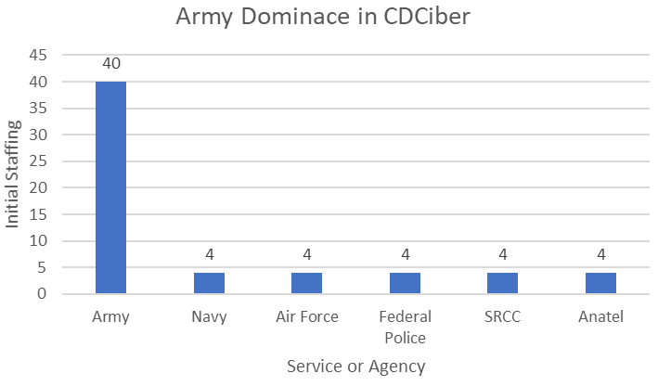
________________________
²¹ (Marchiori de Assis, 2021)

Figure 8) Brazil’s Public Trust in Government
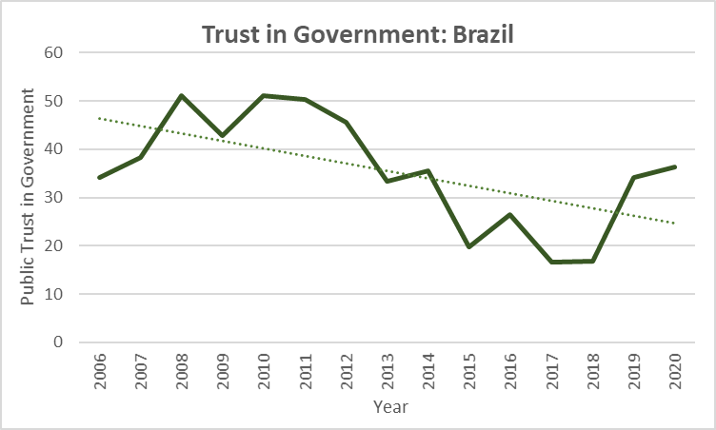
Figure 9) Brazil’s Turbulent Congress 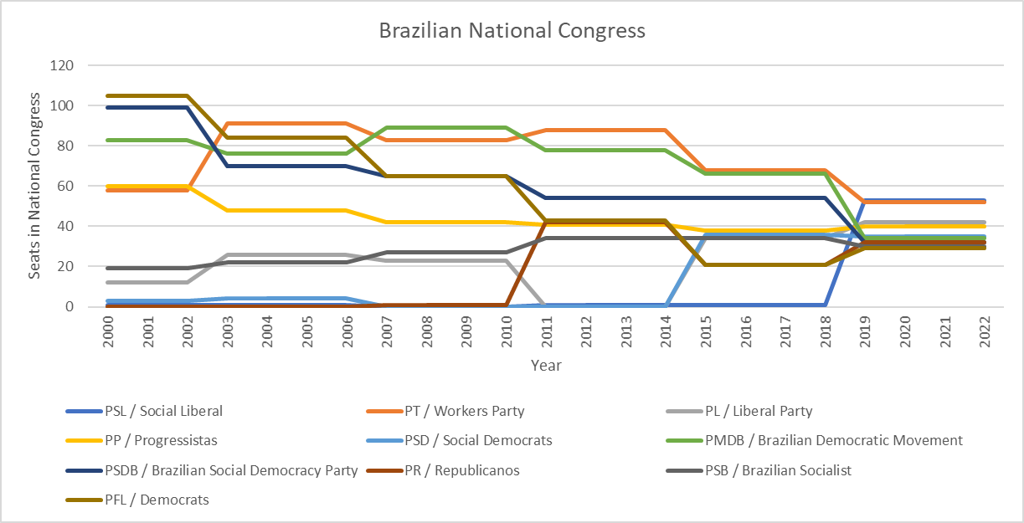
Figure 10) History of Cyber Security and Brazil
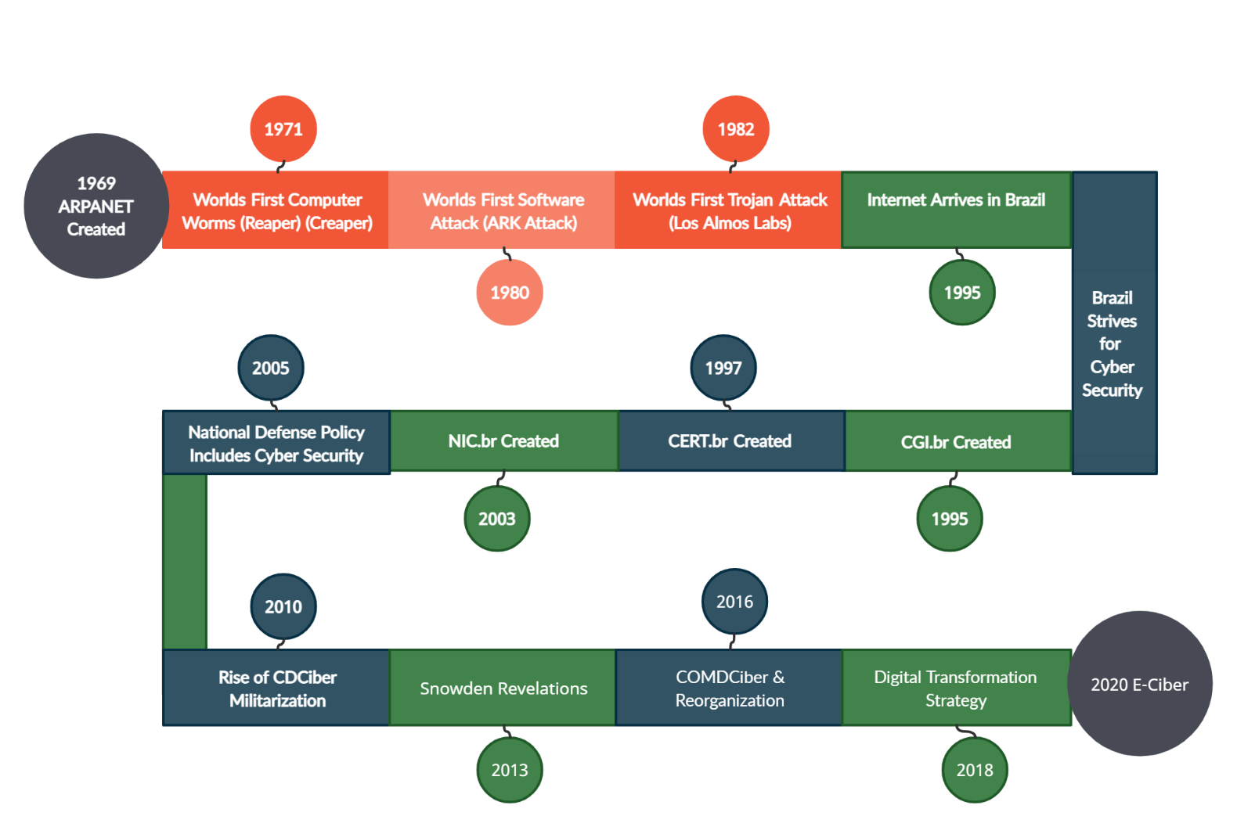

Figure 11) Origin of Cyber Attacks in Brazil⁸³
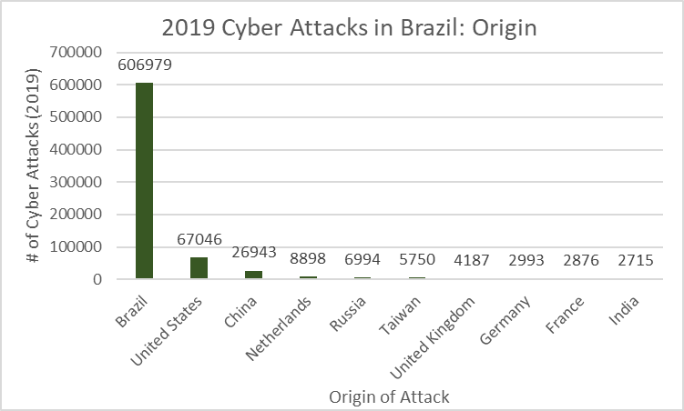
Figure 12) Cyber Attacks by Type⁵⁵
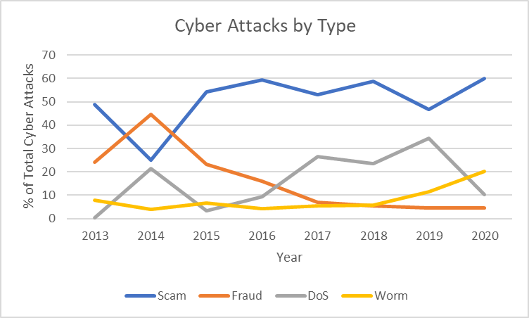
________________________
⁸³ (CTFTime, n.d.)
⁵⁵ (OECD, 2019)
Figure 13) Computer Science Programs in Brazil’s Top Universities⁸³
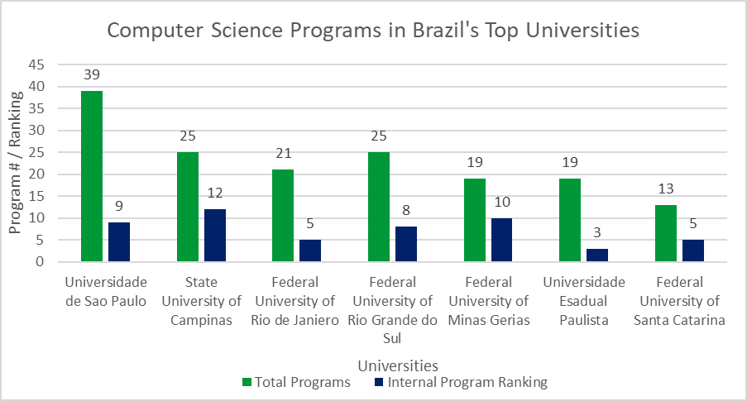
Figure 14) Brazil at CTF Time Competitions⁸⁰
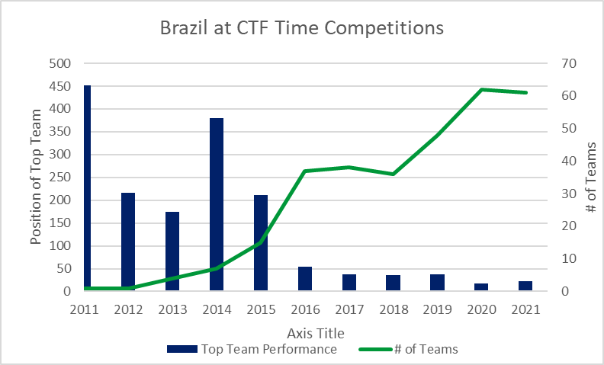______________________
⁸³ (CTFTime, n.d.)

⁸⁰ (Mari, Sale of state-owned tech companies postponed again in Brazil, 2022)

Figure 15) Cyber Maturity Model⁸⁵

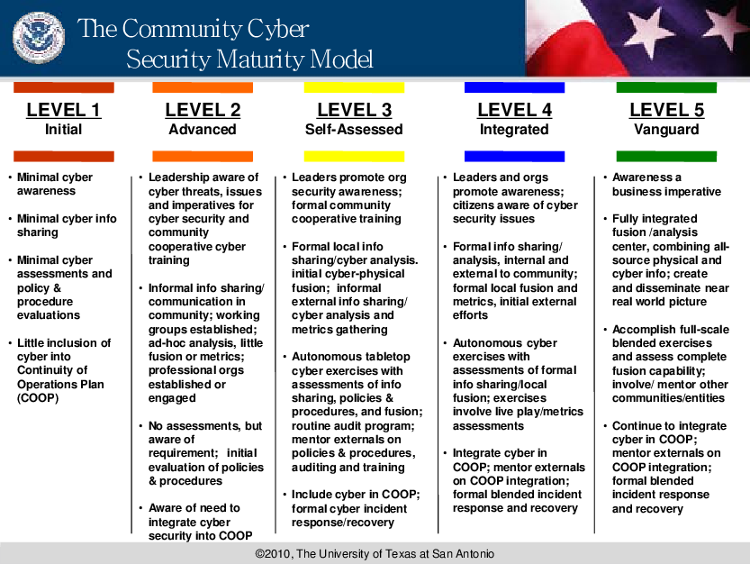

Figure 16) NCSI Cyber Security Scores⁸⁷

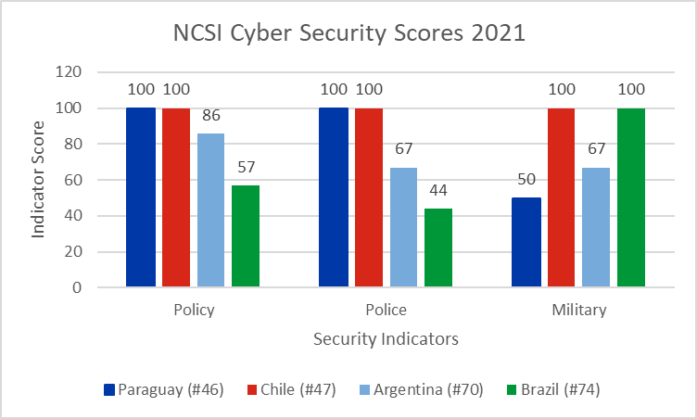

References
Accenture. (2021). Cyber Threat. Accenture.
Addison, R. (2020, July 24). Insights learned from leading Brazil’s critical infrastructure protection. Retrieved from https://industrialcyber.co/features/insights-learned-from-leading-brazils-critical-infrastructure-protection/
Agrafiotis, I., Bada, M., Kastelic, A., & Nagyfejeo, E. (2018). Cybersecurity Capacity Review. Organization of American States.
Antunes, P., & Cepik, M. (2003). Brazil's New Intelligence System: An Institutional Assessment. International Journal of Intelligence and CounterIntelligence, 349-373.
Ayres, G. (2021, December 30). Economies in Cyber Security: Scandinavia and the Baltics.
Azevedo, M. A. (2021, June 1). Brazil’s idwall raises $38M for identity validation platform. June.
Banco Central do Brasil. (n.d.). History of the Central Bank of Brazil. Retrieved from https://www.bcb.gov.br/pre/historia/historia_bc_en.asp?frame=1
Bauman, Z., Bigo, D., Esteves, P., Guild, E., Jabri, V., Lyon, D., & Walker, R. B. (2014). After Snowden: Rethinking the Impact of Surveillance. International Political Sociology, 8(2), 121-144.
Belchior, Miriam; Cardozo, José Eduardo; Bernardo Silva, Paulo; Campolina Diniz, Clélio. (2014, April 23). LAW No. 12,965. General Secretariat Sub-chief for Legal Affairs.
Belli, L. (2021). CyberBRICS: Cybersecurity Regulations in the BRICS Countries. Springer Nature.
Black Fog. (2022, January 4). The State of Ransomware in 2021. Retrieved from https://www.blackfog.com/the-state-of-ransomware-in-2021/
Bolzani, J., Prates, M., Roman, F., & Dos Santos, M. (2021, May 6). Central-Bank Independence Comes to Brazil.
Borne, T., & Canabarro, D. (2015). The Brazilian Reactions to the Snowden Affairs: Implications for the Study of International Relations in an Interconnected World. Conjuntura Austral: Journal of the Global South, 50-74.
Brazilian General Data Protection Law (LGPD, English translation). (2020, October). Retrieved from https://iapp.org/media/pdf/resource_center/Brazilian_General_Data_Protection_Law.pdf
Campos, M. B. (2021). Cyber Guardian Exercise: A Case Study in Brazil to Address Challenges in Cybersecurity and Protect Critical Infrastructure. SANS Institute.
Capano, G., & Woo, J. J. (2017). Resilience and robustness in policy design: a critical appraisal. Policy Sci, 399-426.
Cardona, C. (2015). National Cybersecurity Strategy Green Paper. European Union Agency for Cybersecurity.
Carnegie. (n.d.). Timeline of Cyber Incidents Involving Financial Institutions. Retrieved from Carnegie Web site: https://carnegieendowment.org/specialprojects/protectingfinancialstability/timeline#click-hide
Chester Networks . (2022, January 4). Portuguese media empire struck in the latest cyberattack on news outlets. Retrieved from Chester Networks Web site: https://chesternetworks.com/portuguese-media-empire-struck-in-the-latest-cyberattack-on-news-outlets/
Conselho Nacional de Justica. (2020, September 21). Estatiticas do Poder Judiciario. Retrieved from https://app.powerbi.com/view?r=eyJrIjoiMWYyMmEwOTgtNmZhZS00ZGQ4LTk1YTgtMzY0NTg5OWRlMGQyIiwidCI6ImFkOTE5MGU2LWM0NWQtNDYwMC1iYzVjLWVjYTU1NGNjZjQ5NyIsImMiOjJ9
Council on Foreign Relations. (2018, April 10). Brazil's Critical Infrastructure Faces a Growing Risk of Cyberattacks.
Cruz Lobato, L., & Hurel, L. M. (2018). A Strategy for Cybersecurity Governance in Brazil. September: IGARAPÉ Institution.
CTFTime. (n.d.). Brazil. Retrieved from CTFTime Website: https://ctftime.org/stats/2021/BR
Digital Rights LAC. (2013, September 19). The Snowden case and the Brazilian reaction.
DLA Piper . (2022, January 24). Data Protection Laws of the World: Brazil. Retrieved from DLA Piper Web site: https://www.dlapiperdataprotection.com/index.html?t=law&c=BR#:~:text=The%20Brazilian%20General%20Data%20Protection,Data%20Protection%20Act%20(GDPR).
Federal Government of Brazil. (2017, April 27). Joint Command in Cyber Defense. Retrieved from Government of Brazil Web site: https://www.gov.br/defesa/pt-br/centrais-de-conteudo/noticias/ultimas-noticias/comando-conjunto-na-defesa-cibernetica
Ford, A. (2020, December 1). Brazil Hits Enter on Digital Piracy Crackdown. Retrieved from https://insightcrime.org/news/brief/brazil-hits-enter-on-digital-piracy-crackdown/
Gomes da Silva, C. M. (2019). CYBER SECURITY: A CASE STUDY OF BRAZIL. Islamabad: National Defence University.
GRA Quantum. (2016). CYBERSECURITY: The Greatest Hurdle of the 2016 Olympic Games . GRA Quantum.
Harris, S. (2009, November 10). Brazil To "60 Minutes": It Wasn't A Hacker.
Healthcare IT News . (2020, August 10). Data protection laws in COVID-19 times.
Hoepers, C. (2005, October). Cybersecurity and Incident Response Initiatives: Brazil and Americas.
Hurel, L. M. (2020, April 5). Brazil’s First National Cybersecurity Strategy: An Analysis of its Past, Present and Future.
Instituto Brasileira de Defesa do Consumidor. (n.d.). Tackling the Pandemic Requires Collective Efforts. Retrieved from https://idec.org.br/institutional-report
Inter-American Development Bank . (2020). Cybersecurity: Risk, Progress, and the Way Forward in Latin America and the Caribbean. OAS.
Kaspersky. (2021, May 17). Brazilian malware on the rise: Kaspersky discovers new local banking Trojan is going global.
Lowenthal, M. M. (2019). Intelligence: From Secrets to Policy. CQ Press.
Manjikian, M., & Romaniuk, S. N. (2021). Routledge Companion to Global Cyber-Security Strategy. Routledge.
Mann, R. (2021, September 6). Cyberattacks grow 23% in Brazil in 2021 and reach 1,400 threats per minute. Retrieved from https://www.riotimesonline.com/brazil-news/technology/cyberattacks-grow-23-in-brazil-in-2021-and-reach-1400-threats-per-minute/
Marchiori de Assis, B. (2021). Building Cyber Operational Capabilities: Brazil's Efforts over the Past Two Decades. UNIDIR.
Mari, A. (2021, September 13). Brazil debates creation of national strategy to tackle cybercrime.
Mari, A. (2021, December 16). Brazil investigates use of staff credentials in cyberattacks against government bodies. Retrieved from ZDNET: https://www.zdnet.com/article/brazil-investigates-use-of-staff-credentials-in-cyberattacks-against-government-bodies/
Mari, A. (2021). Brazilian Ministry of Health suffers cyberattack and COVID-19 vaccination data vanishes. 10: December.
Mari, A. (2021, December 1). Most Brazilian businesses set to boost cybersecurity spend in 2022.
Mari, A. (2022, February 28). Manufacturing is the most targeted sector by ransomware in Brazil.
Mari, A. (2022, February 8). Sale of state-owned tech companies postponed again in Brazil. Retrieved from https://www.zdnet.com/article/sale-of-state-owned-tech-companies-postponed-again-in-brazil/
Mari, A. (2022, February 21). Security spend to reach $1 billion in Brazil in 2022.
Ministerio de Tecnologias de la Informacion Y Comunicacion. (n.d.). State Information Security Governance Model. Retrieved from Ministerio de Tecnologias de la Informacion Y Comunicacion: https://www.cert.gov.py/gobernanza-seguridad
Ministry of Defense. (2005). NATIONAL DEFENSE POLICY . Ministry of Defense.
Ministry of Defense. (2008). Brazil: National Strategy of Defense. Ministry of Defense. Retrieved from https://www.files.ethz.ch/isn/154868/Brazil_English2008.pdf
Ministry of the Ineterior and Public Security. (2020, January). AMENDS SUPREME DECREE NO. 533, OF 2015, OF THE MINISTRY OF THE INTERIOR AND PUBLIC SECURITY, WHICH CREATES THE INTER-MINISTERIAL COMMITTEE ON CYBERSECURITY. Retrieved from https://www.bcn.cl/leychile/navegar?idNorma=1140740
Mix, D. E. (2020). Estonia, Latvia, and Lithuania: Background and U.S.-Baltic Relations. Congressional Research Service .
Nakasone, P. M. (2018). Cyberspace Strategy Symposium Proceedings. USCYBERCOM.
National Cybersecurity Preparedness Consortium. (2022). The Community Cyber Security Maturity Model. Retrieved from National Cybersecurity Preparedness Consortium Web site: https://nationalcpc.org/ccsmm.html
National Law Review. (2020, September 28). Brazil's LGPD Takes Effect - With Early Enforcement.
NCSI. (n.d.). Brazil. Retrieved from National Cyber Security Index: https://ncsi.ega.ee/country/br/?pdfReport=1
NIST. (n.d.). cyberspace. Retrieved from NIST Web site: https://csrc.nist.gov/glossary/term/cyberspace
OECD. (2019). Digital security policy in Brazil. OECD.
OECD. (2022). Trust in government. Retrieved from https://data.oecd.org/gga/trust-in-government.htm
Peleg, N., & Shmueli, G. (2018). Cyber Security Strategy Review for Paraguay. CYGOV.
Sharma, T. (2019, November 28). WORLD’S TOP 10 CYBER CRIME HOTSPOTS. November.
Smith, M. (2013, December). Snowden offers to help Brazil spying investigation, hints at asylum request. NBC News.
Soares, E. (2021). Brazil: Punishment for Crimes Committed Electronically or Over Internet Increased. Retrieved from https://www.loc.gov/item/global-legal-monitor/2021-06-08/brazil-punishment-for-crimes-committed-electronically-or-over-internet-increased/
Stronell, A. (2020). Brazil’s cyber security strategy leaves much to be desired . 25: September.
Temer, M., & Westphalen Etchegoyen, S. (2018). The National Information Security Policy Sub-chief for Legal Affairs. General Secretariat.
U.S. News. (n.d.). Best Global Universities in Brazil. Retrieved from U.S. News Web site: https://www.usnews.com/education/best-global-universities/brazil
Woollacott, E. (2020, August 31). Brazil reaches towards cybersecurity maturity.
World Bank. (n.d.). GDP per capita (current US$) - Brazil.

(Hurel, 2020)
(NIST, n.d.)
(Agrafiotis, Bada, Kastelic, & Nagyfejeo, 2018)
(Agrafiotis, Bada, Kastelic, & Nagyfejeo, 2018)
(Mari, Brazil investigates use of staff credentials in cyberattacks against government bodies, 2021)
(Harris, 2009)
(Accenture, 2021)
(Mari, 2021)
(Azevedo, 2021)
(Lowenthal, 2019)
(Cruz Lobato & Hurel, 2018)
(Cruz Lobato & Hurel, 2018)
(Hurel, 2020)
(Hurel, 2020)
(Hoepers, 2005)
(Gomes da Silva, 2019)
(Hoepers, 2005)
(Hurel, 2020)
(Ministry of Defense, 2005)
(Ministry of Defense, 2008)
(Marchiori de Assis, 2021)
(Belli, 2021)
(Belli, 2021)
(Belli, 2021)
(Belli, 2021)
(Belchior, Miriam; Cardozo, José Eduardo; Bernardo Silva, Paulo; Campolina Diniz, Clélio, 2014)
(Belchior, Miriam; Cardozo, José Eduardo; Bernardo Silva, Paulo; Campolina Diniz, Clélio, 2014)
(Belchior, Miriam; Cardozo, José Eduardo; Bernardo Silva, Paulo; Campolina Diniz, Clélio, 2014)
(Digital Rights LAC, 2013)
(Digital Rights LAC, 2013)
(Smith, 2013)
(Smith, 2013)
(Smith, 2013)
(Smith, 2013)
(Bauman, et al., 2014)
(Cruz Lobato & Hurel, 2018)
(Federal Government of Brazil, 2017)
(Federal Government of Brazil, 2017)
(Gomes da Silva, 2019)
(Nakasone, 2018)
(Gomes da Silva, 2019)
(Manjikian & Romaniuk, 2021)
(DLA Piper , 2022)
(Brazilian General Data Protection Law (LGPD, English translation), 2020)
(World Bank)
(Temer & Westphalen Etchegoyen, 2018)
(Temer & Westphalen Etchegoyen, 2018)
(Hurel, 2020)
(Antunes & Cepik, 2003)
(Brazilian General Data Protection Law (LGPD, English translation), 2020)
(National Law Review, 2020)
(Healthcare IT News , 2020)
(Healthcare IT News , 2020)
(Borne & Canabarro, 2015)
(OECD, 2019)
(OECD, 2019)
(Sharma, 2019)
(Hurel, 2020)
(Mari, Brazil debates creation of national strategy to tackle cybercrime, 2021)
(Woollacott, 2020)
(Stronell, 2020)
(Kaspersky, 2021)
(Mari, Most Brazilian businesses set to boost cybersecurity spend in 2022, 2021)
(Mari, Security spend to reach $1 billion in Brazil in 2022, 2022)
(Banco Central do Brasil)
(Bolzani, Prates, Roman, & Dos Santos, 2021)
(Instituto Brasileira de Defesa do Consumidor)
(Mann, 2021)
(Addison, 2020)
(Council on Foreign Relations, 2018)
(Black Fog, 2022)
(Mari, Manufacturing is the most targeted sector by ransomware in Brazil, 2022)
(Conselho Nacional de Justica, 2020)
(Soares, 2021)
(GRA Quantum, 2016)
(Ford, 2020)
(Carnegie, n.d.)
(Chester Networks , 2022)
(Conselho Nacional de Justica, 2020)
(Mari, Sale of state-owned tech companies postponed again in Brazil, 2022)
(Carnegie, n.d.)
(U.S. News, n.d.)
(CTFTime, n.d.)
(National Cybersecurity Preparedness Consortium, 2022)
(Capano & Woo, 2017)
(Campos, 2021)
(NCSI, n.d.)
(Ministry of the Ineterior and Public Security, 2020)
(Ministerio de Tecnologias de la Informacion Y Comunicacion, n.d.)
(Peleg & Shmueli, 2018)
(Inter-American Development Bank , 2020)
(Mix, 2020)
(Ayres, 2021)
(World Bank)
(Hurel, 2020)
(OECD, 2022)

